Tableau Lecture 3

Table of content:

| Table of content:  Agenda:  Theory on different types of tables:  Theory on different data structure  Dataset used for the class:  Business Problem-1:Display sales for each sub category by region for all the years in a table format  Business Problem 2 :Display sales of for each subcategories by region for all the years in a table format and highlight values that has the highest and lowest sales  Business problem 3-Display sales and profit for each subcategories by region for all the years in a table format  Business problem 4: Create a group called as small items which include Binder, Bookcases, Envelope, Fastener and supplies and compare its sale with the rest of the categories  Business problem 5 -create a set of customers with highest profit  Business Problem 6 -Find the top 5 product subcategories by sales  Business problem 7- Find top customers by sales but low profitability  Business problem 8: Allow users to filter out the top 10 products subcategories by average discount.  Business problem 9: Build a Hierarchy of Product category and Sub Category and have a plot which displays sales of product by category and drill it down using the hierarchy to display sales by sub category |
| --- |

### Agenda:

* Charts
  + Text Table
  + Highlight Table
  + Heat Map
  + Difference Between Highlight table and Heat Map
* Groups
* Sets
  + Static
  + Dynamic
  + Combined
* Groups Vs Sets
* Parameter and its application
* Hierarchy
* Sorting

### Theory on different types of tables:

1. Text table: A text table is the most basic type of table in Tableau, and displays data in a grid-like format with columns and rows. You can customize the appearance of the text table by changing the font, color, and formatting of the text, as well as by adding calculations and filters.
2. Highlight table: A highlight table is a type of table that allows you to emphasize specific data points based on their values. For example, you can create a highlight table that shows sales by region, and highlight the regions with the highest sales using a different color or shading. You can also use the highlight table to filter, sort, and drill down on your data.
3. A heatmap in Tableau is a type of visualization that displays data as a matrix of colored rectangles, where each rectangle represents a cell in the matrix and the color of the cell represents the value of the data. The heatmap is a great way to analyze large amounts of data by showing the patterns and trends in the data in an easy-to-understand way.

### Theory on different data structure

1. Set: A set is a custom subset of data that you can define based on a specific condition or criteria. For example, you can create a set of customers who have purchased a particular product, or a set of sales representatives who have met a certain sales target. Once you create a set, you can use it to filter, highlight, or create calculations.
2. Group: A group is a way to combine data into higher-level categories. For example, you can group a list of products by category, or group a list of customers by geographic region. Once you create a group, you can use it to filter, aggregate, or create calculations.
3. Hierarchy: A hierarchy is a way to organize data into a tree-like structure, where each level represents a different level of detail. For example, you can create a hierarchy that starts with country, then breaks down into region, then breaks down into city. Once you create a hierarchy, you can use it to drill down or roll up your data, or to create calculations that aggregate data at different levels of detail.

### Dataset used for the class:

[Sample - Superstore-Main.xlsx](https://docs.google.com/spreadsheets/d/1sM1Kjgy99k2tHBtKP5OXcpQLz7SC5yGr/edit?usp=sharing&ouid=107681937864127182413&rtpof=true&sd=true)

#### 

### Business Problems:

#### Business Problem-1:Display sales for each sub category by region for all the years in a table format

**Solution:**

* **Business Context**
  + Assume you are working as a data analyst for the super-store as a data analyst. Manager of the store wants to understand what the top selling items(sub category) in each region are. This helps them to take business decisions like what to stock in each region, is there any business category lagging behind.
* **Intro to text table:**
  + Text tables are also called pivot tables or cross-tabs
  + Text table is a tubular view representing data.
  + text tables are created by placing one dimension on the **Rows** shelf and another dimension on the **Columns** shelf. You then complete the view by dragging one or more measures to **Text** on the **Marks** card.
* **Demonstration of creating a text table**
  + Step-1: Drag “**order date”** to rows

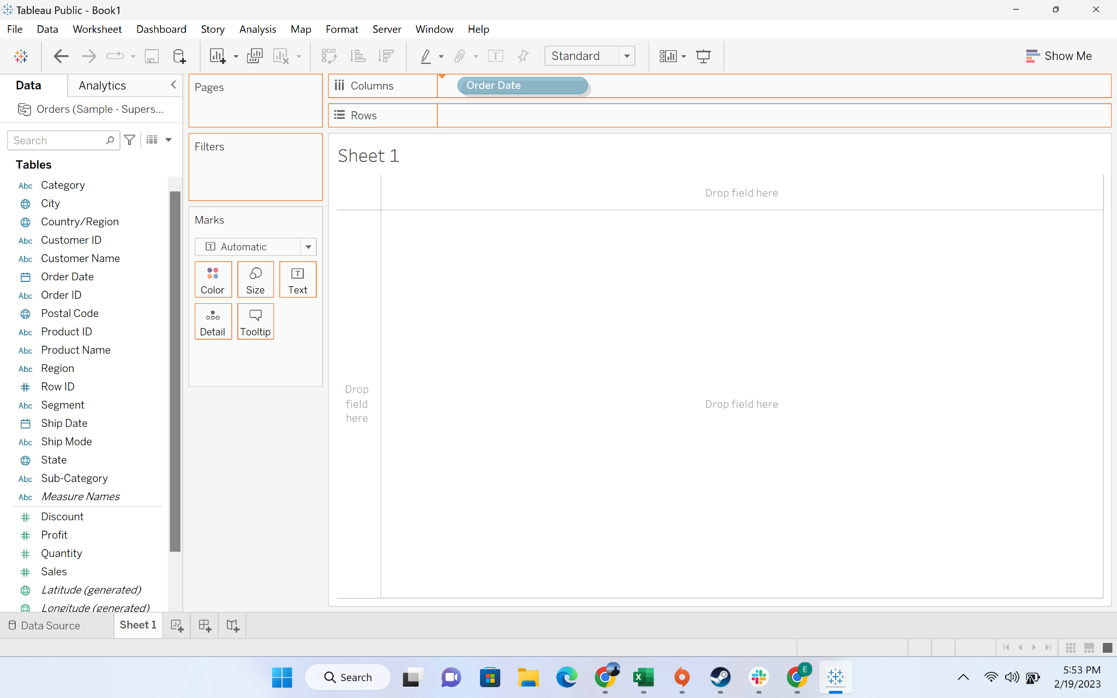

* Drag **“sub-category”** to column

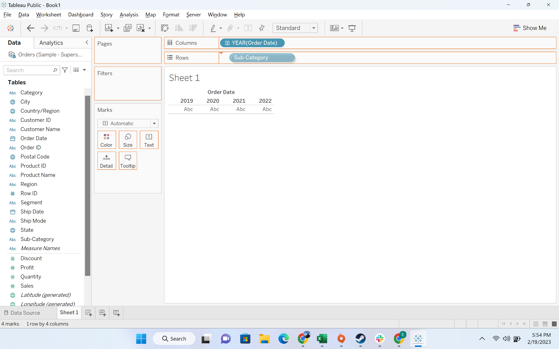

* Drag **“Region”** to rows

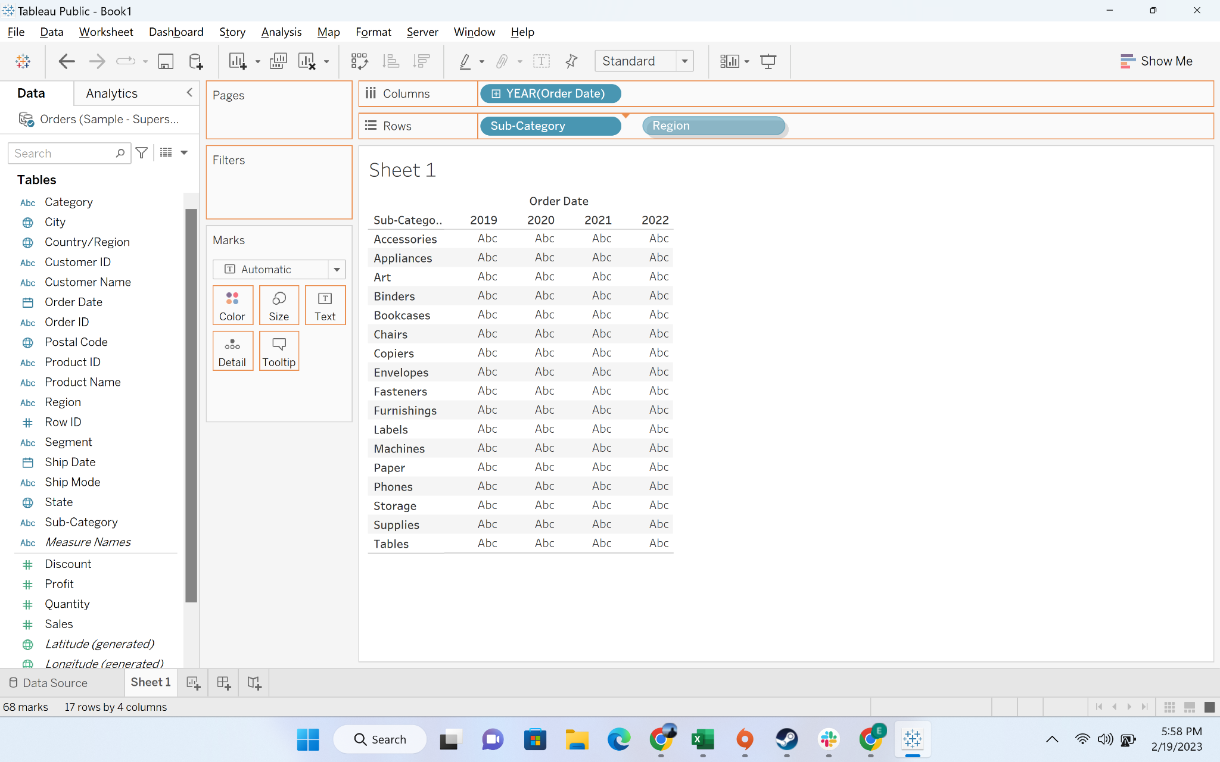

* Move “sales” to labels

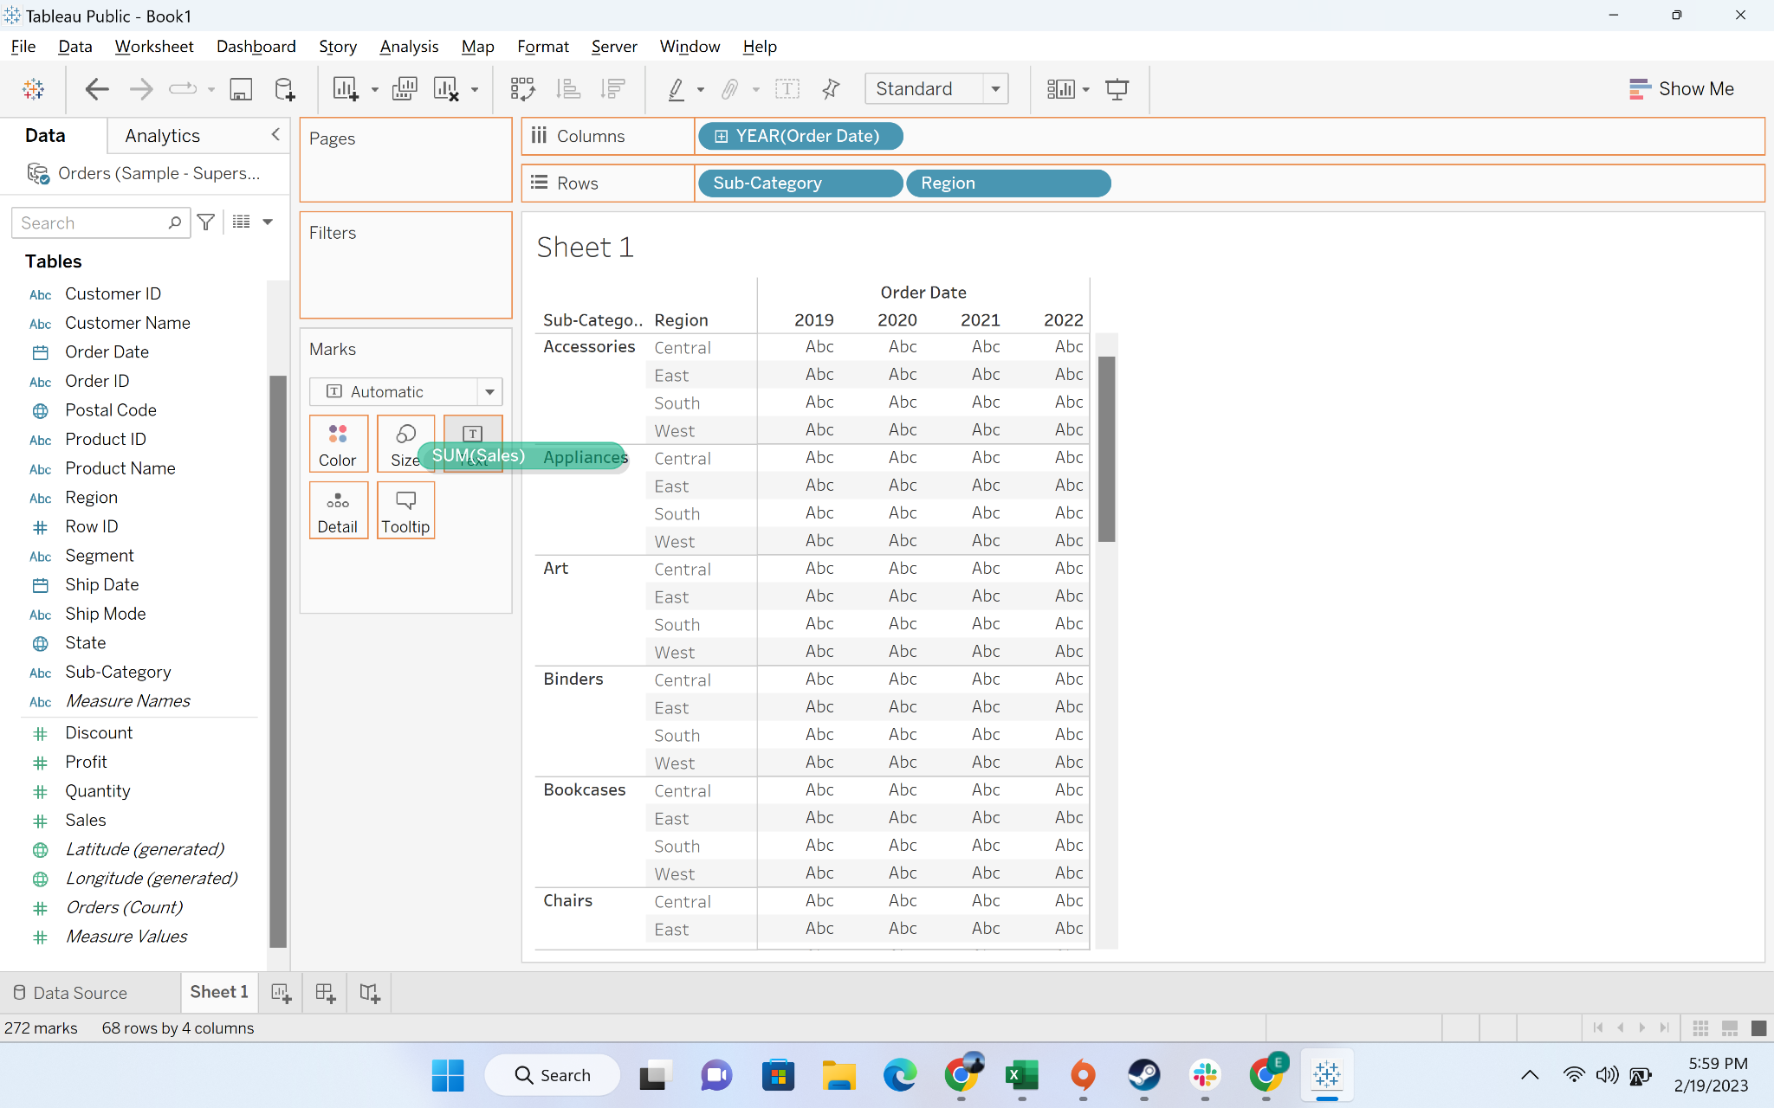

* Output: text table

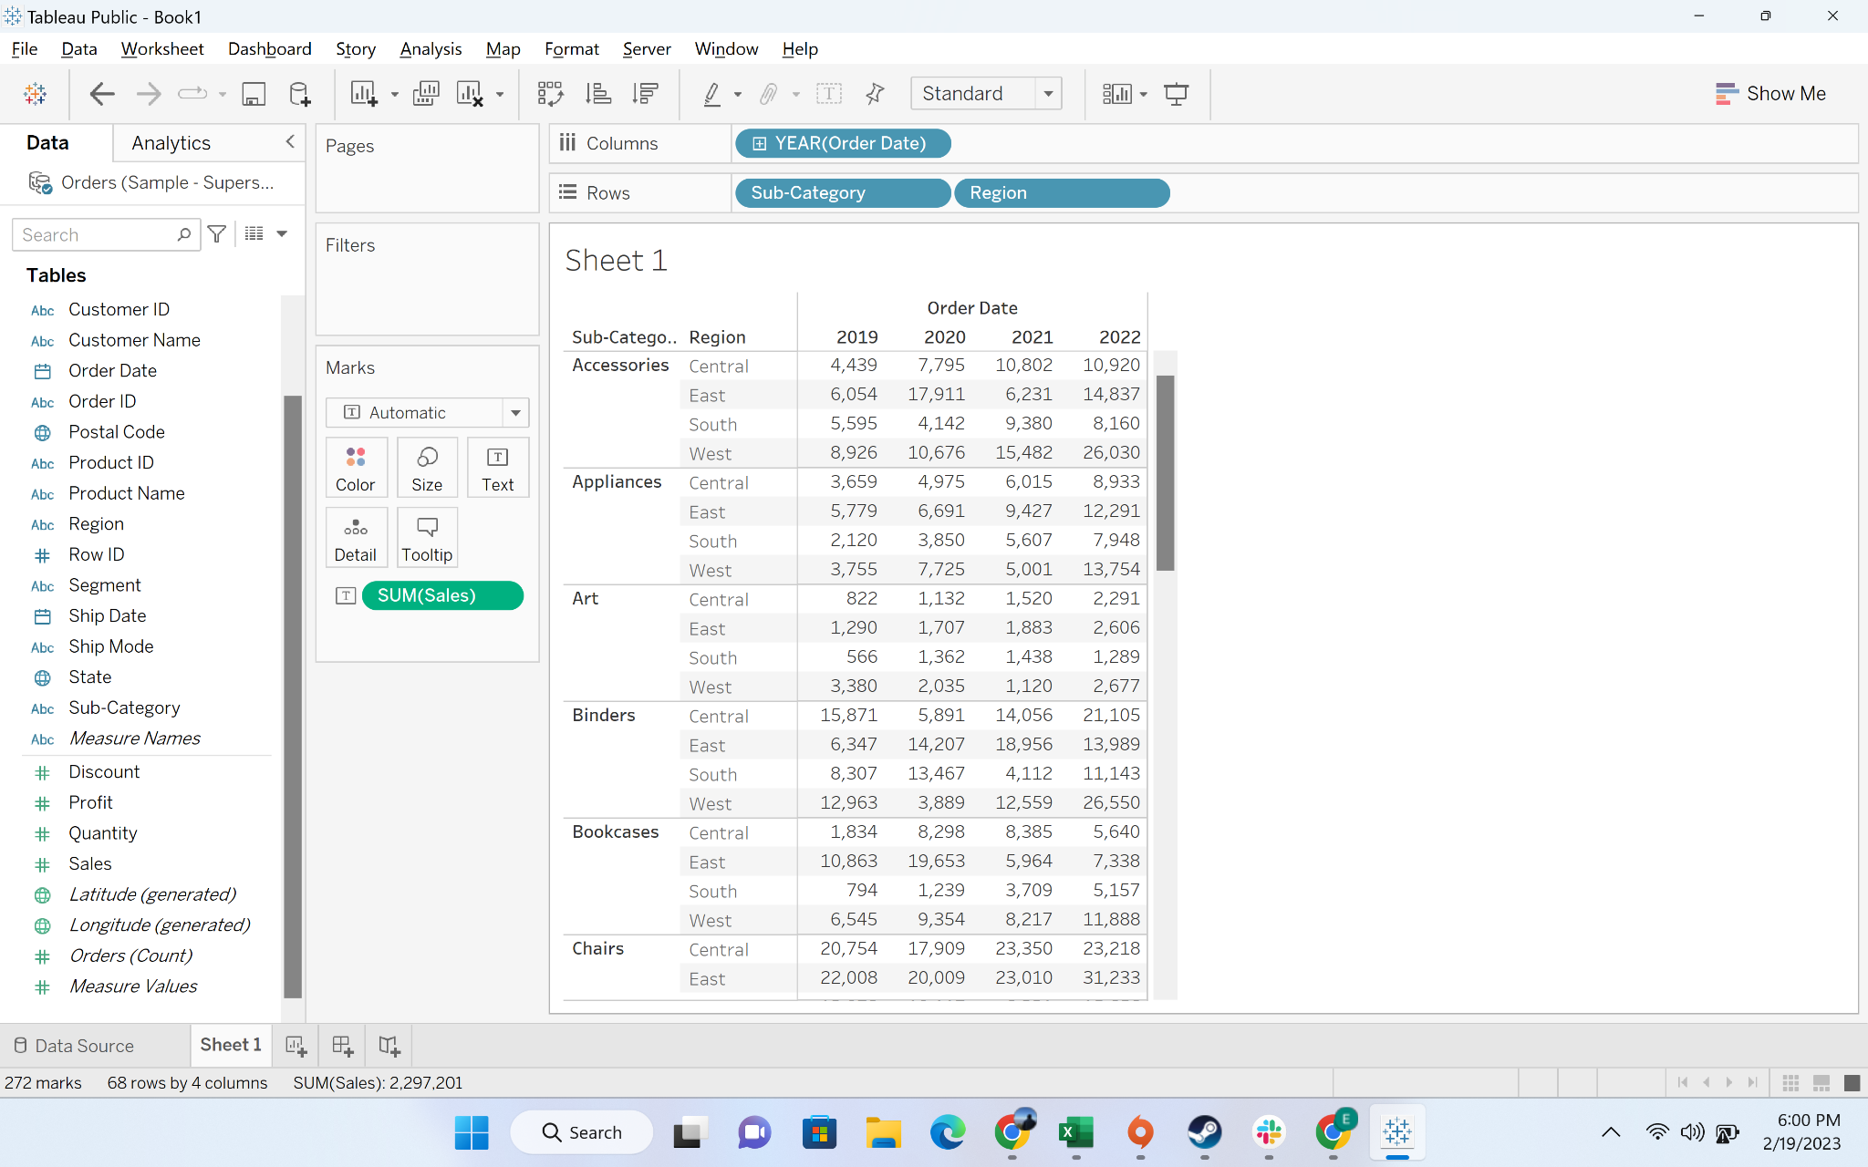

* Using data crosstab to create text table
  + Step-1: Drag Order date to columns

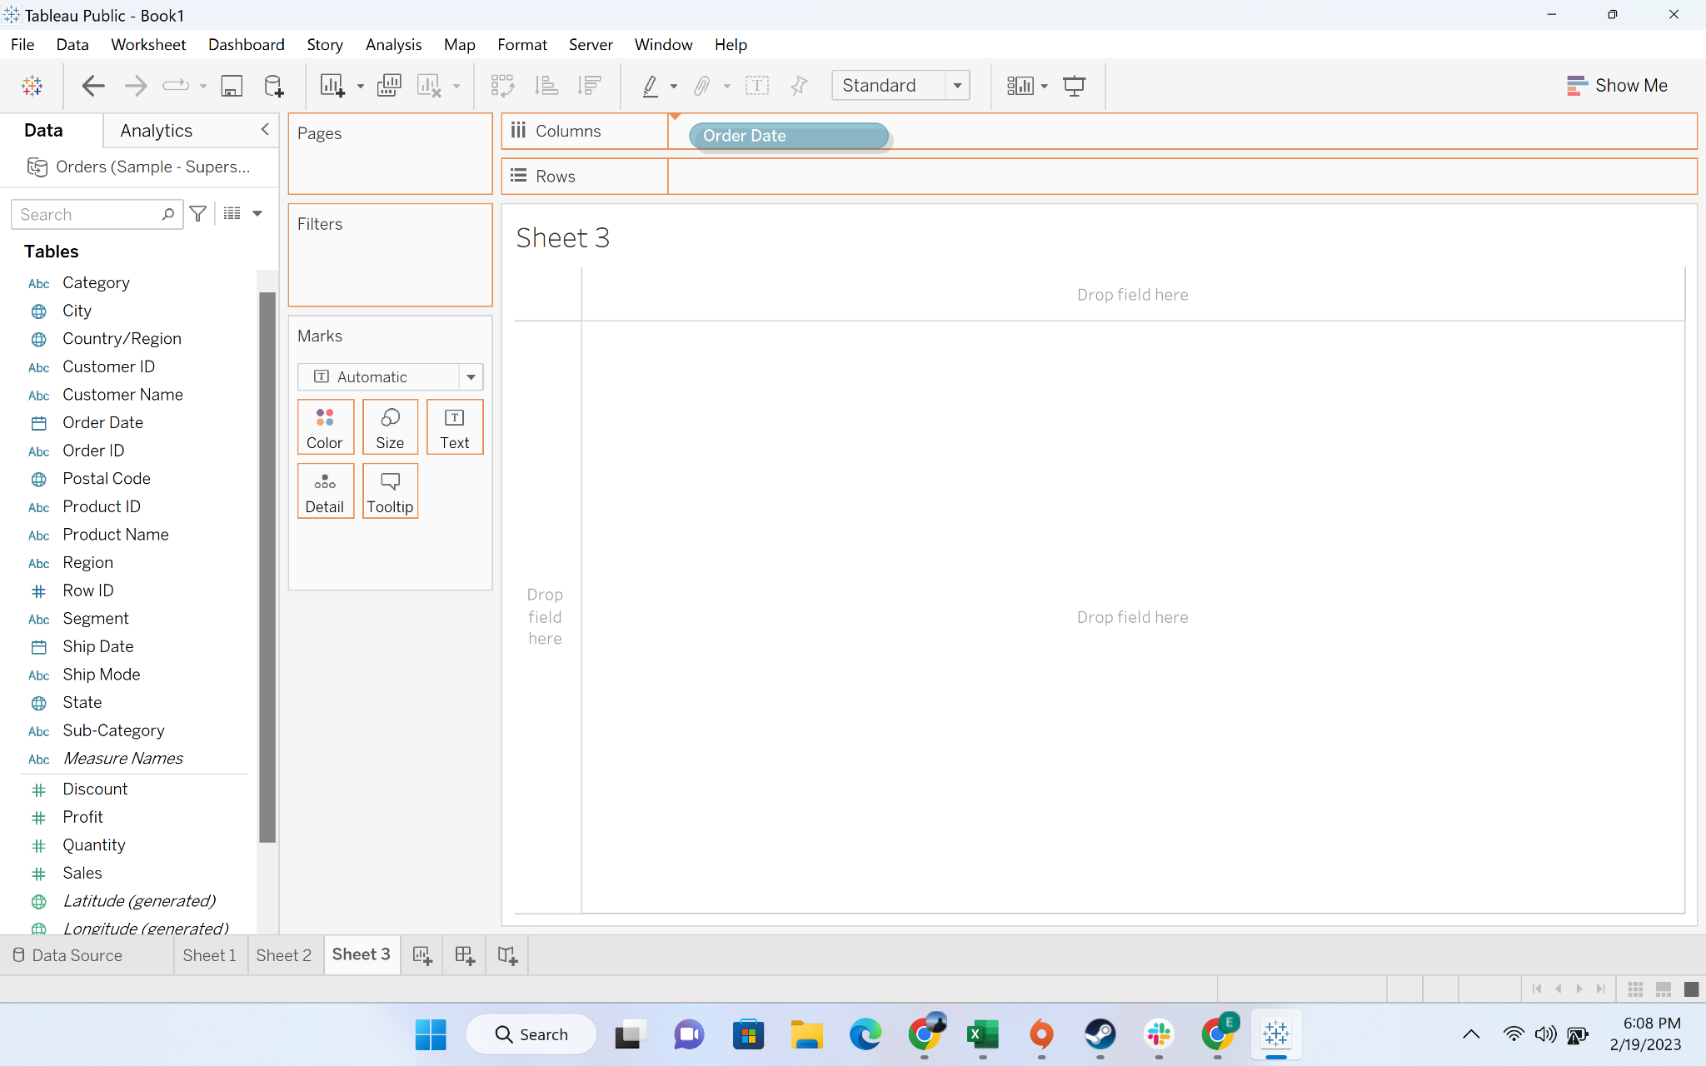

* + Step-2: Drag “sum” to rows

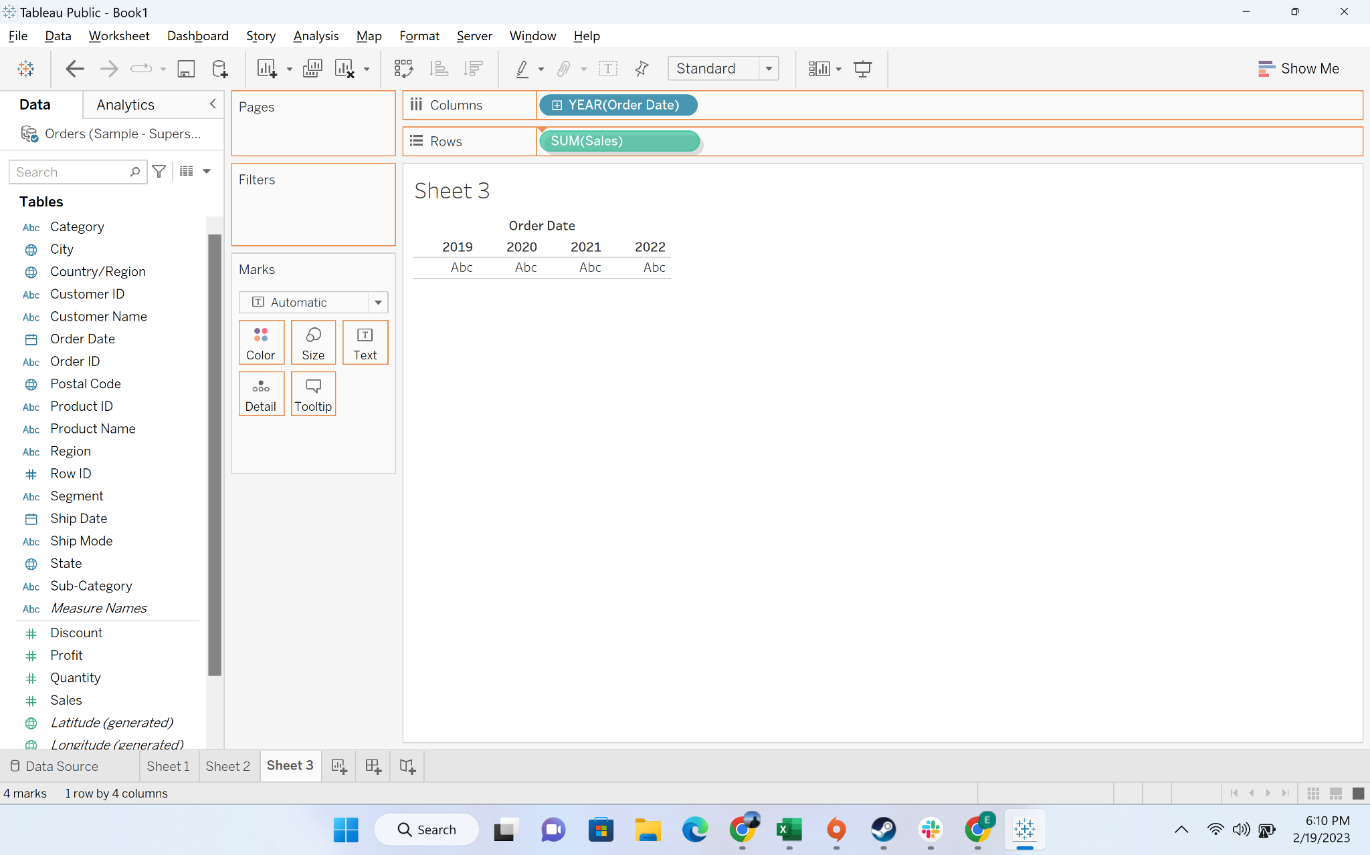

* + Step-3: Drag “Sub Category” to rows

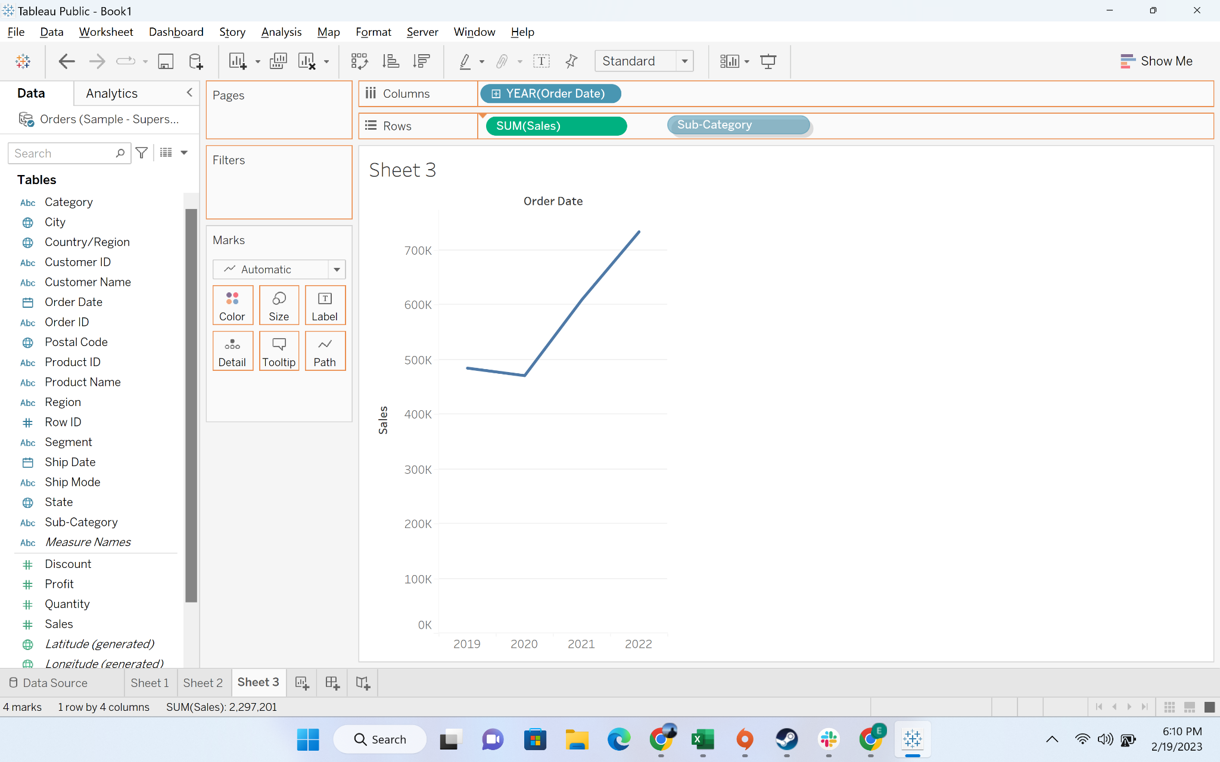

* + Step-4: Drag “Category” to rows

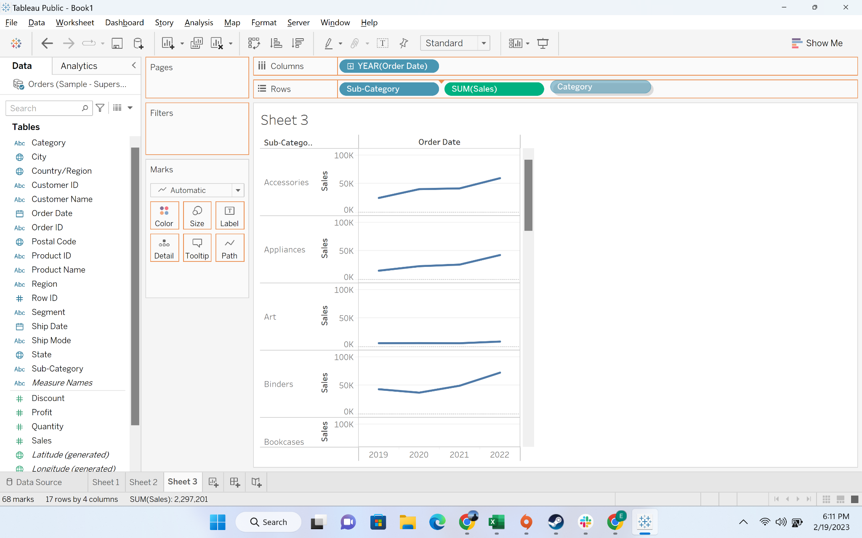

* + Right click on sheet and click “Duplicate as Tab”

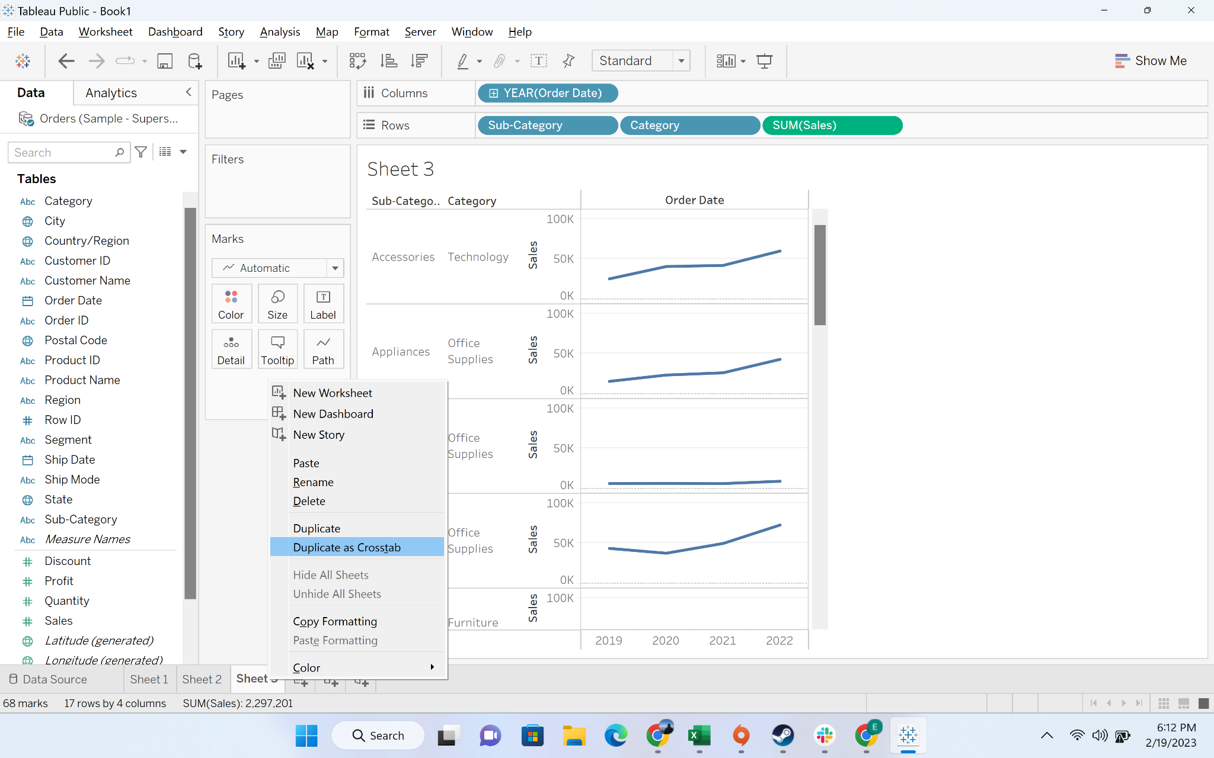

* + Output

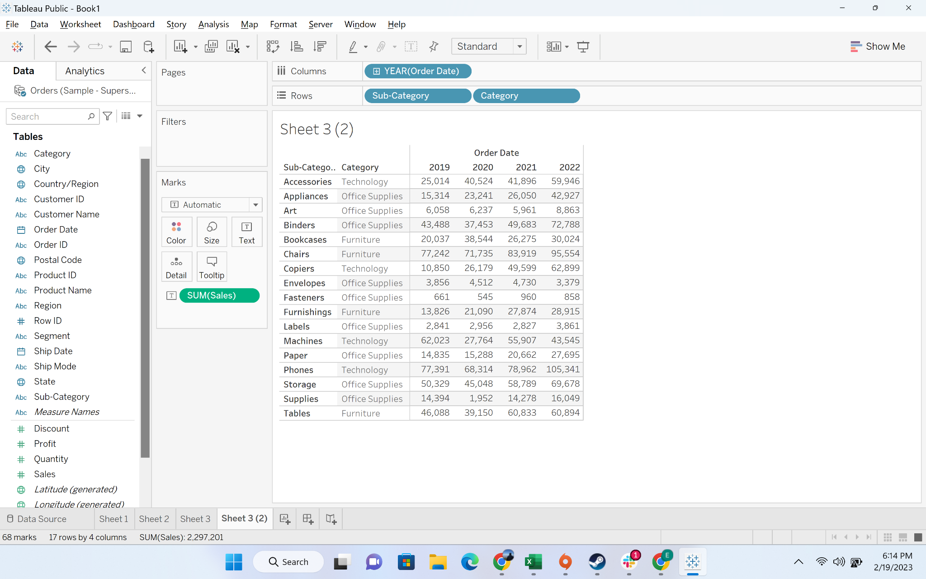

#### Business Problem 2 :Display sales of for each subcategories by region for all the years in a table format and highlight values that has the highest and lowest sales

**Solution:**

* **Business Context**
  + Assume you are working as a data analyst for the super-store as a data analyst. You have to make a report for senior leadership. Senior leadership is generally away from the day to day operations and get multiple reports in a day. Senior leadership prefers reports which are intuitive and can be self explanatory. **One way of doing this is using colors to compare categories within a dimension**
* **Intro to highlight table:**
  + Highlight tables allow us **to compare categorical data using color**.
  + First, we have to create text tables by placing one dimension on the **Rows** shelf and another dimension on the **Columns** shelf. You then select Square as the mark type and place a measure of interest on the Color shelf.
* **Demonstration of creating a highlight table**
  + Step-1: We will continue with the visualization we have created in the previous question
  + Step-2: Drag “sales” to color

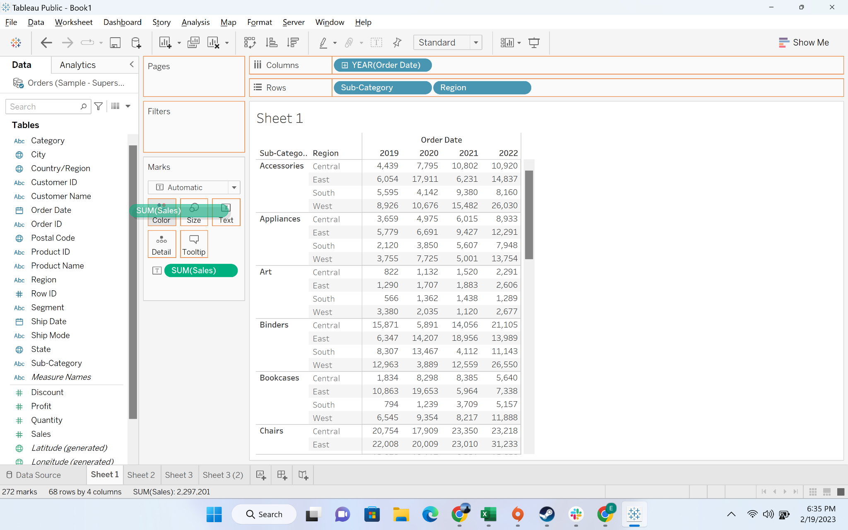

* + Step-3: Make it to “fit width”

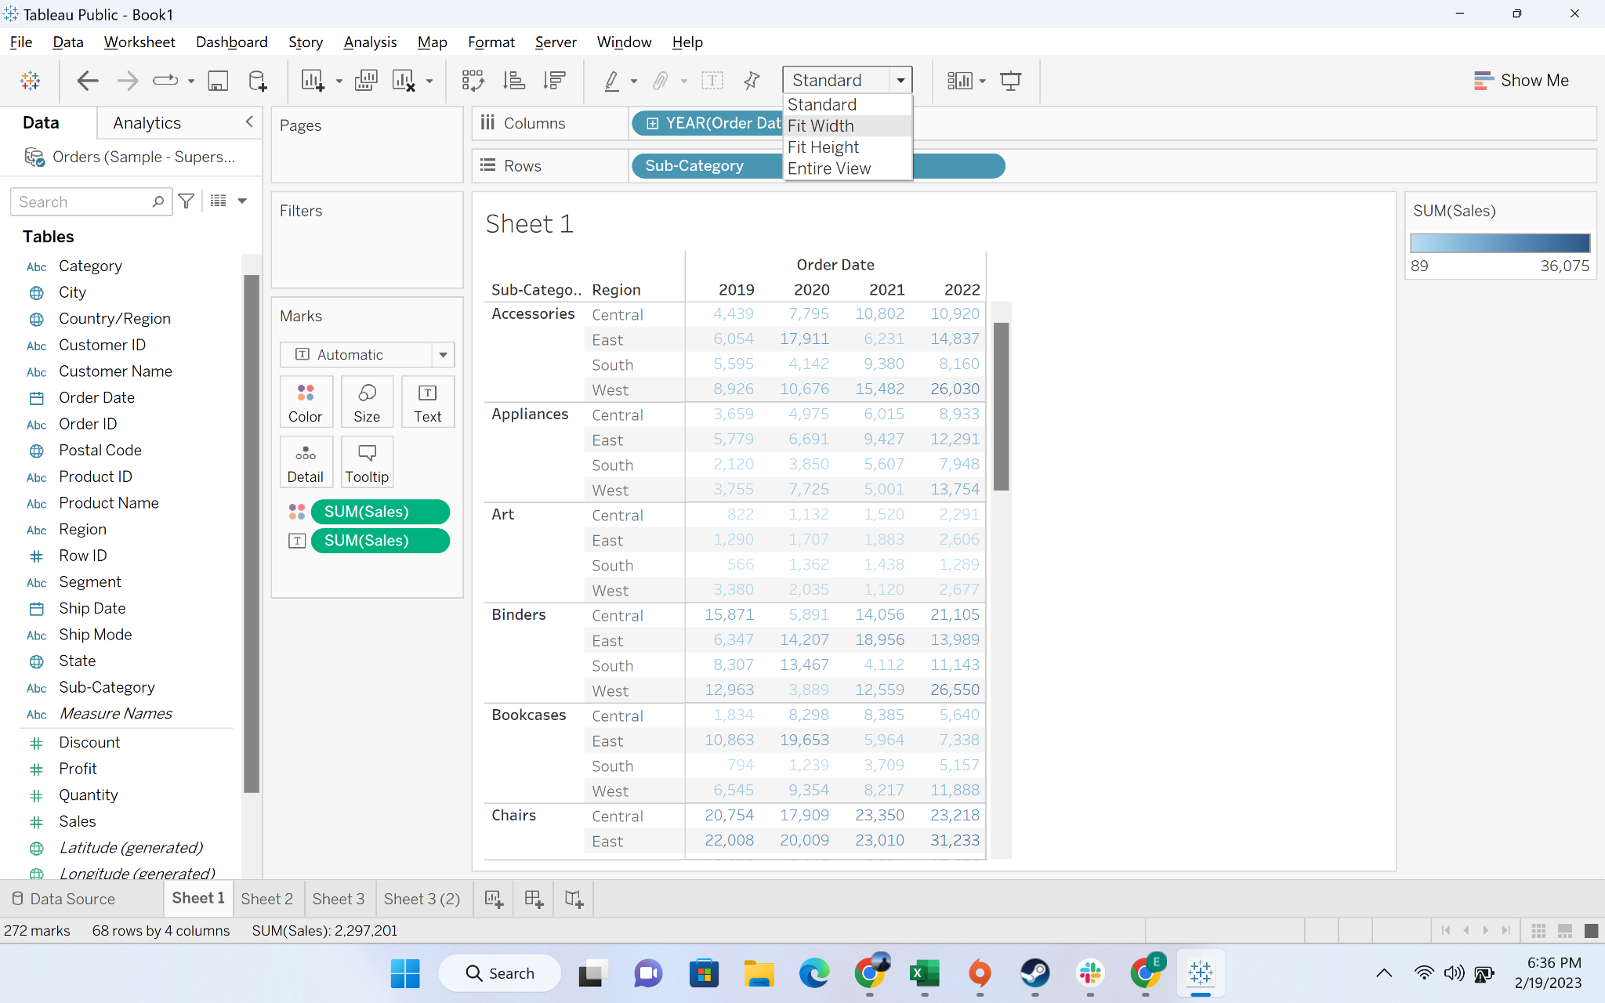

* + Step-3: Change the Marks for “automatic” to **“square”**

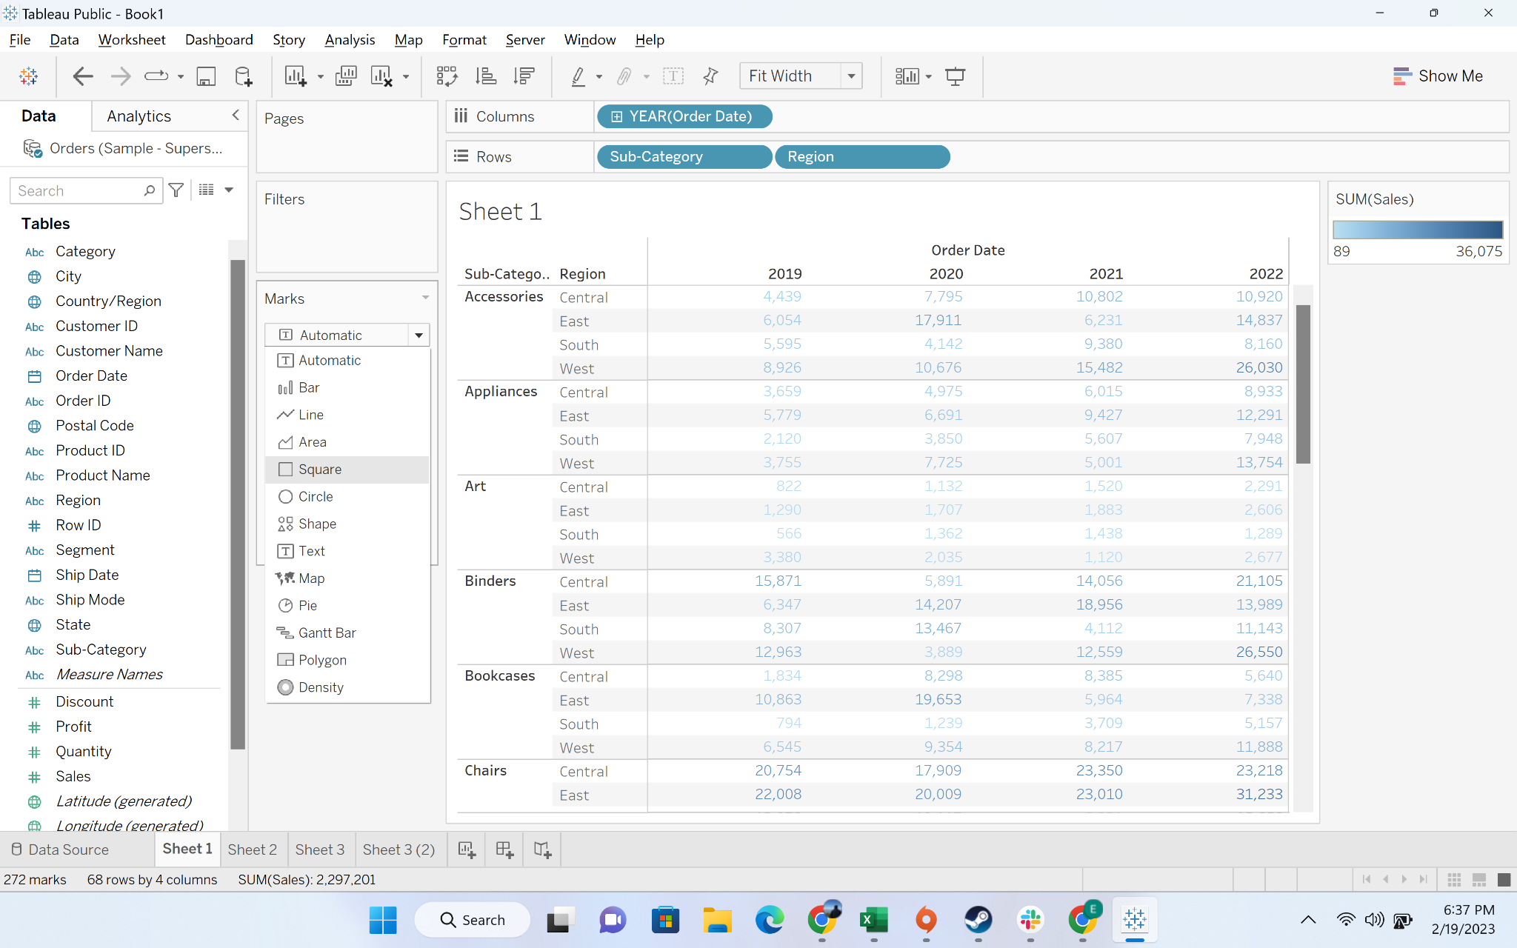

* + Output:

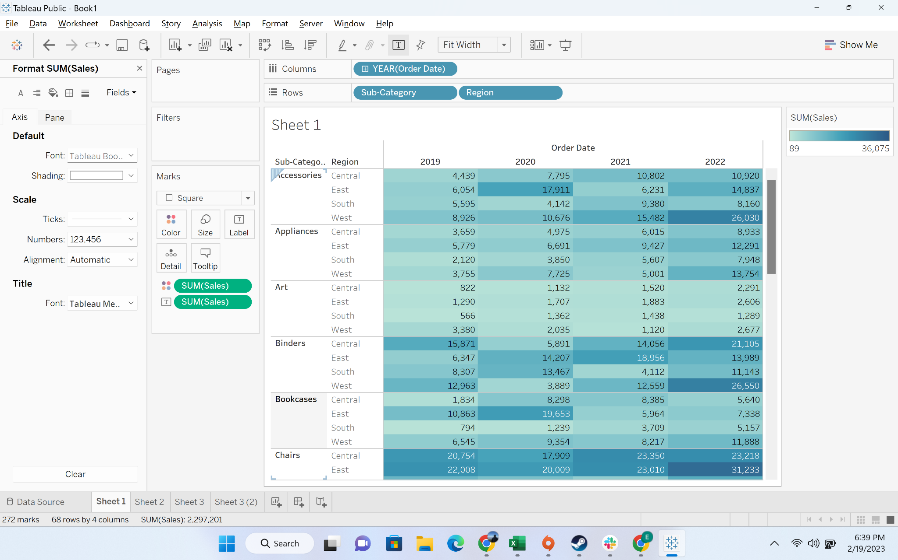

* + You can use edit colors to change the color theme

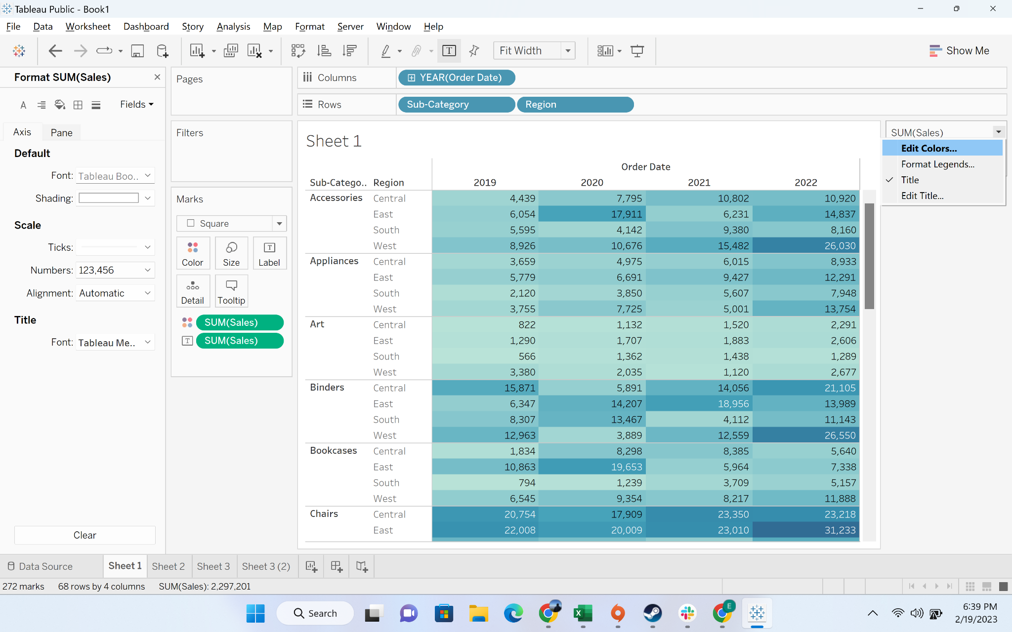

#### Business problem 3-Display sales and profit for each subcategories by region for all the years in a table format

* **Business Context**
  + In most of the business reports, we need to present more than metric. For example, most of the sales managers are interested to know both sales and profit for the region. They want to drive revenue as well as profit. Similarly, most of the new business divisions(for example cloud businesses) are generating revenue, but do not make profit. We have to generate reports which help in quick identification of these
* **Intro to heatmap table:**
  + Highlight tables allow us **to show relationships across multiple dimensions and one or more measure**
  + Heatmaps present patterns, trends, and relationships within the data. They use color and size from two on the same or different measures.
* **Demonstration of creating a heatmap**
  + Step-1: We will continue with the visualization we have created in the previous question
  + Step-2: Drag “profit” to size

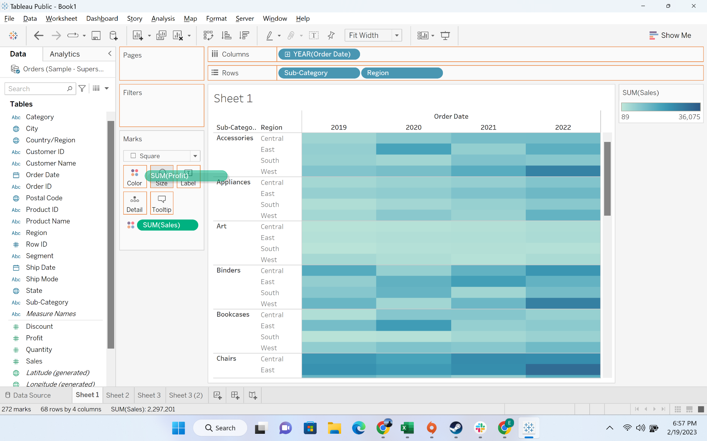

* + Step-3: increase the size

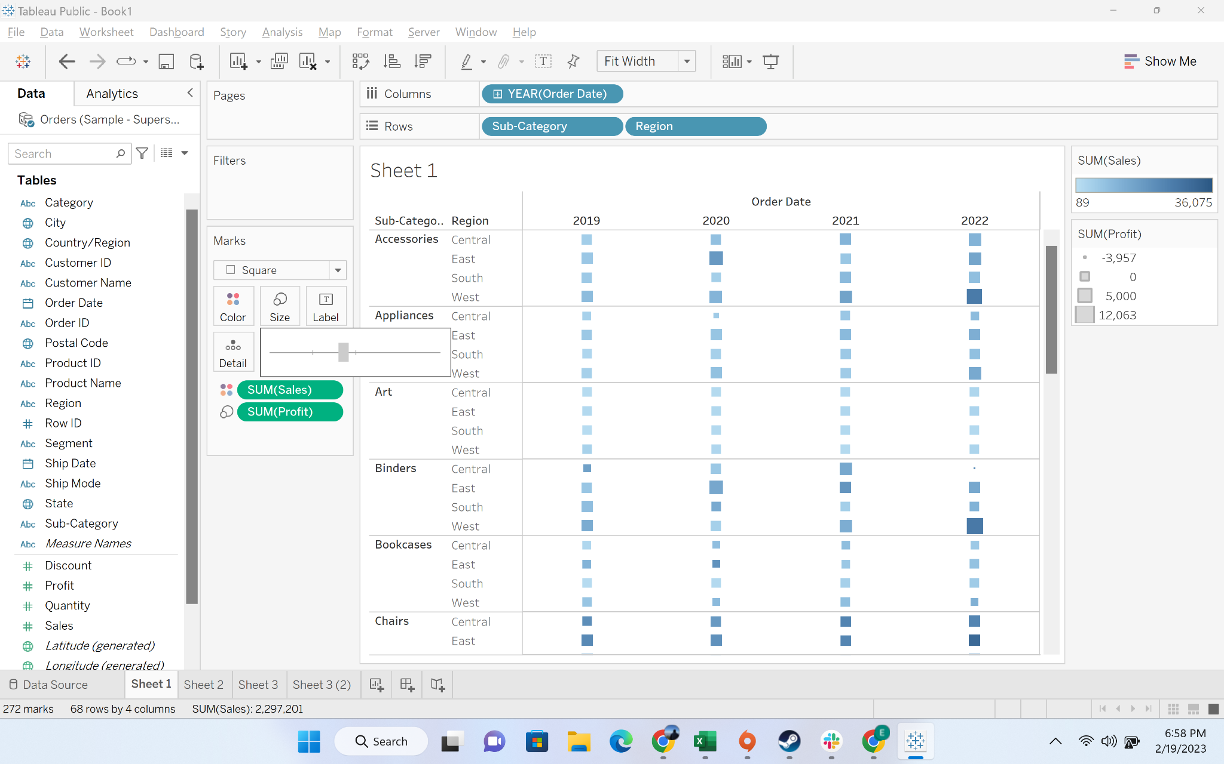

* + Step-4: Output. Color represents the sales.Lighter the color, lesser the sale. Size of the square represents the profit. Larger the square, bigger the profit

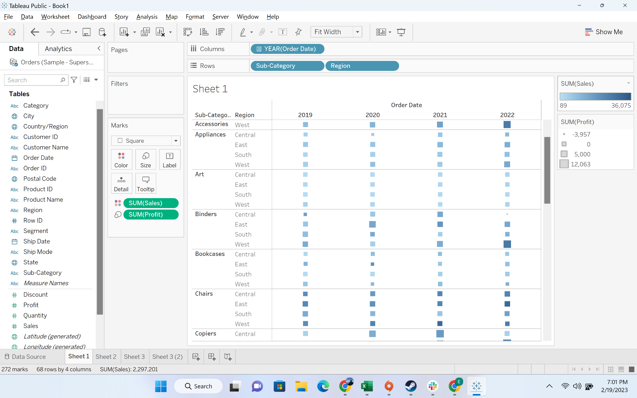

#### Business problem 4: Create a group called as small items which include Binder, Bookcases, Envelope, Fastener and supplies and compare its sale with the rest of the categories

Solution:

* **Business Context**
  + Many times in business analysis, we have to group values within a dimension and do comparative analysis.
    - For example: if we take a tableau test for this batch. Assume, we have a column which tells the college degree of each student. Some students might be from technical branches like computer science, electronics, whereas others could be from non-technical branches(like mining, commerce, arts). Now if we have to understand if our course is effective for non -technical student, we have to group together students into IT and non-IT
* **Intro to Group:**
  + A tableau group is **a collection of multiple members combined in a single dimension to create a higher category of dimension**.
* **Demonstration of creating a Group**
  + Step-1: Create a new sheet and go to “sub-category” and click the dropdown to go to create

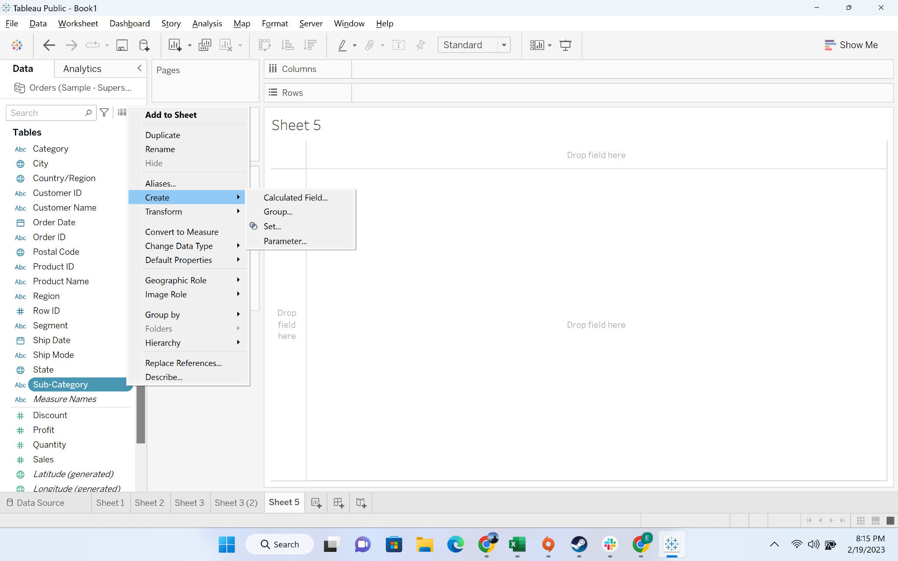

* + Step-2: Click on groups

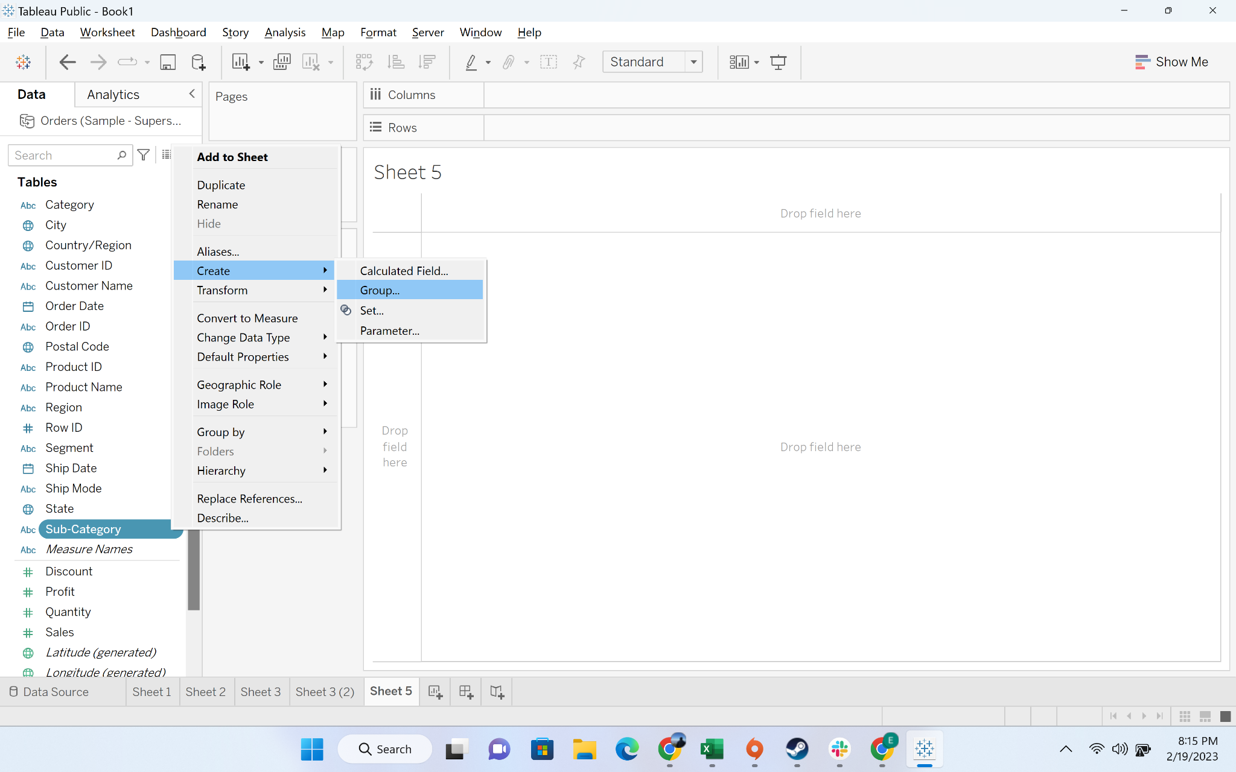

* + Step-3: Select the binder, bookcase, envelope, fastener, and supplies
    - First click on binders,
    - Then press “ctrl” and click on bookcase
    - Then press “ctrl” and click on envelope
    - Then press “ctrl” and click on fastener
    - Then press “ctrl” and click on supplies

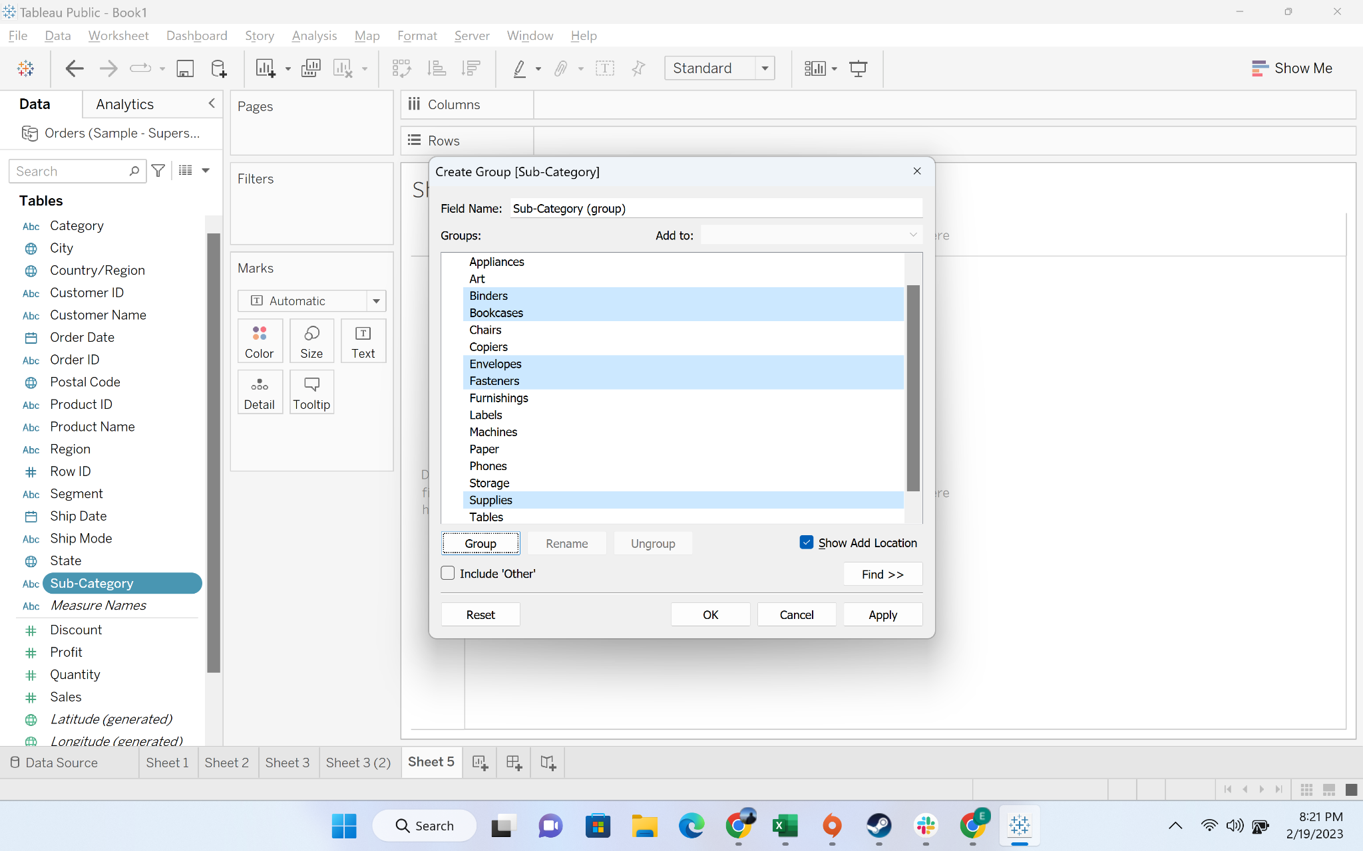

* + Step-4: Press on the “group” button

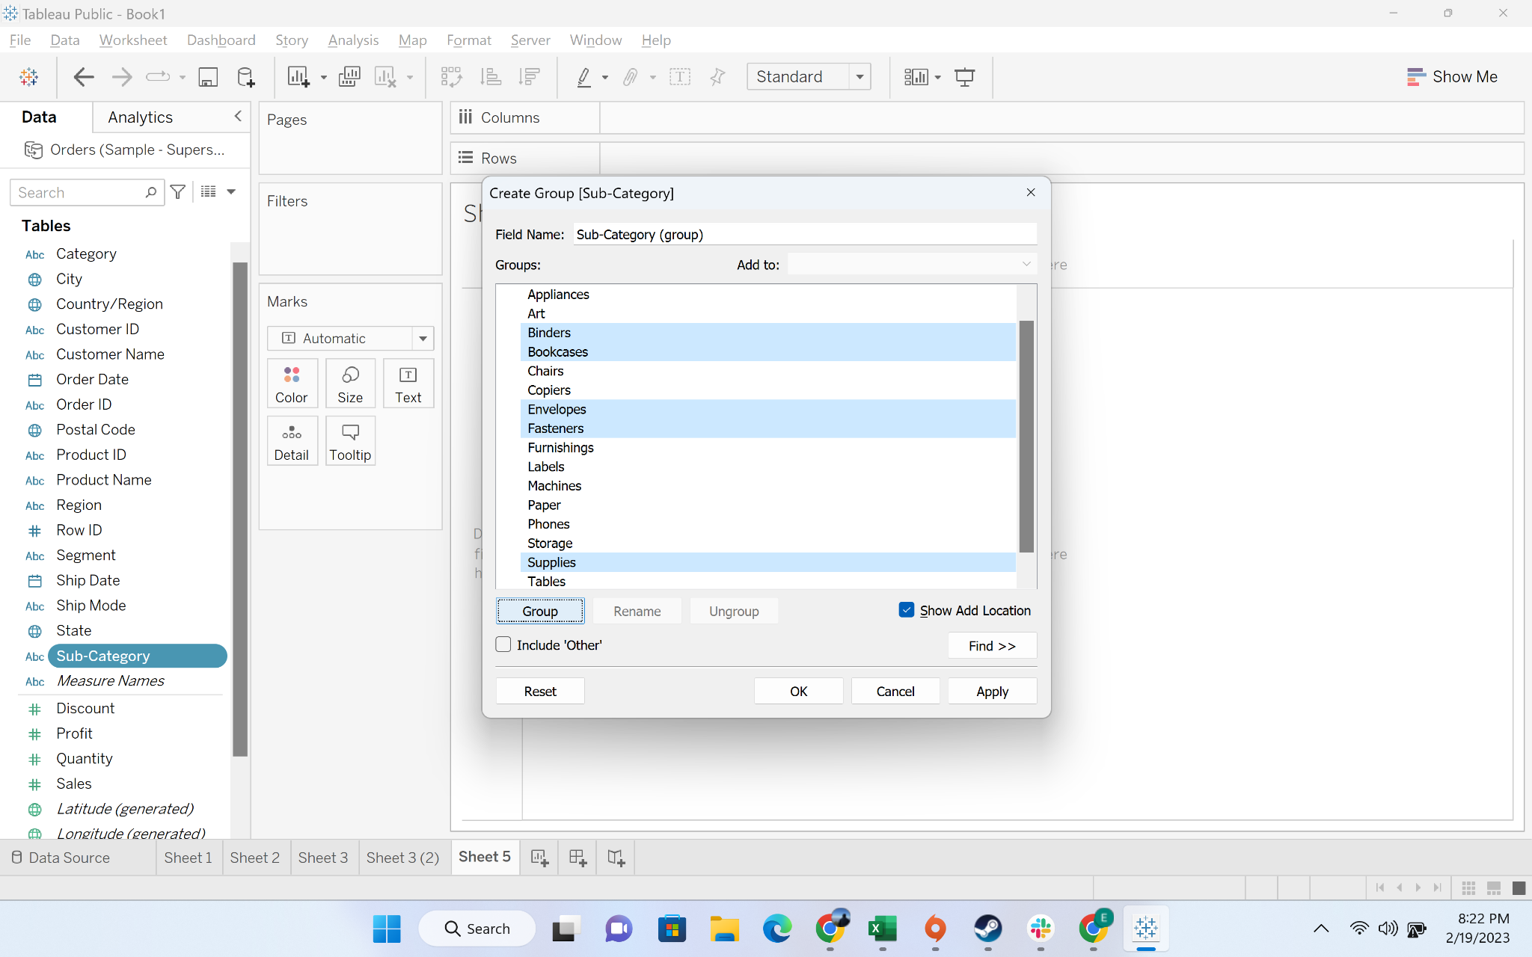

* + Step-5: Output of the group

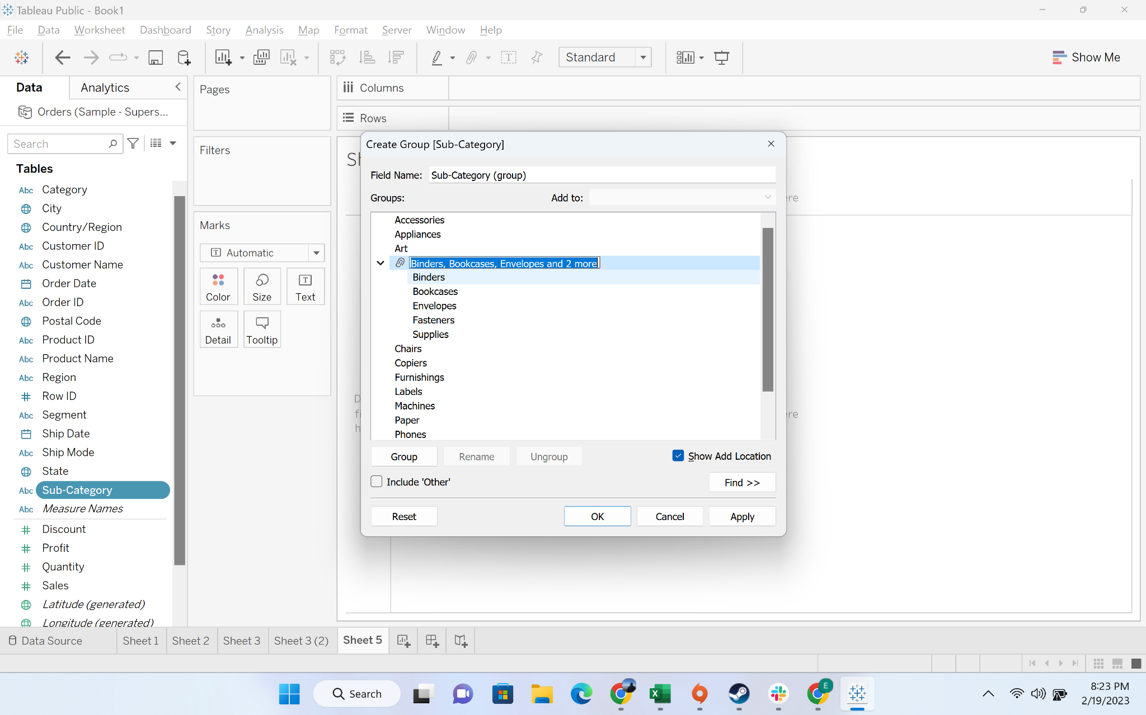

* + Step-6: We will rename it to “small items”

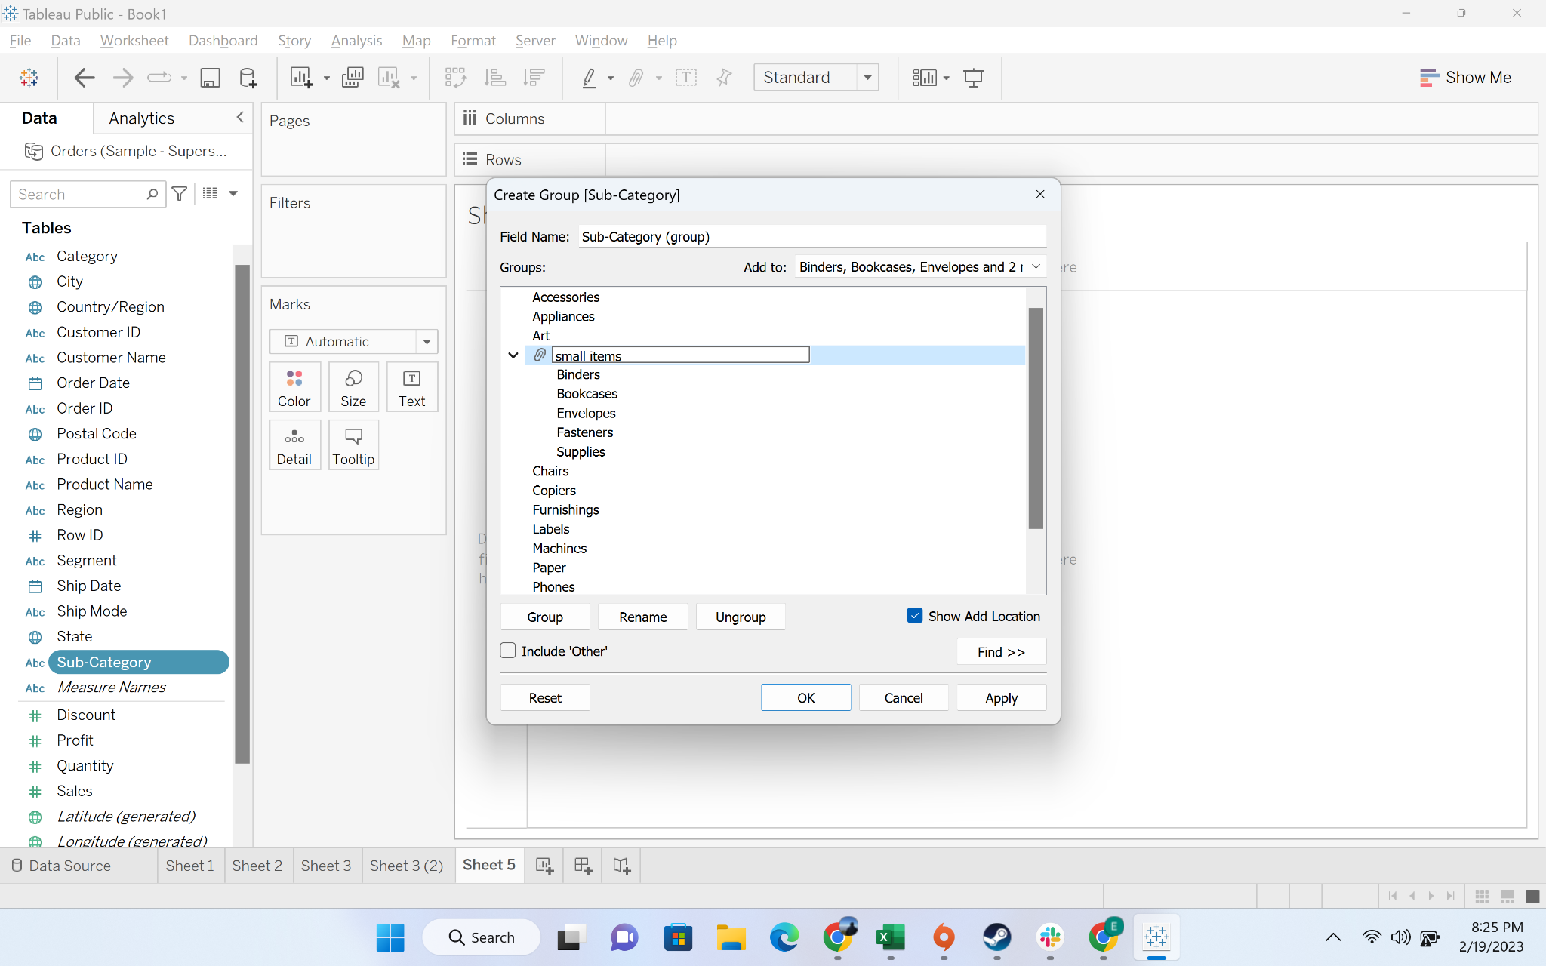

* + Step-7: A new field “Sub-category(group) is created

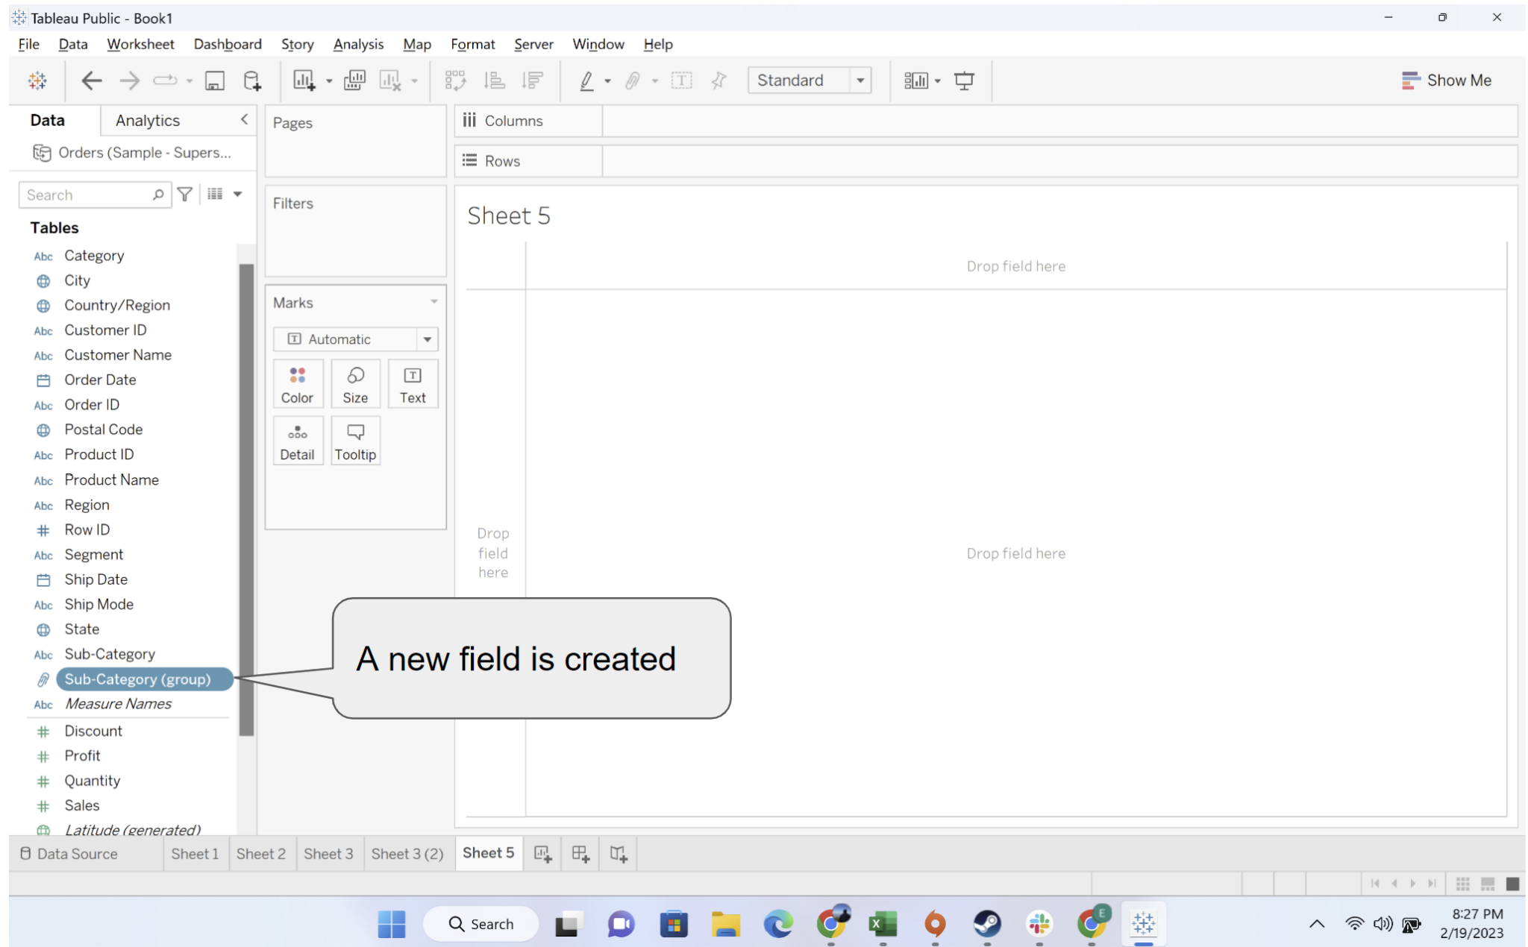

* + Step-8: Drag the “Sub-category(group) to column

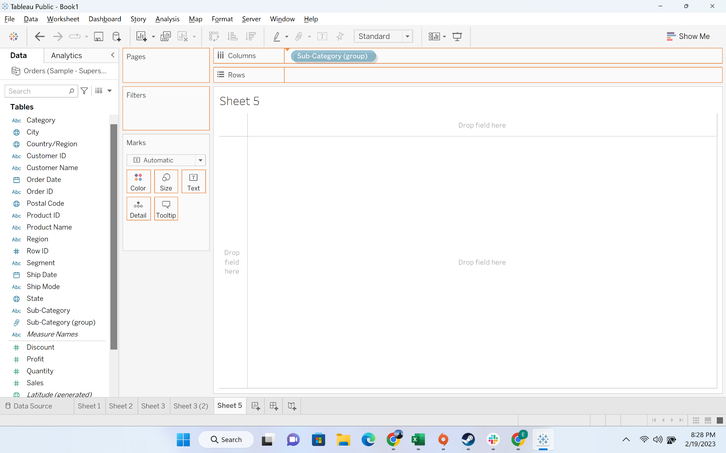

* + Step-8: Drag the “sales” to rows

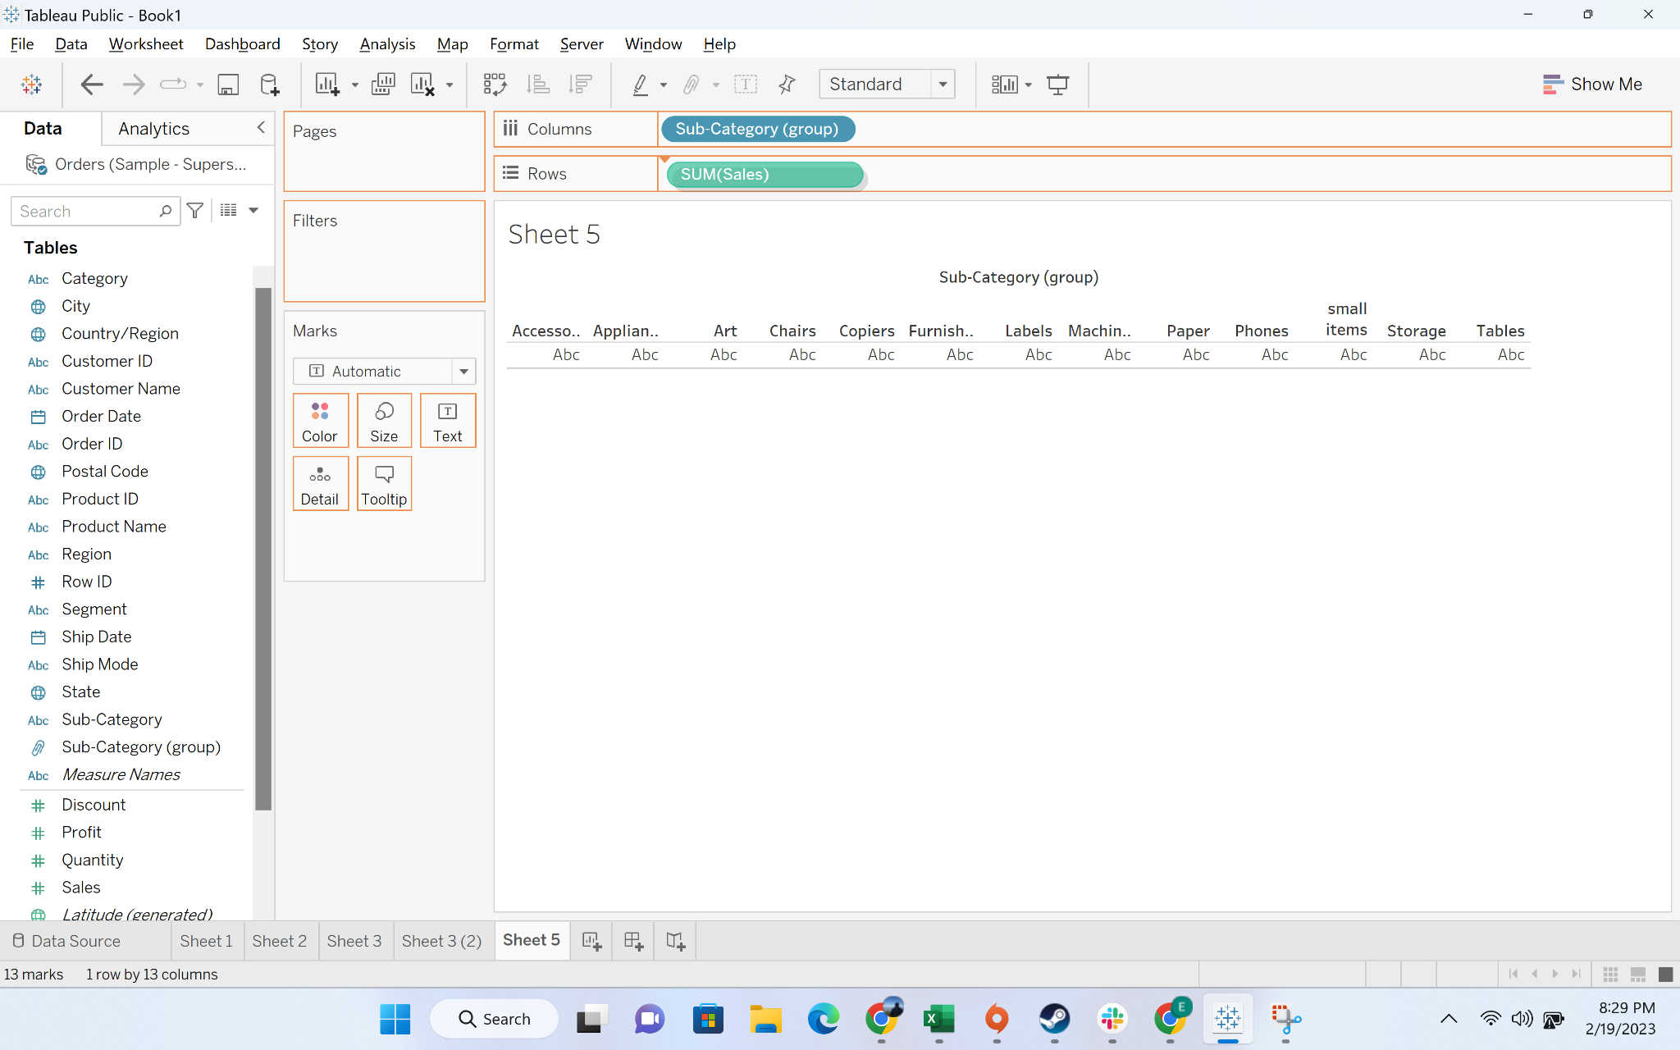

* + Step-8: you can see the “small items” category

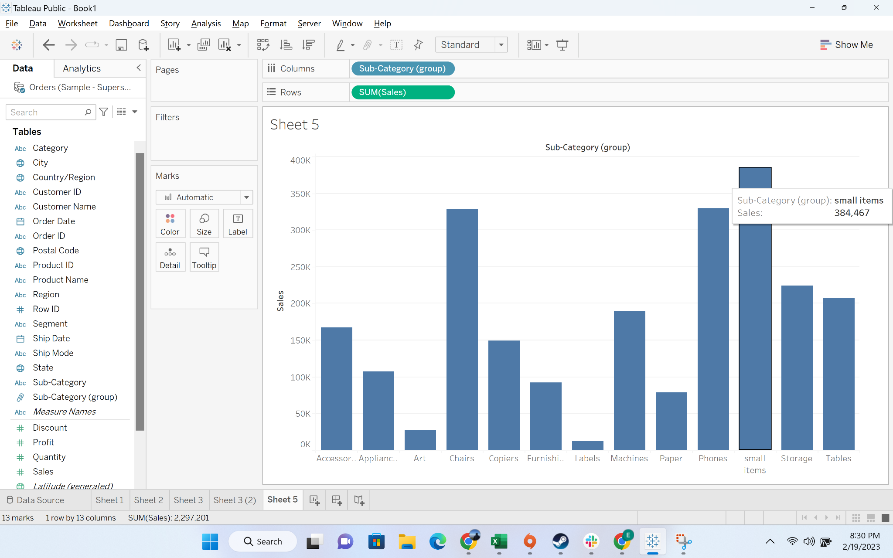

#### Business problem 5 -create a set of customers with highest profit

Solution:

* **Business Context**
  + Sometimes in business, managers and senior leadership are interested to see how a certain section of customers are performing. They want to pay a special monitoring to that certain sections
  + Sometimes we need to have a dynamic selection of users - for example revenue generated by the top 20% customer vs remaining 80% user. Here we need a dynamic selection of users
* **Intro to set:**
  + Tableau Sets are custom fields used to hold the subset of data based on a given condition.
  + We will learn about three types of set
    - Fixed set - where we did not change the choice of subset of data
    - Dynamic set - where the subset keeps on changing
    - Combined set - subset which is created from intersection of two sets
* **Demonstration of creating a fixed set**
  + Step-1: drag customer id to the rows and select all the customers

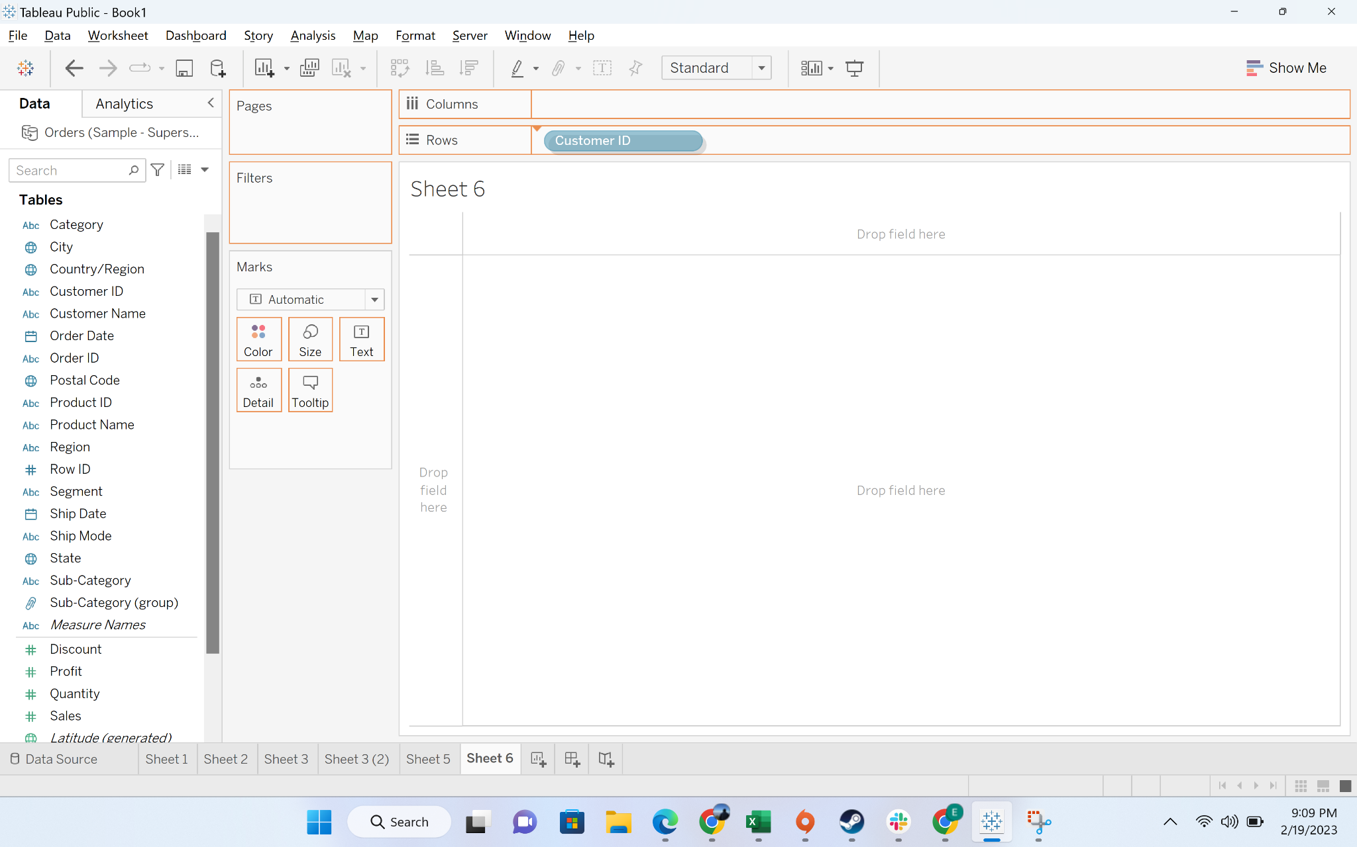

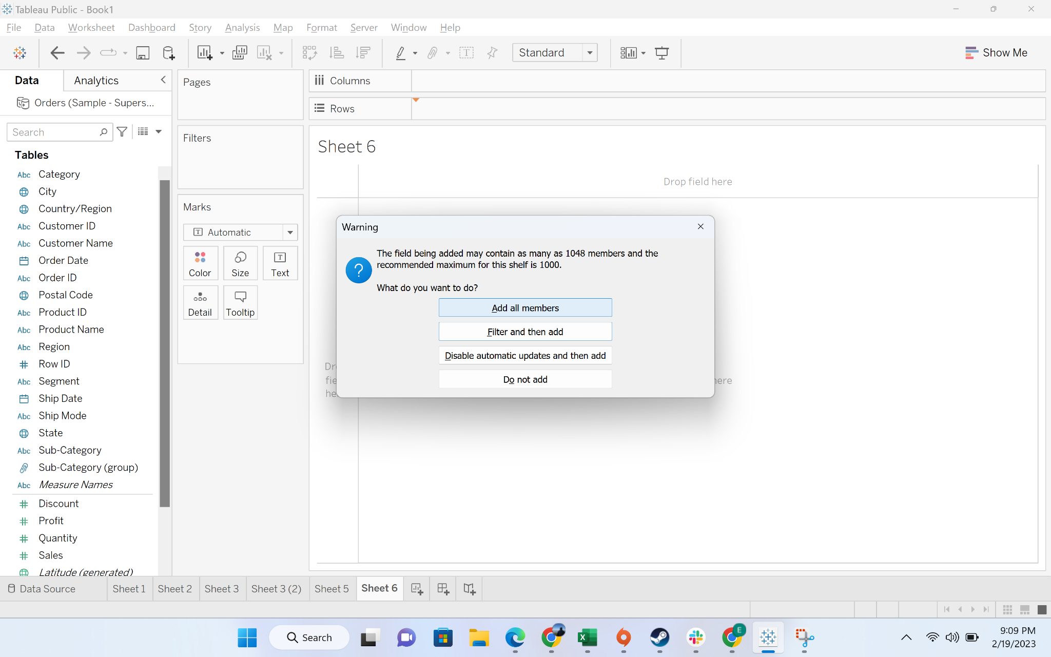

* + Step-2: Drag Sales to labels

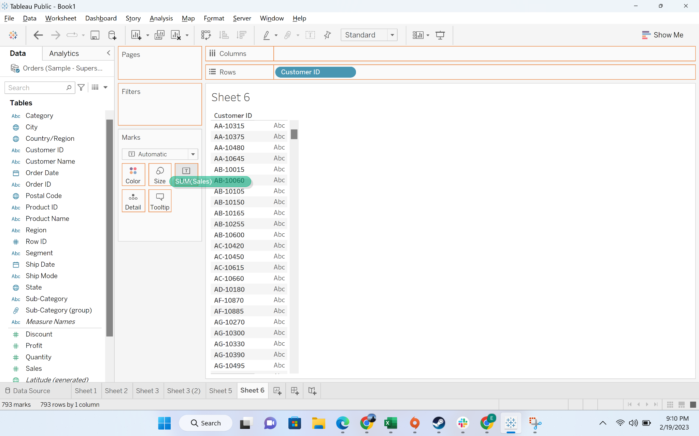

* + Sort the data in descending order

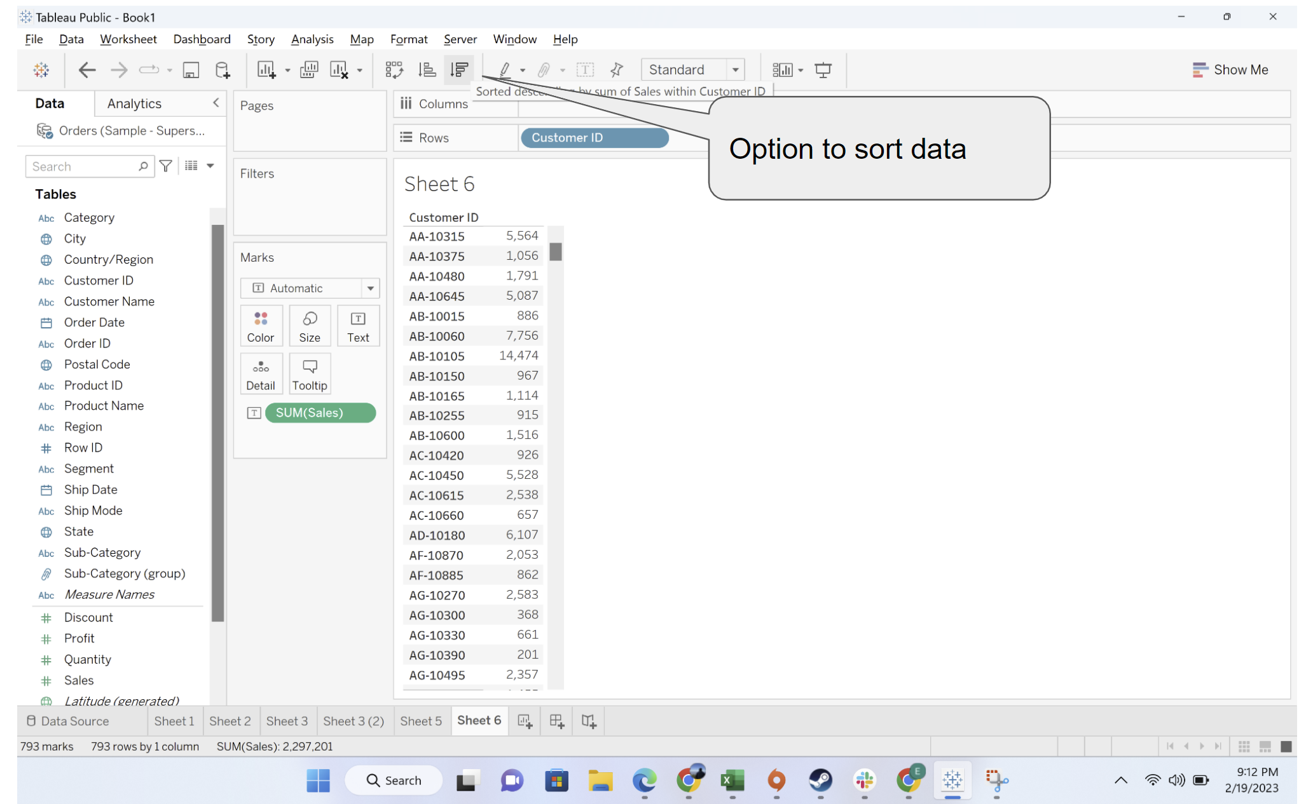

* + Manually select the top 10 rows. For manual selection, press control and then click on record

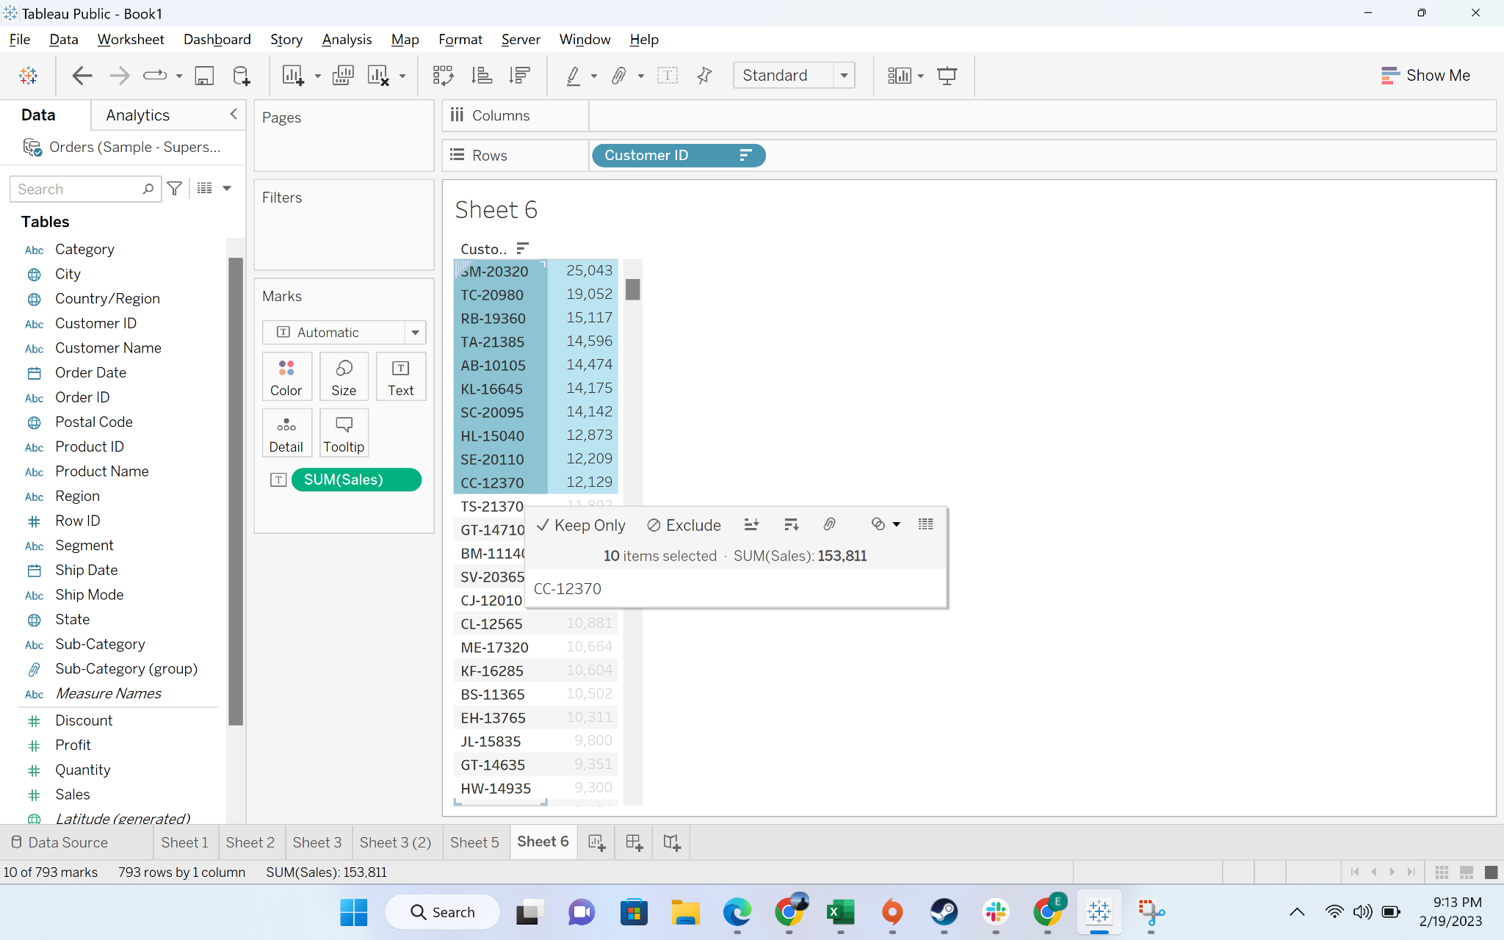

* + Click on the create set button

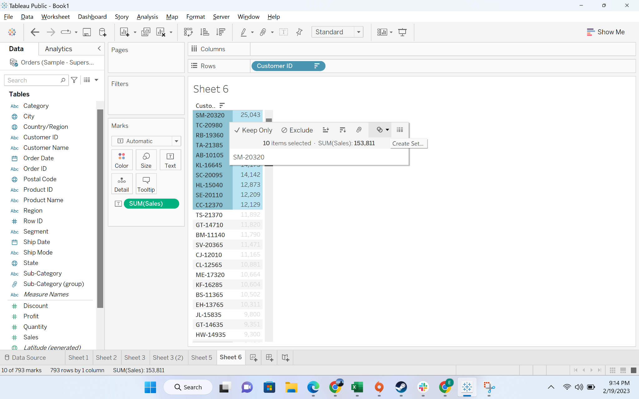

* + Click on the create set button

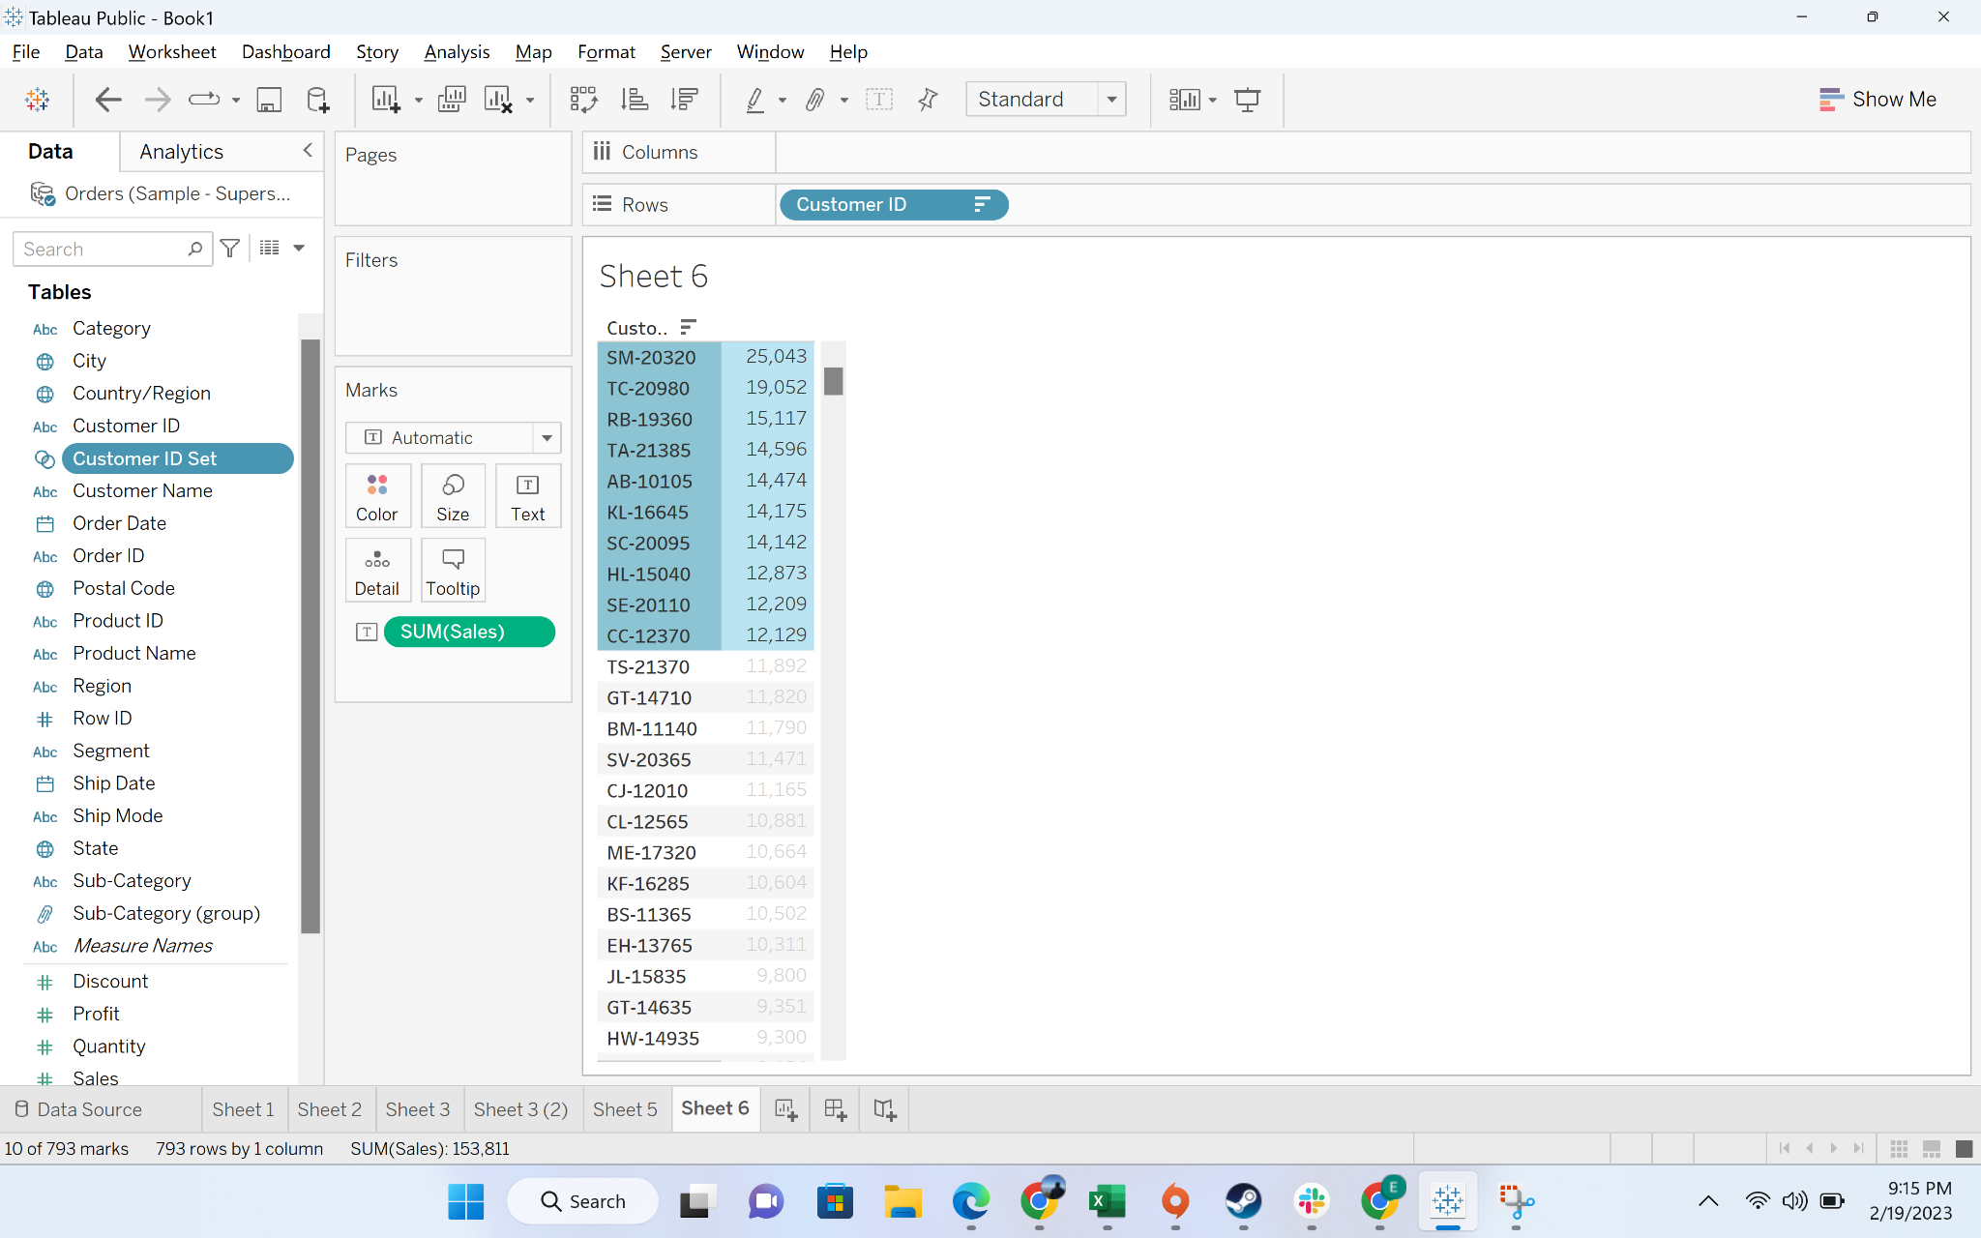

* + Click on the create set button

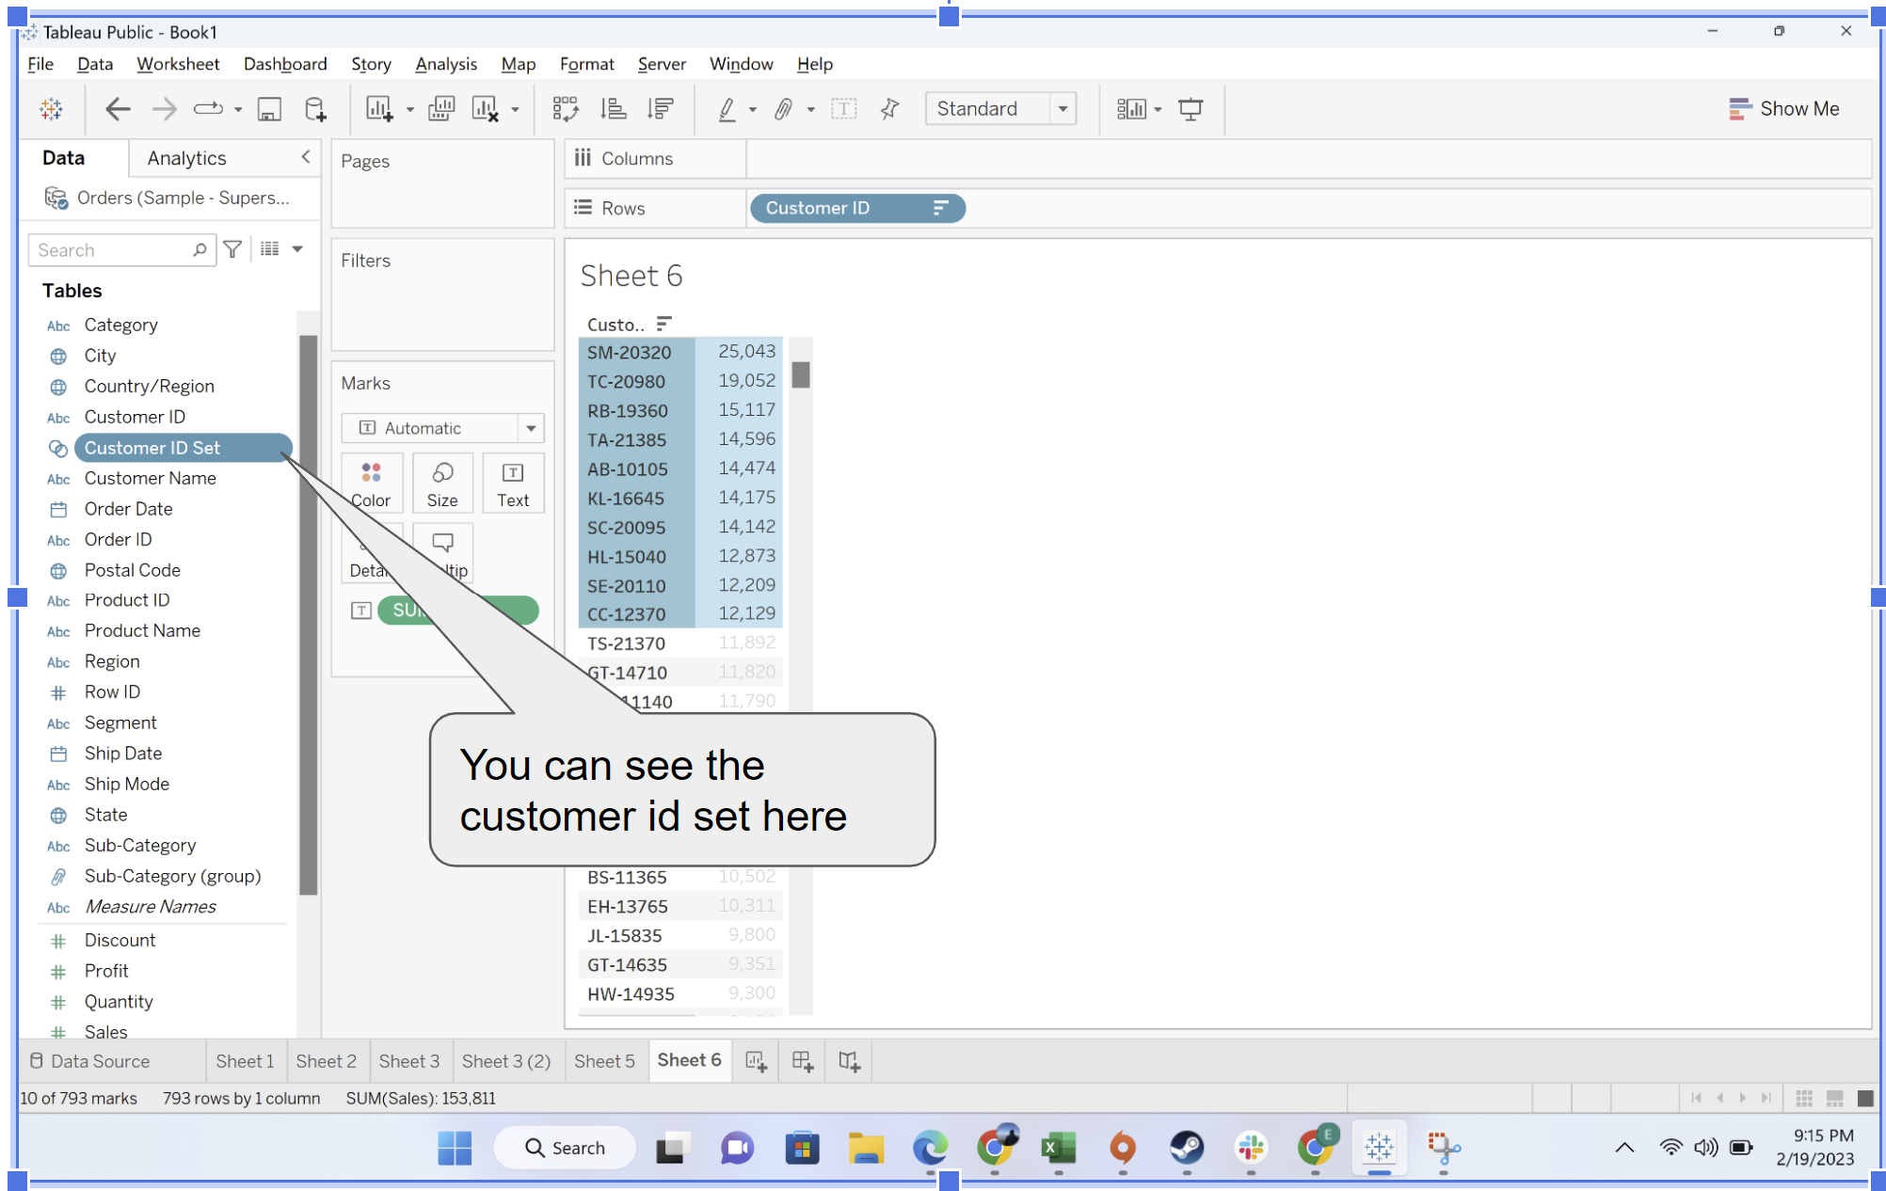

* + Drag the “Customer id set” to rows and profit to label. You can see the set shows data as “IN: or “Out”. “IN” means whether you are part of group or not

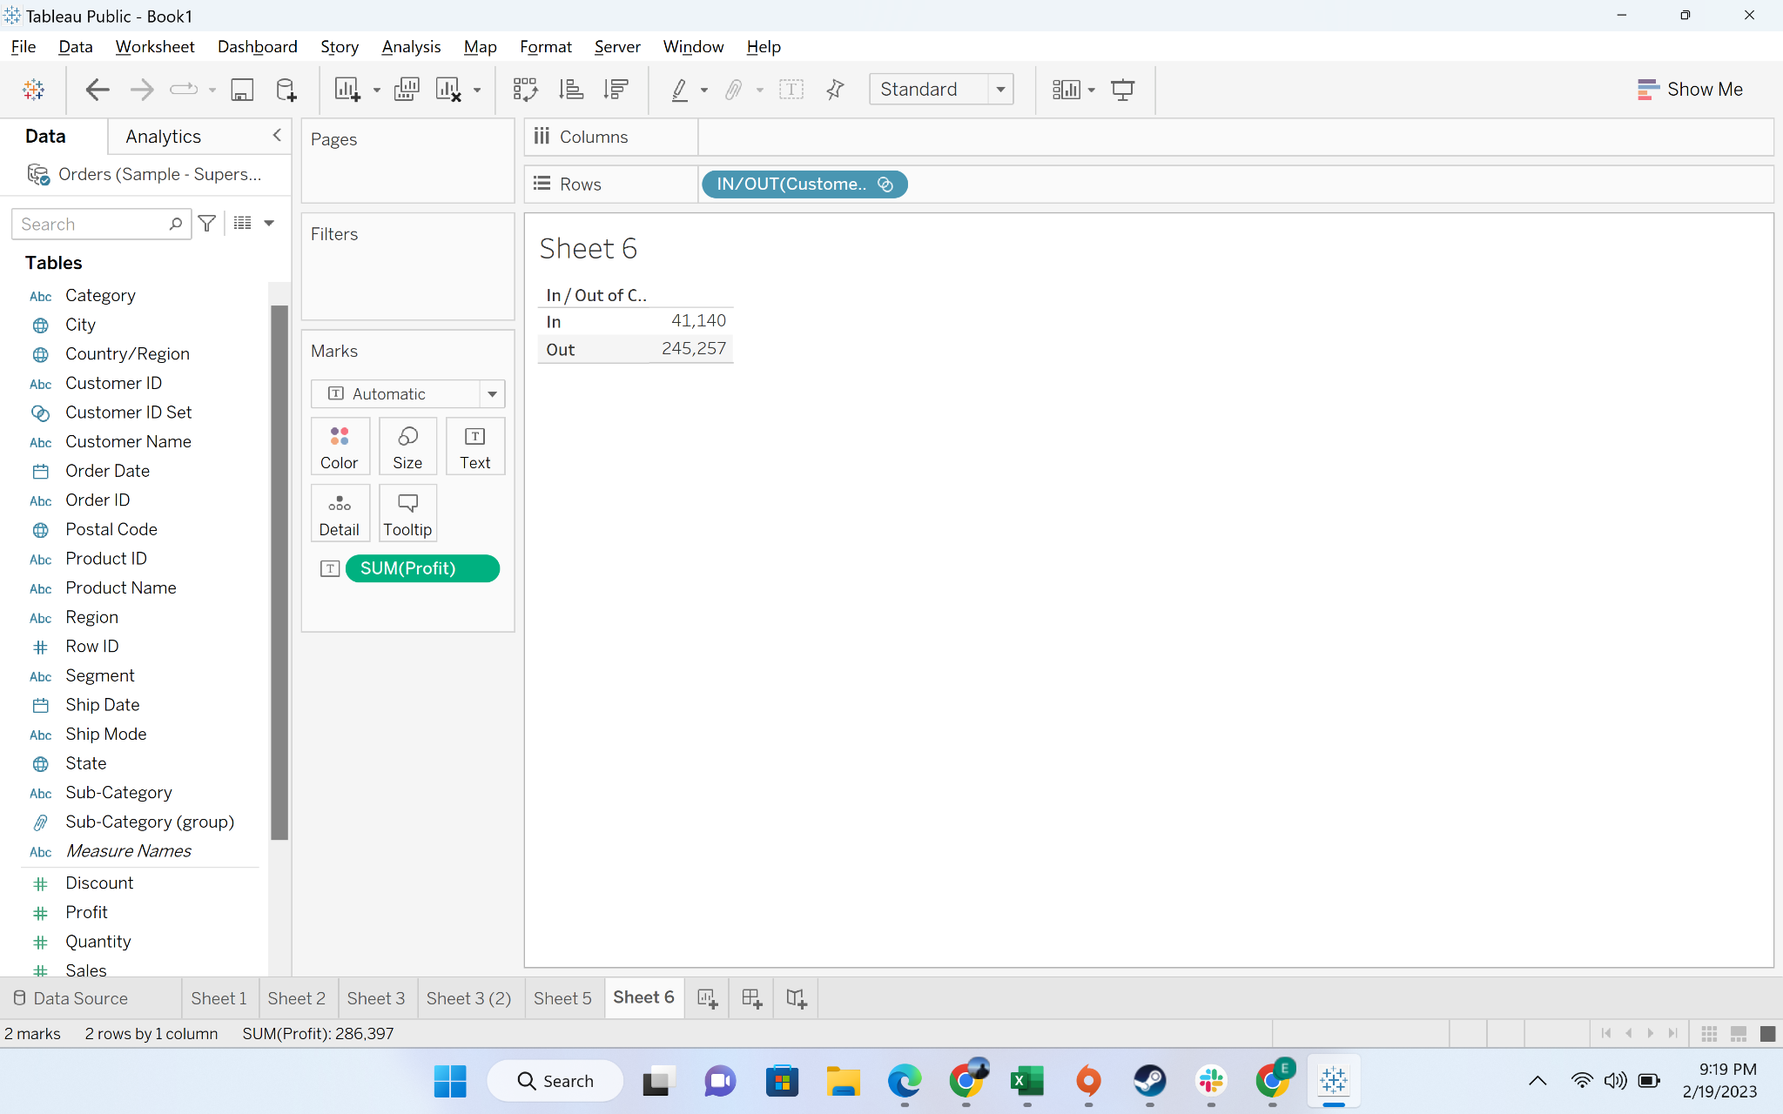

#### Business Problem 6 -Find the top 5 product subcategories by sales

Solution:

* We will now learn about dynamic set creation:
  + Create a bar chart by dragging “sub-category” to columns and “sales” to rows

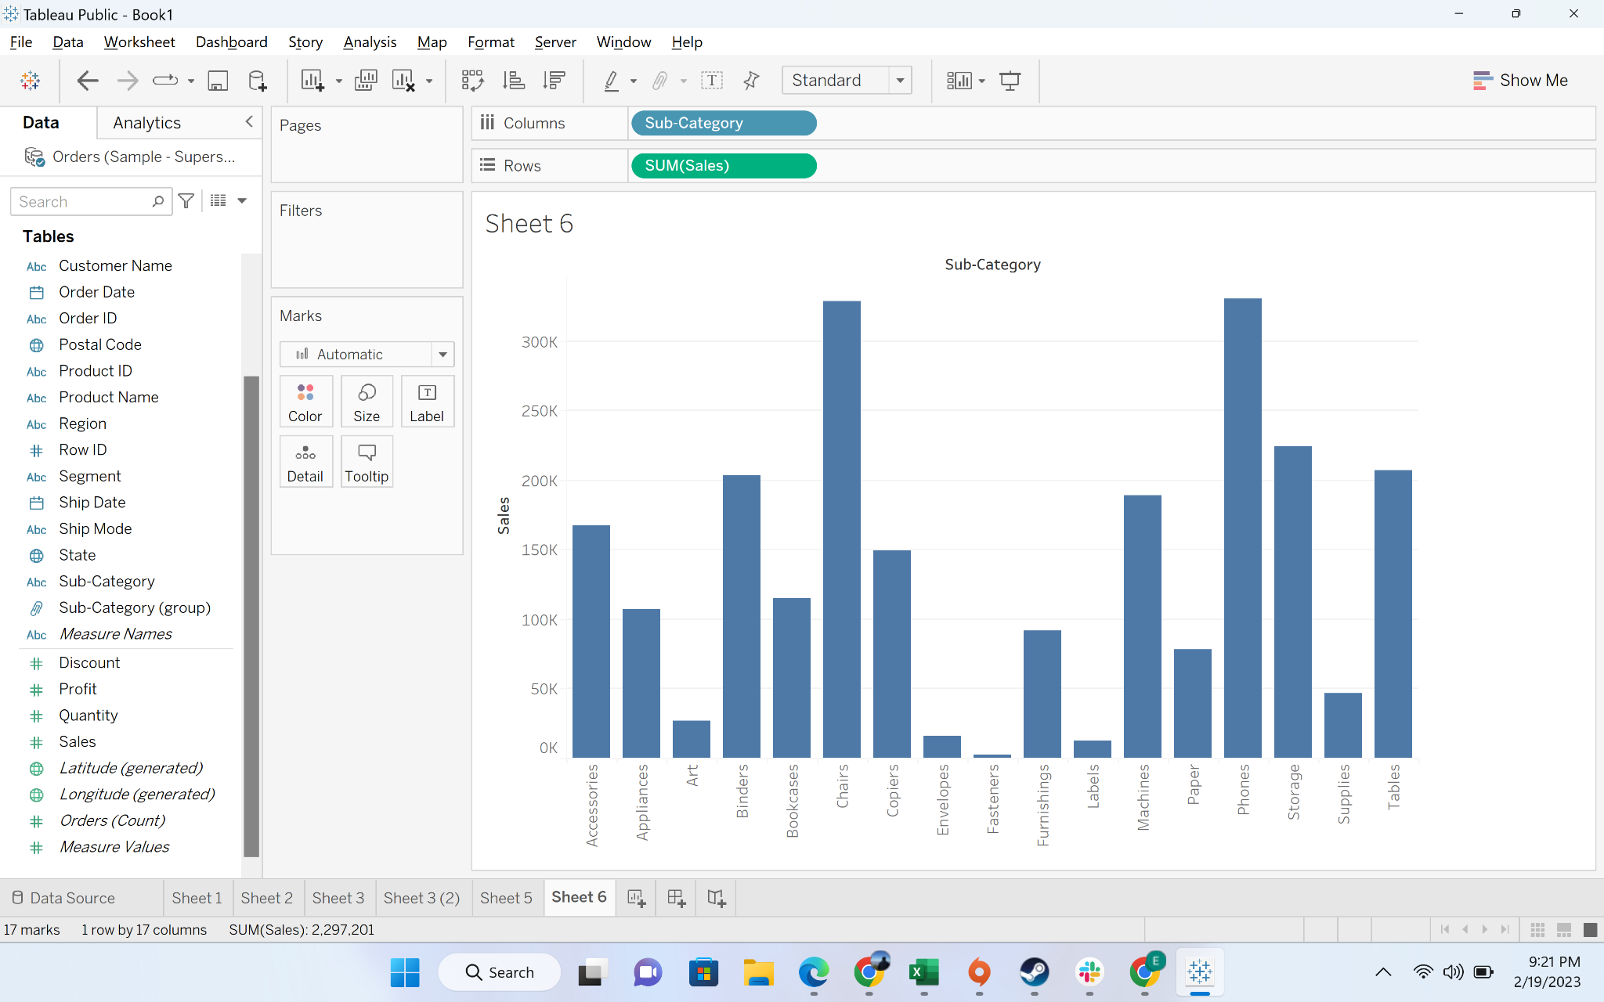

* + Go to sub-category, press the drop-down button, and the go to create

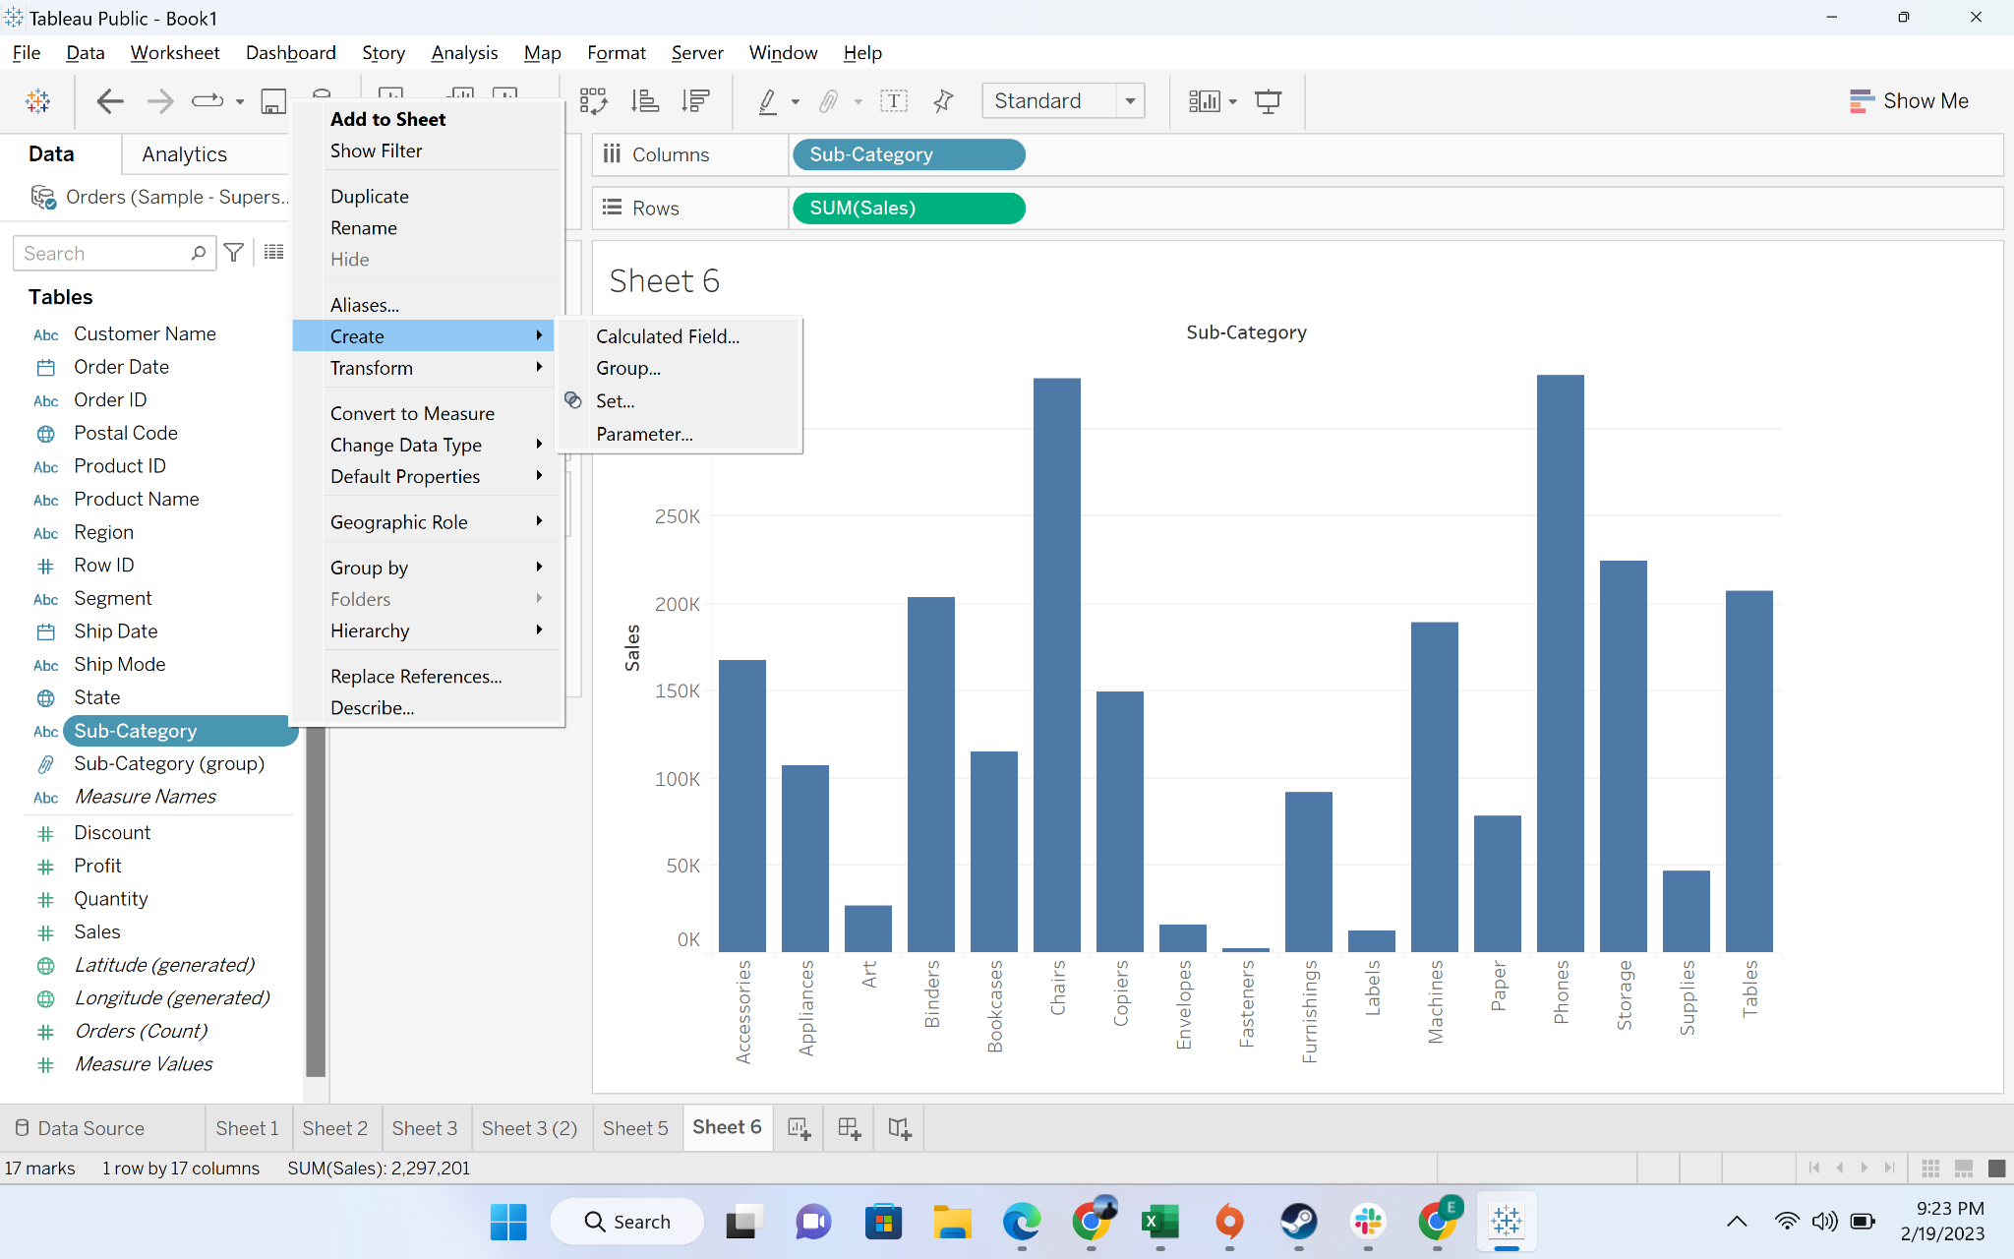

* + Press the set button

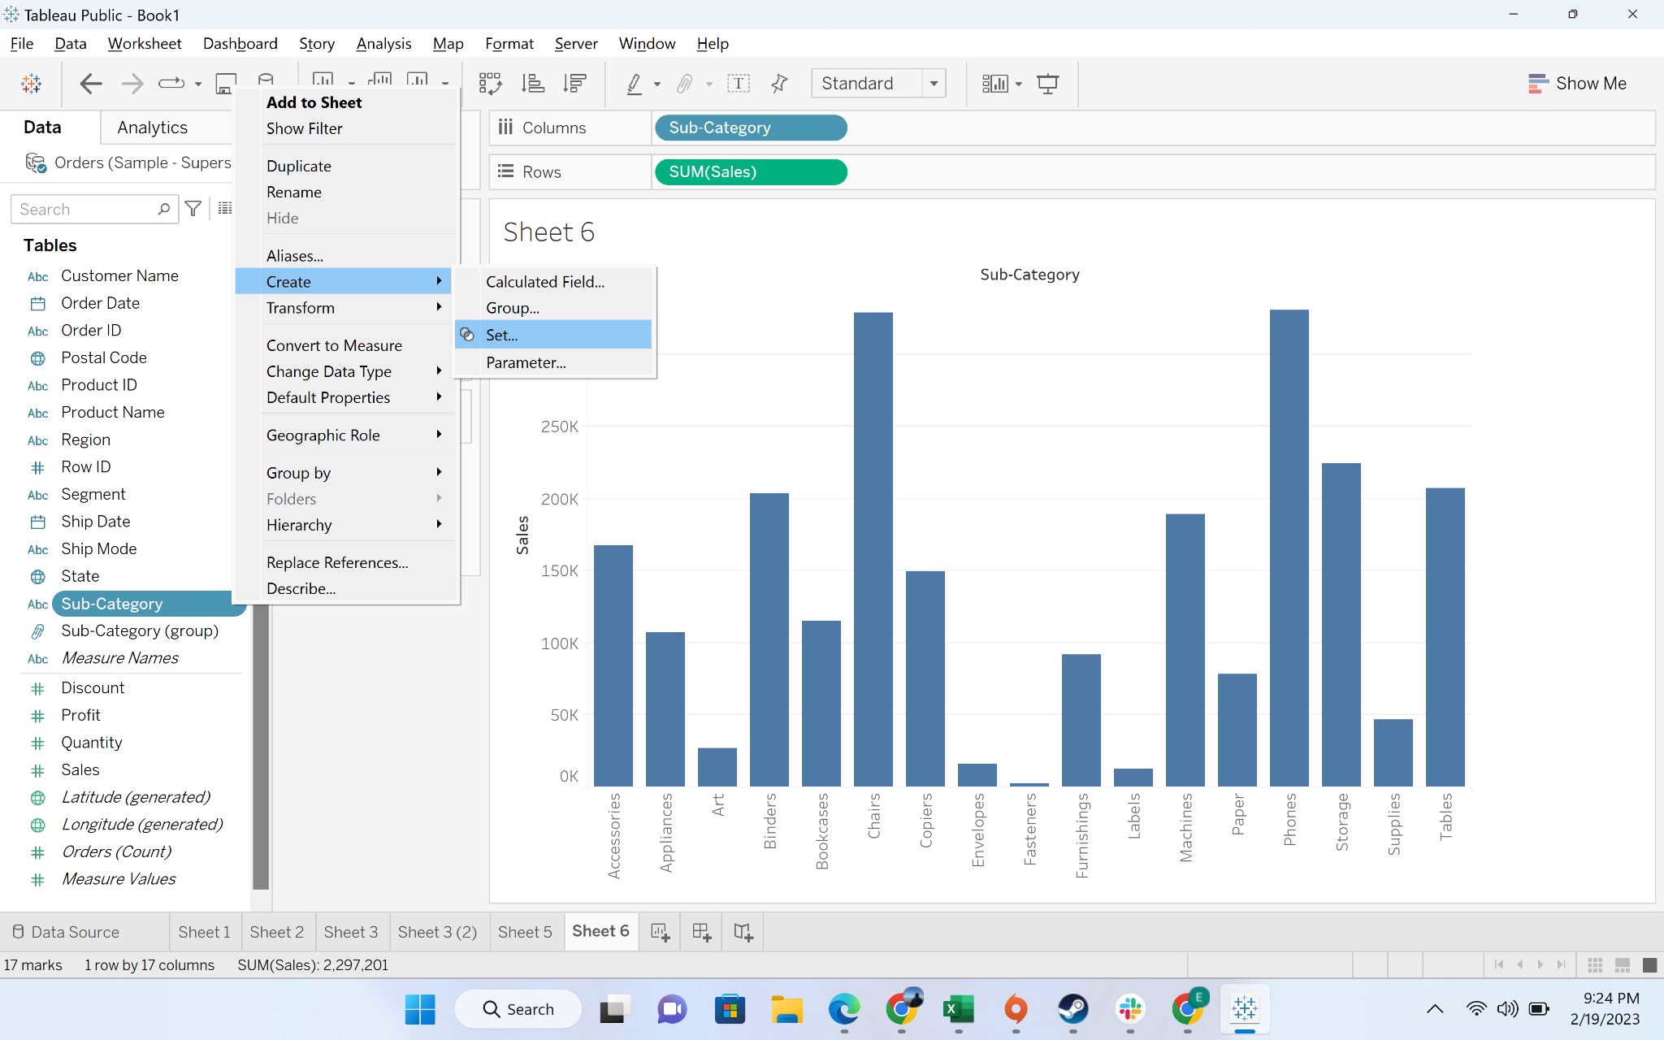

* We can explore various options under set

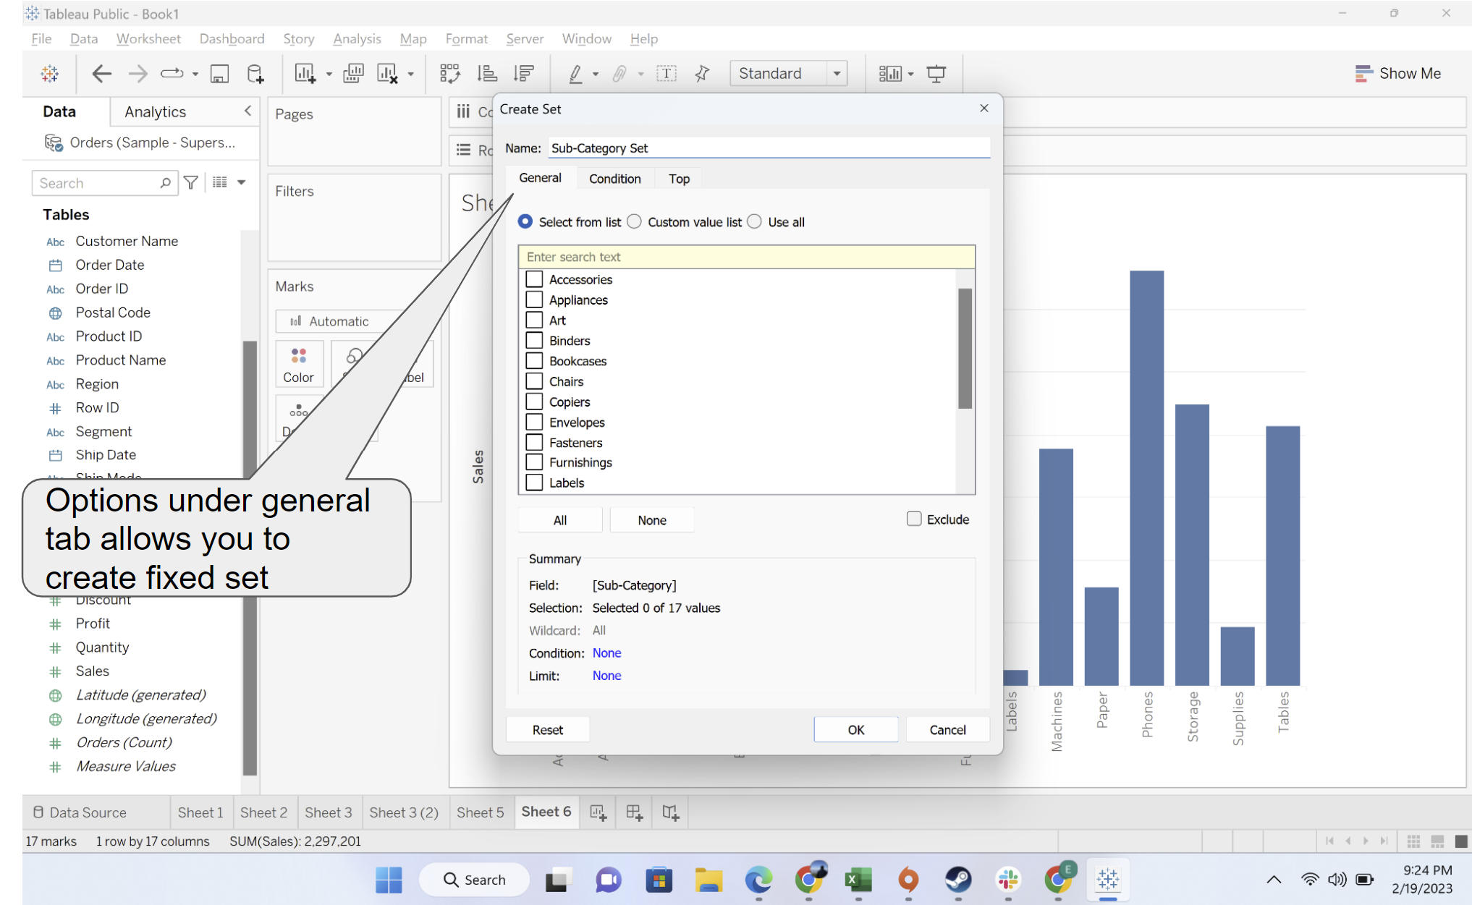

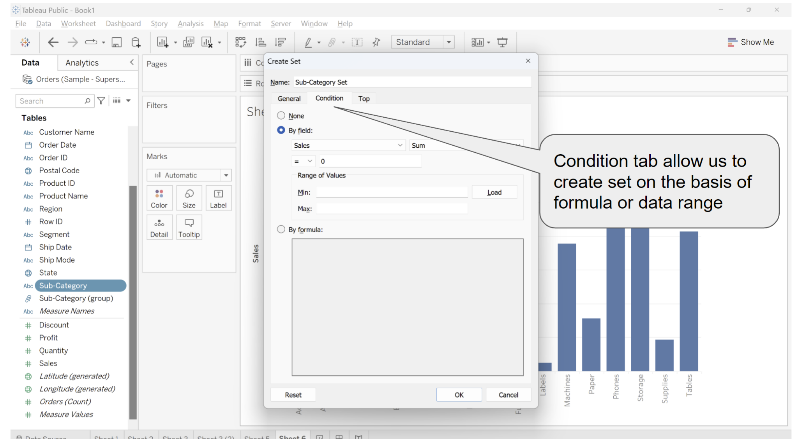

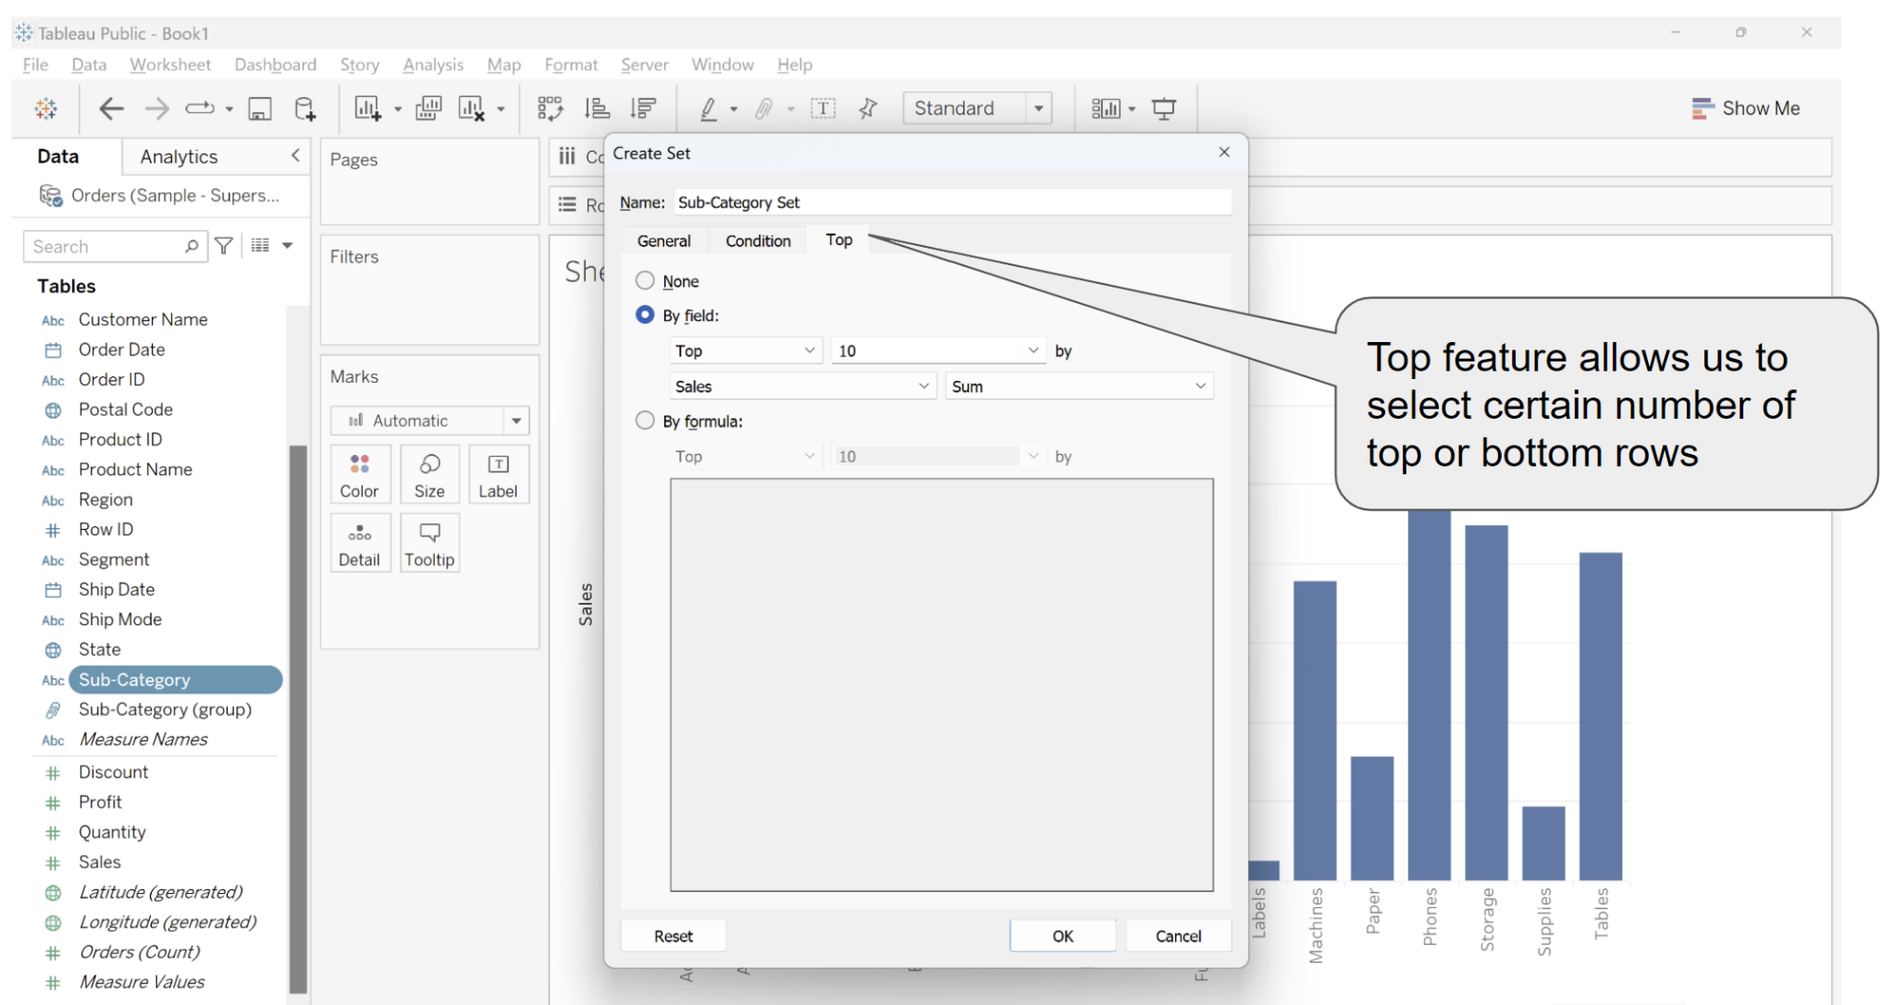

* We will chose top 5 customers by sales

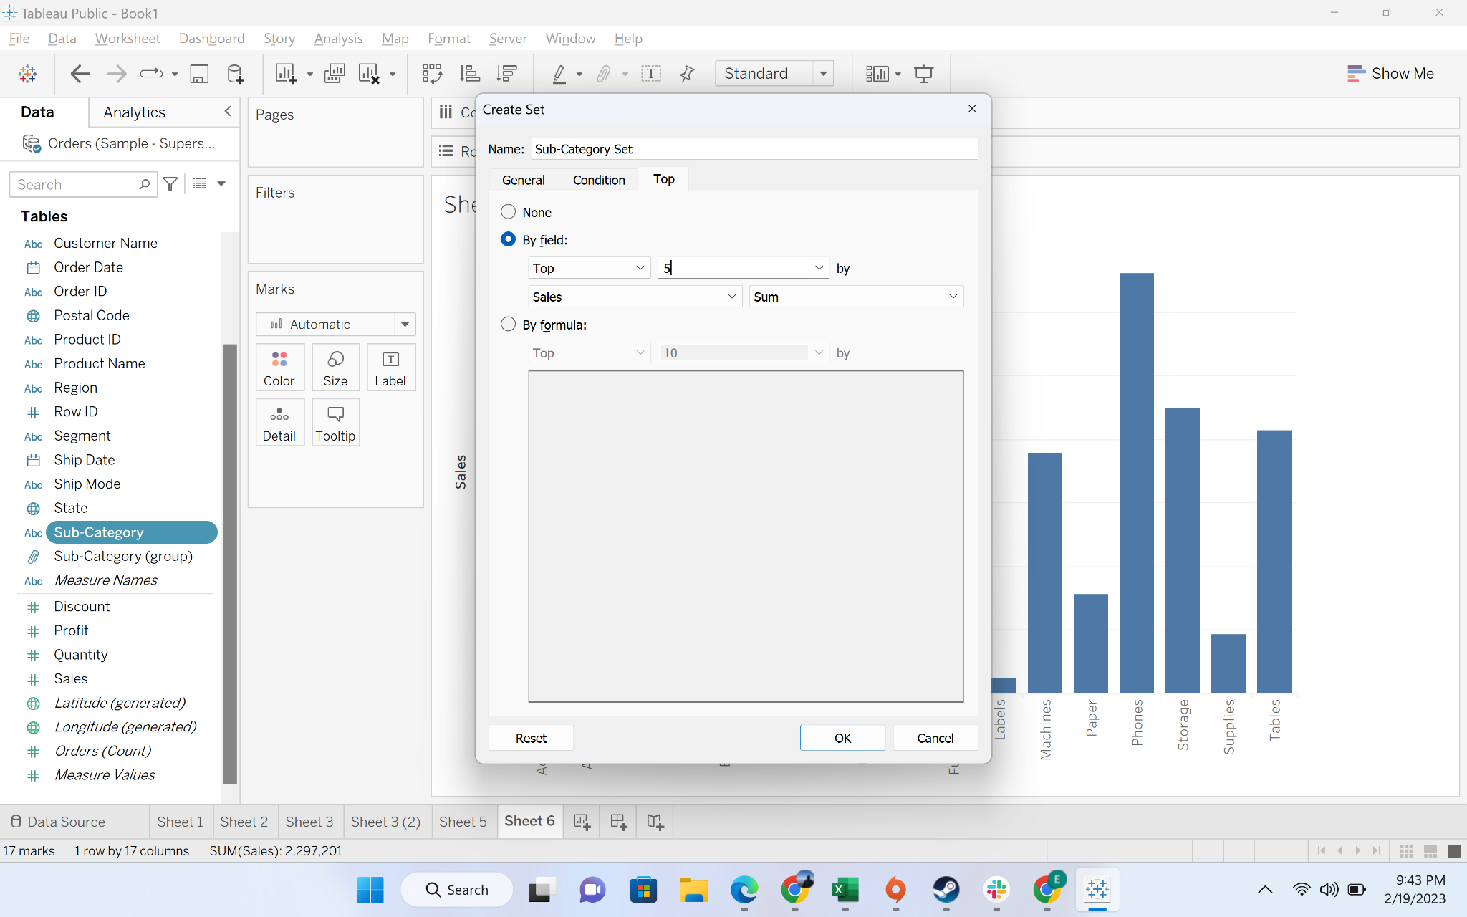

* You can see a new “sub category set”

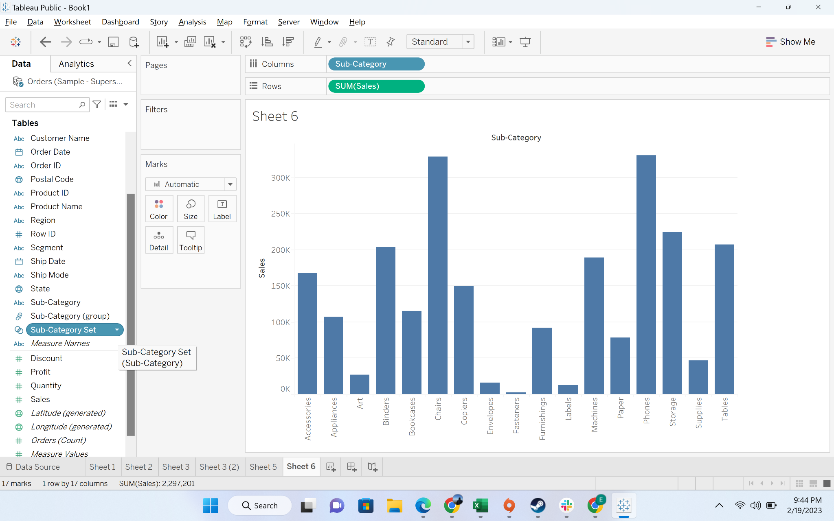

* Drag the “sub category set” to color mark

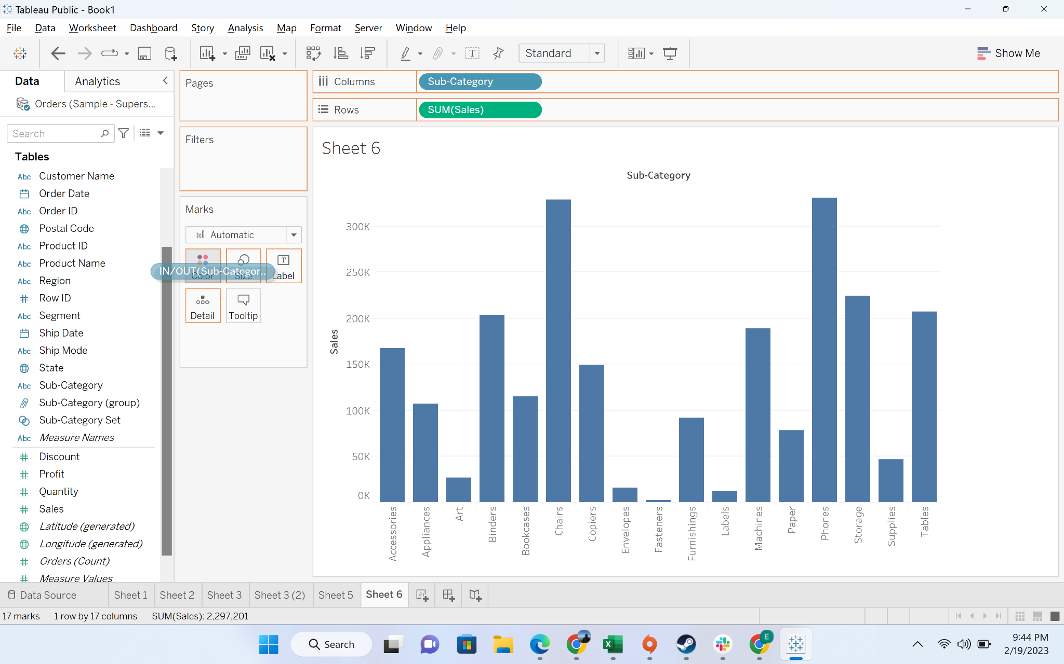

* Categories in the set are shown in blue color whereas others are shown in gry

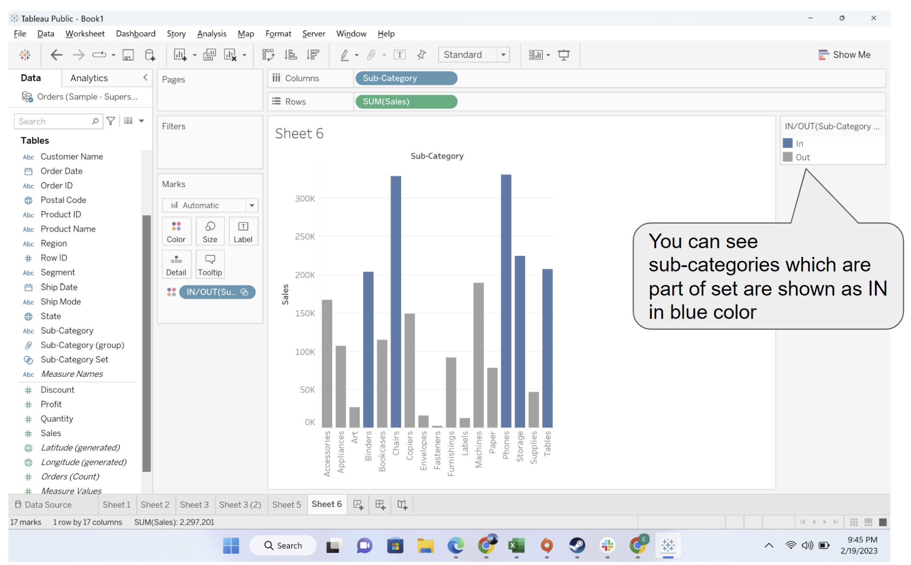

#### Business problem 7- Find top customers by sales but low profitability

Solution:

* Create a set for top 20 customers with maximum sales

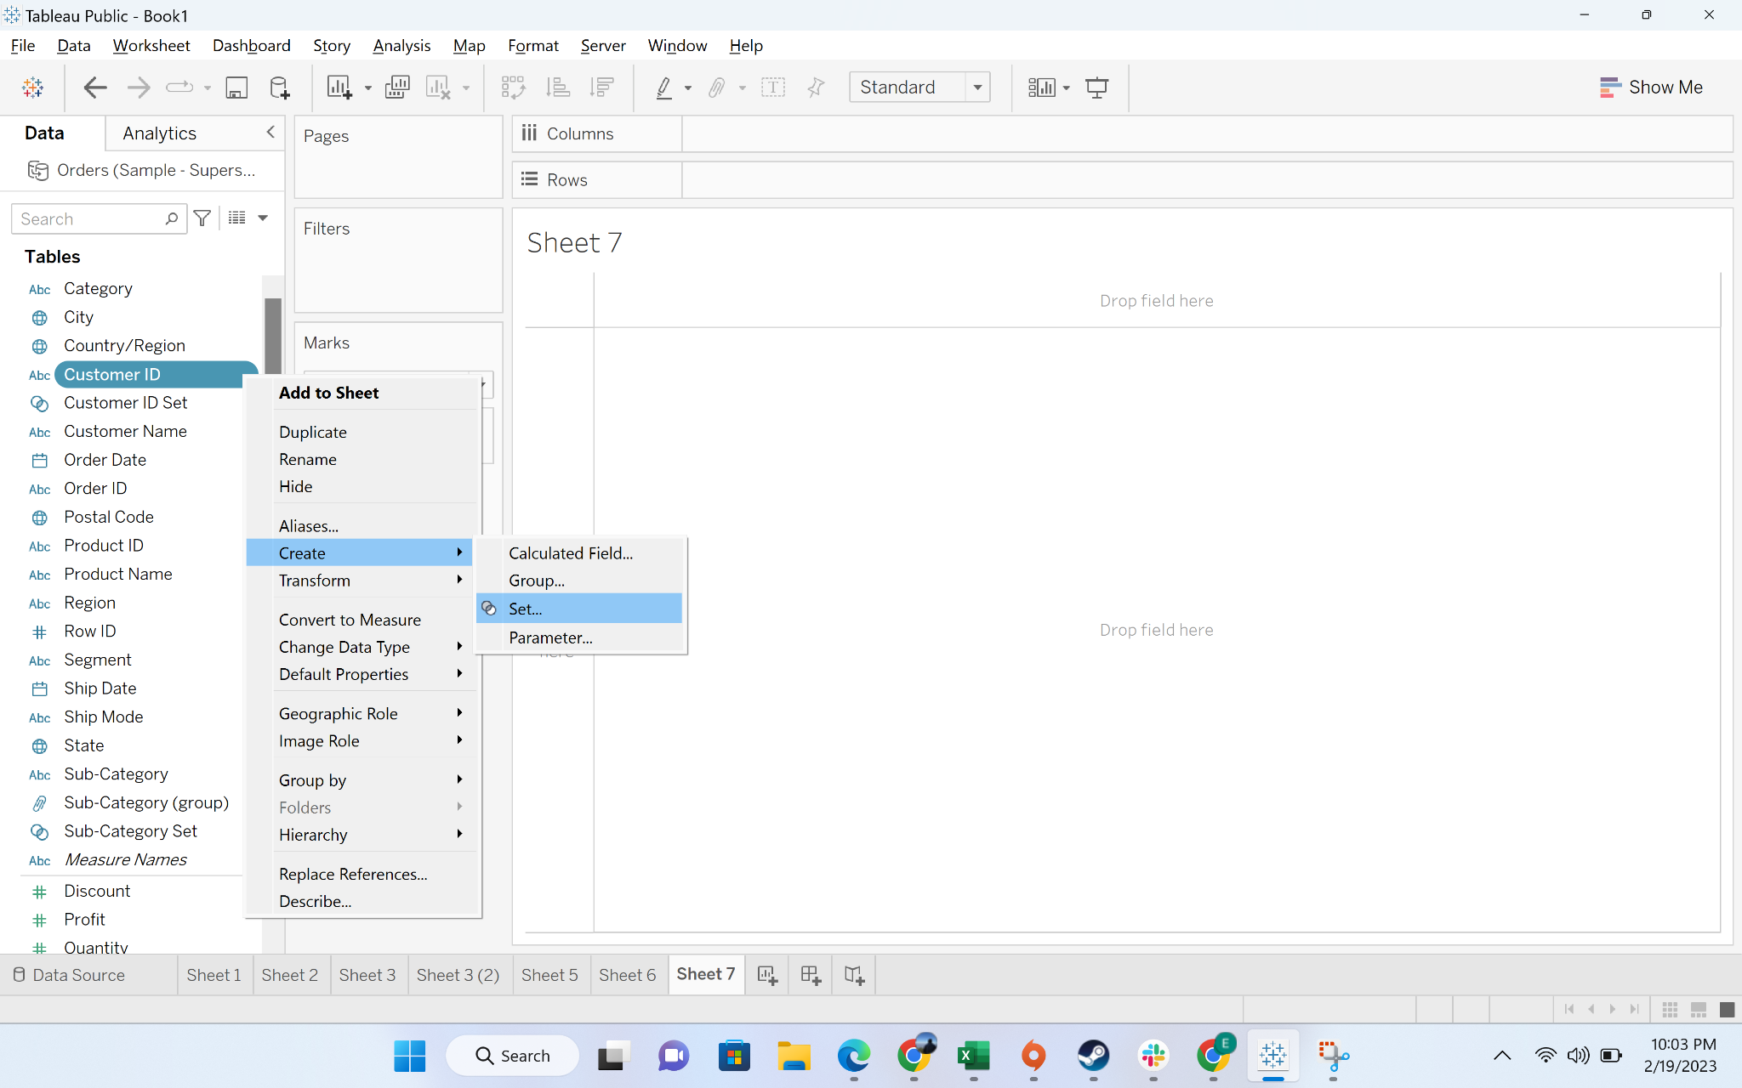

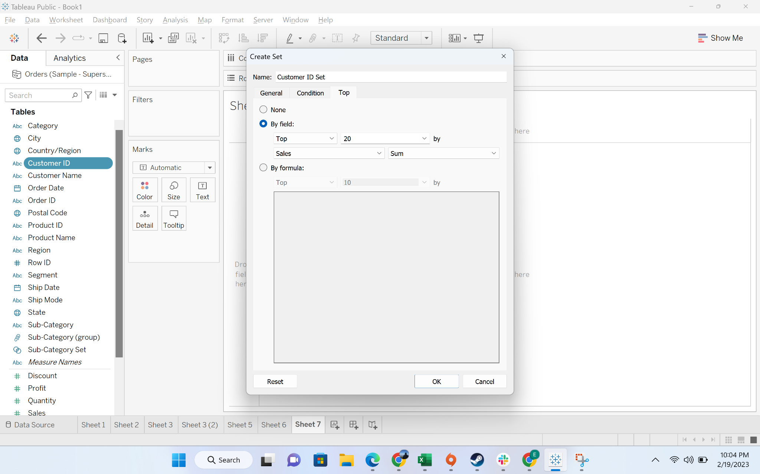

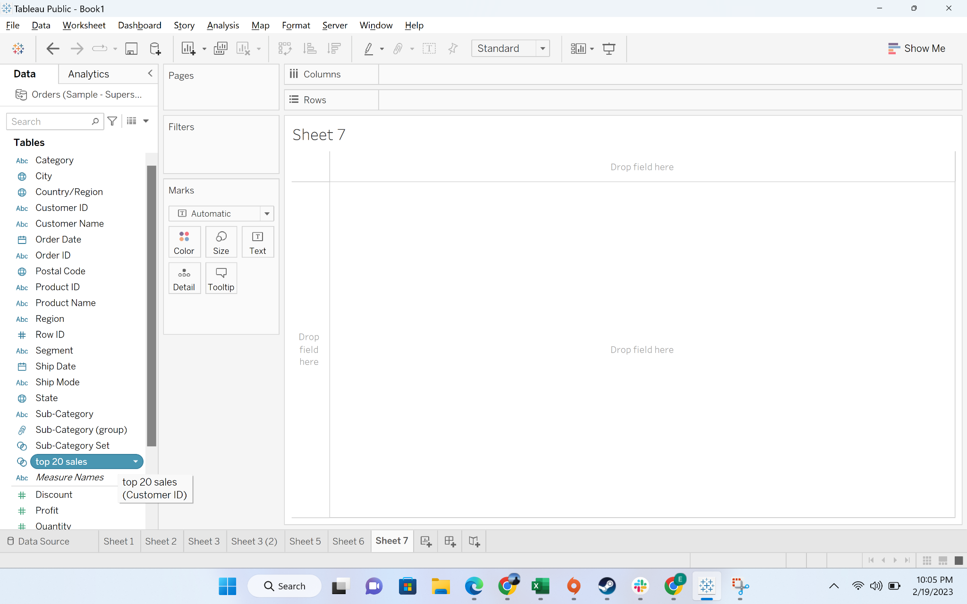

* Create a set of 20 customers which is bottom by profit

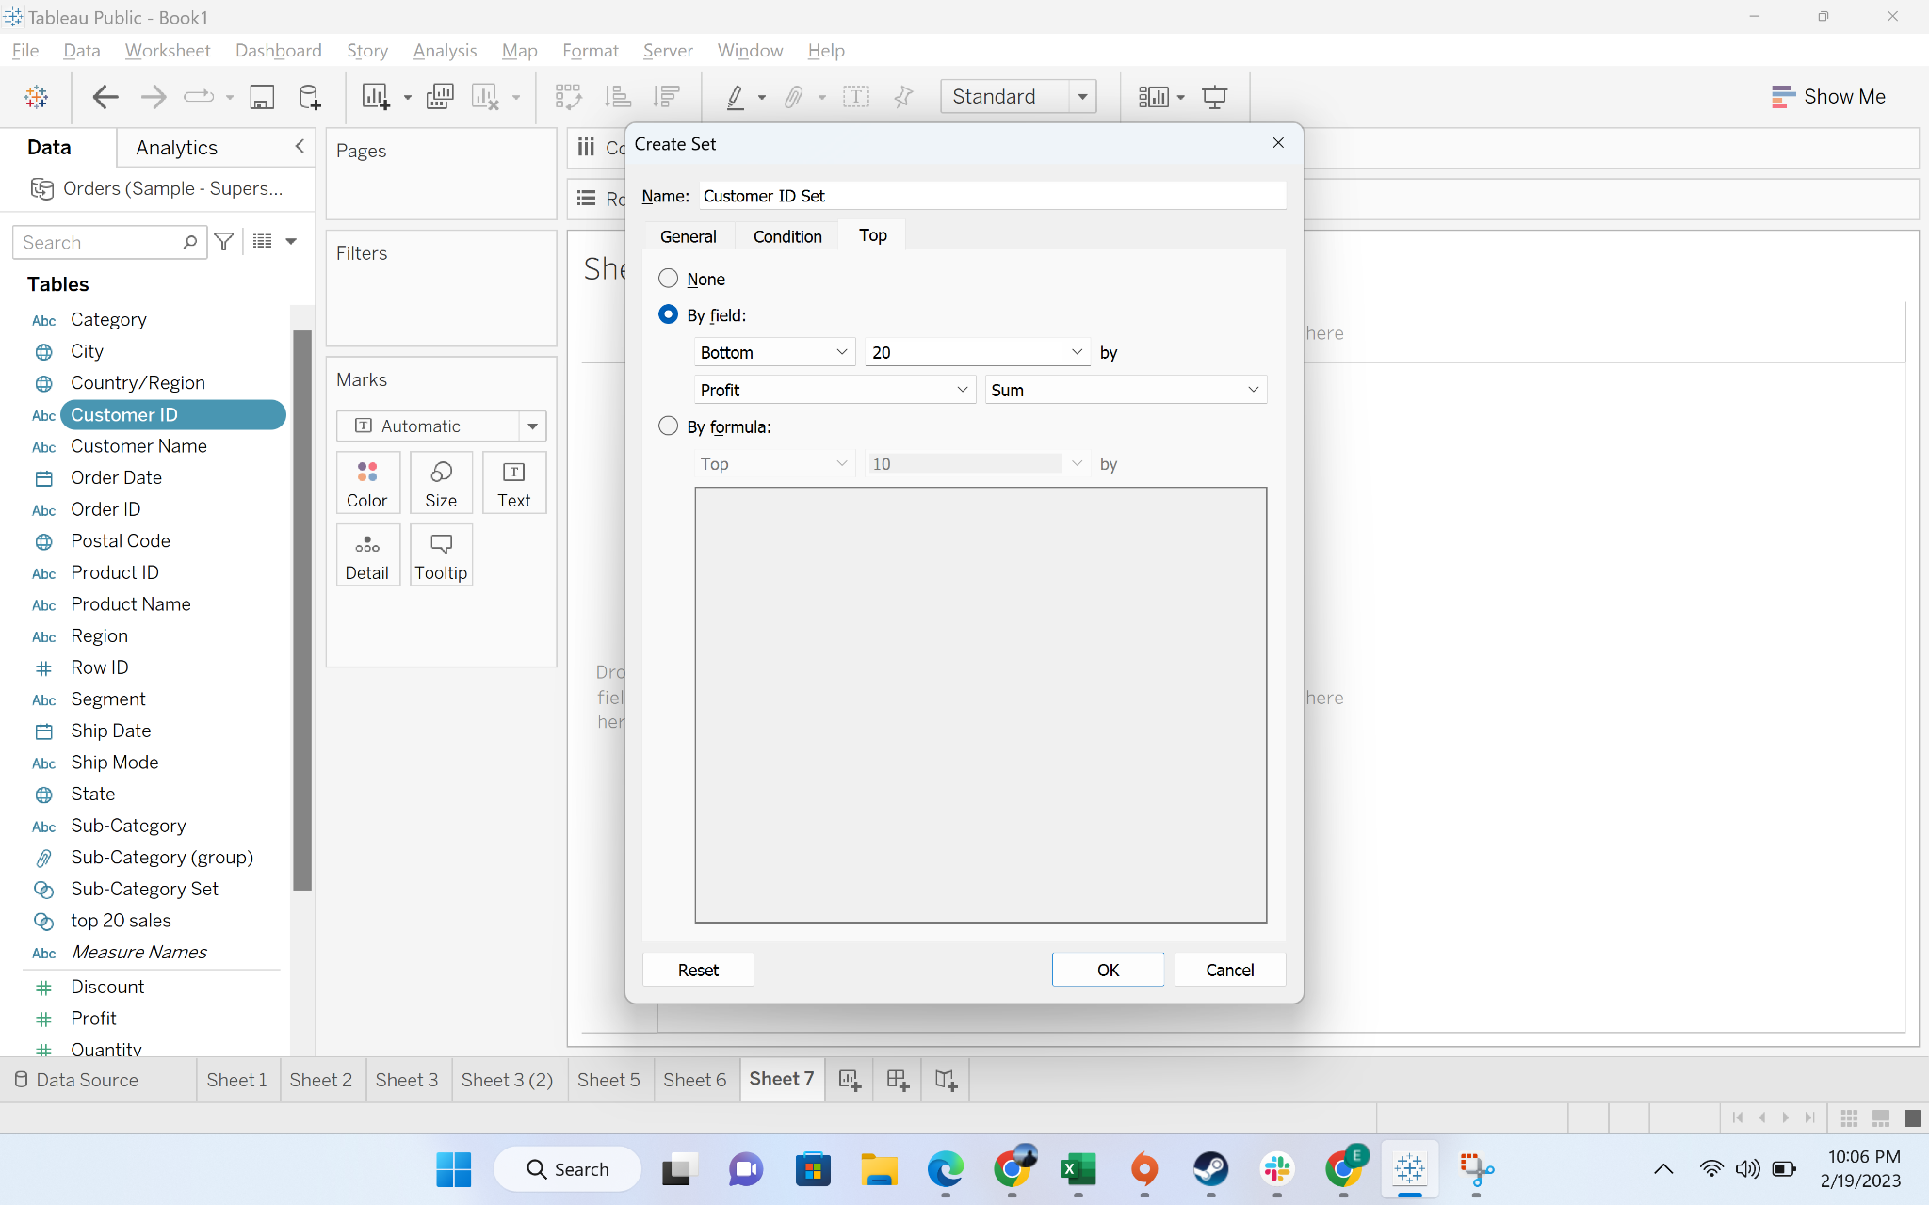

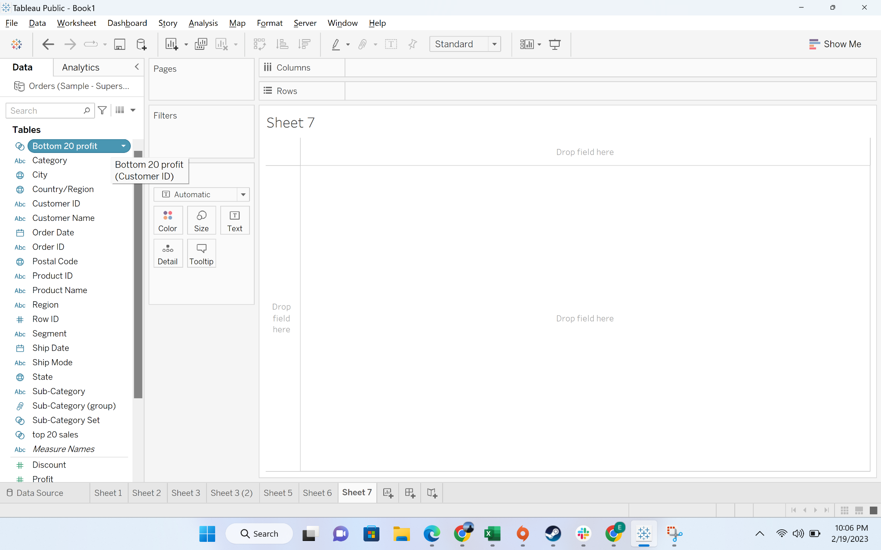

* Go to the set “Top 20 sales” and click on the drop down. You will find option to create combined set

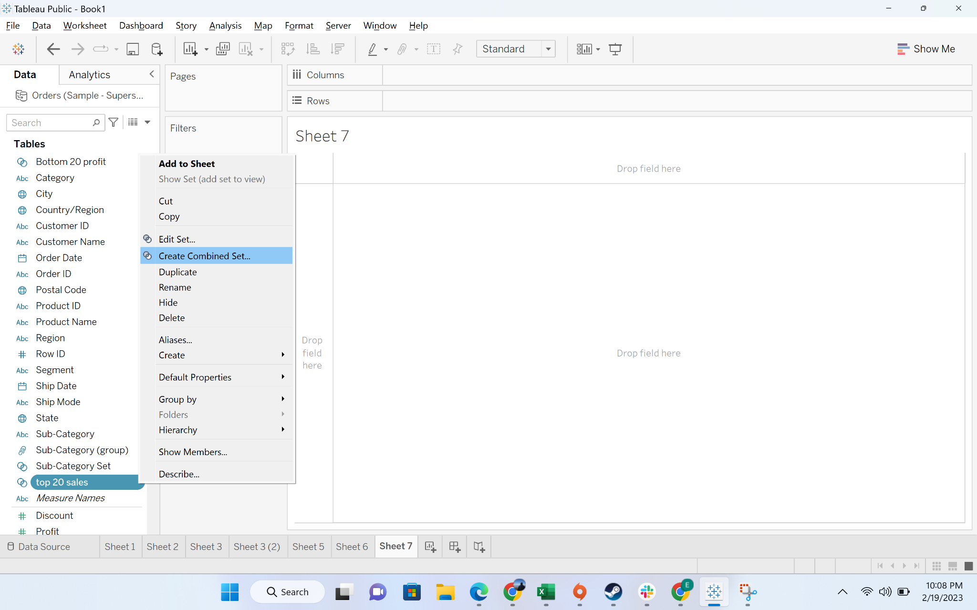

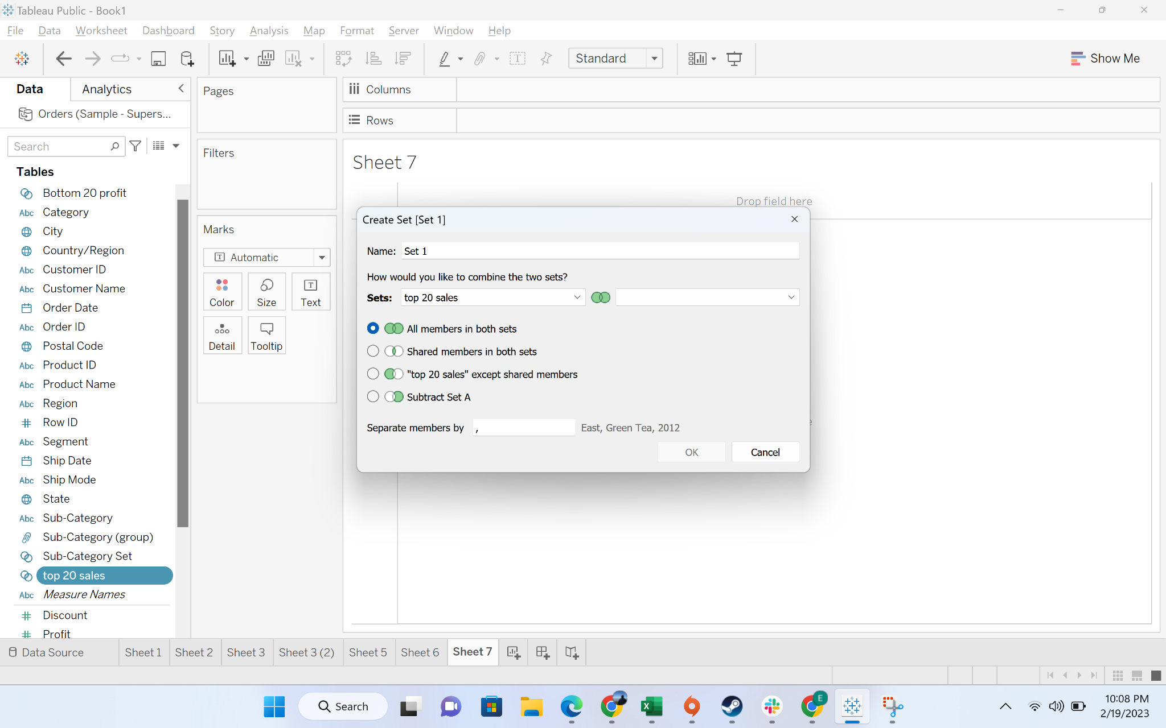

* Combine with the bottom 20 profit set

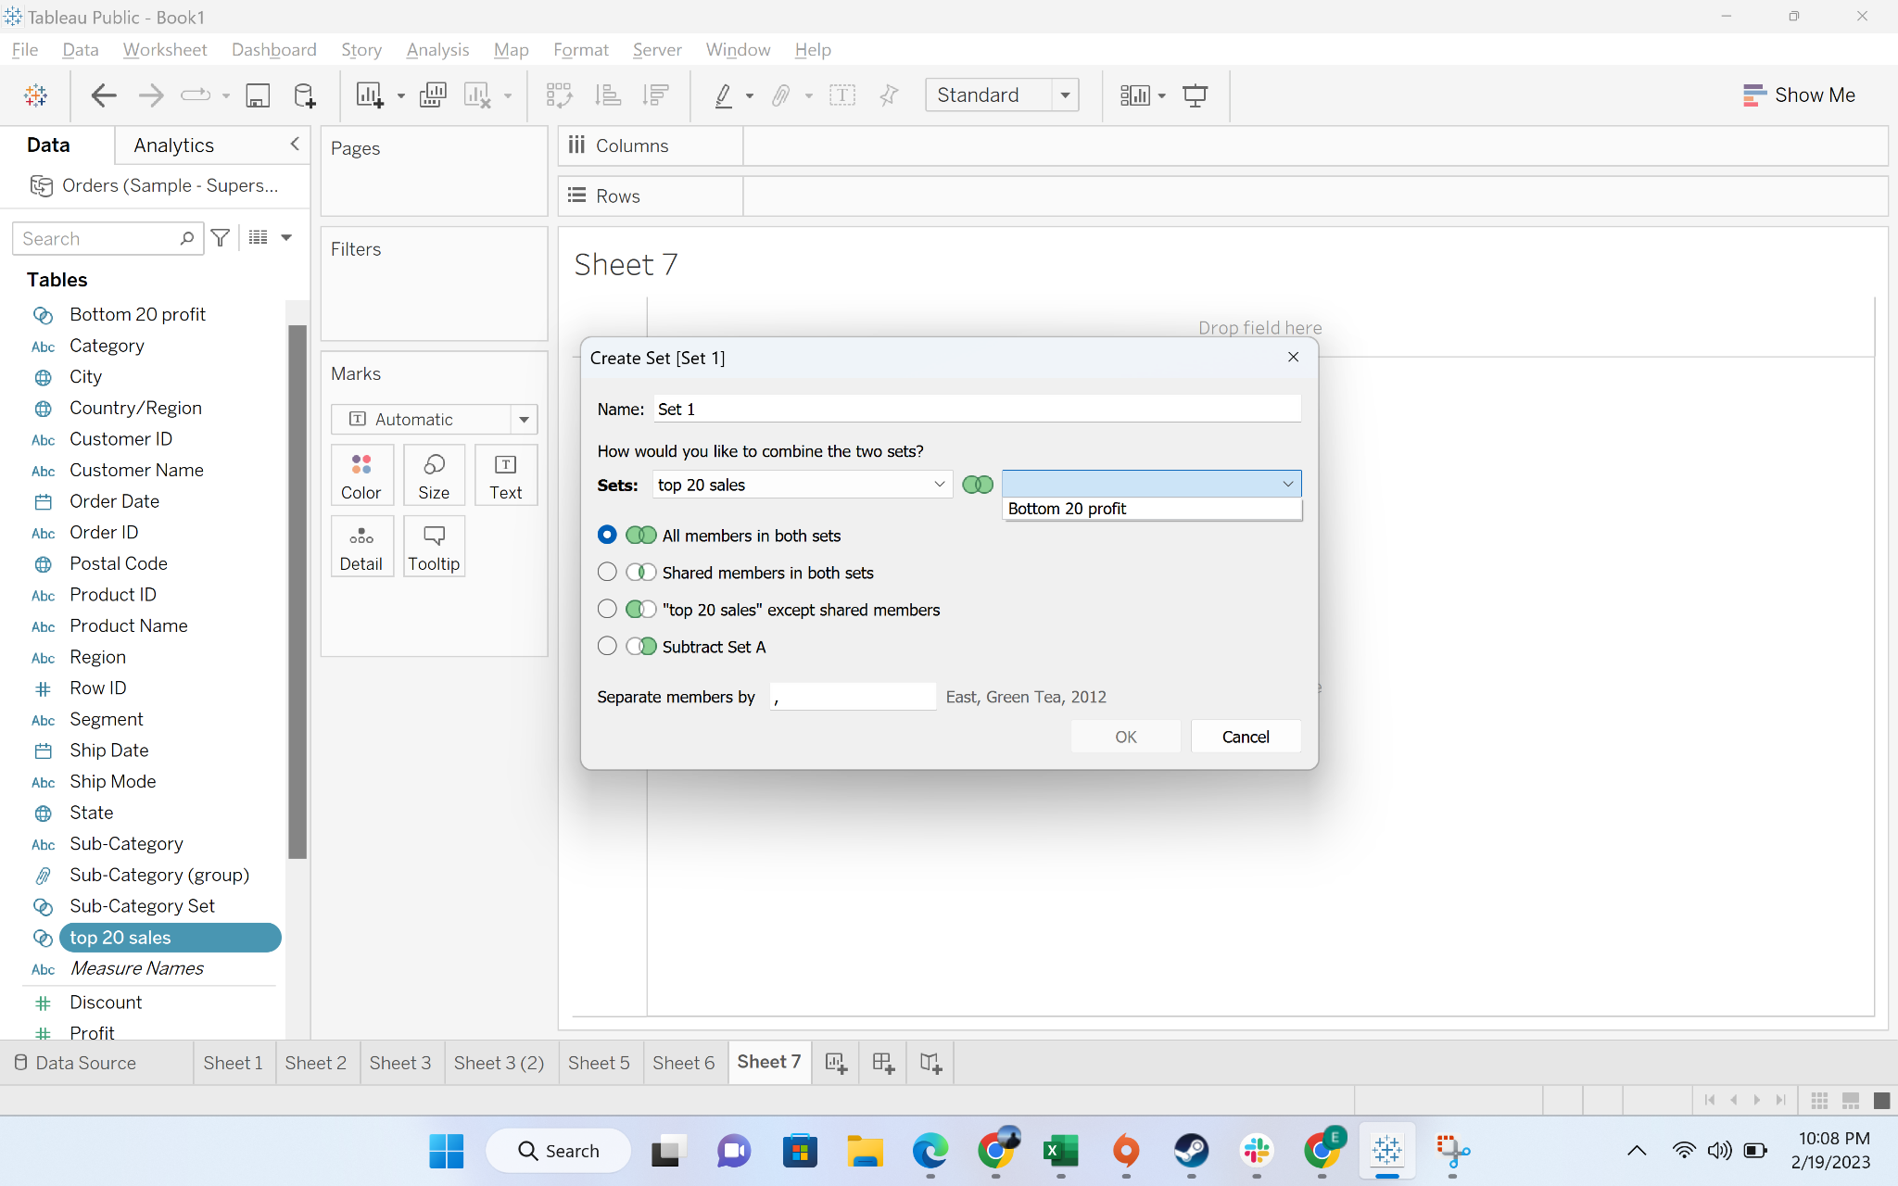

* Choose the “shared members in both the set” option

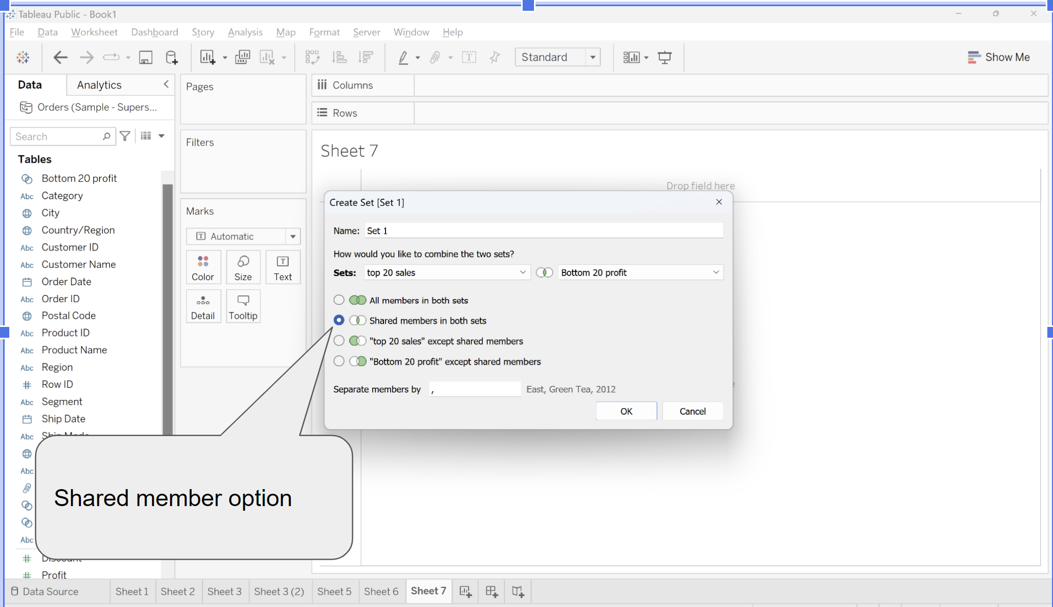

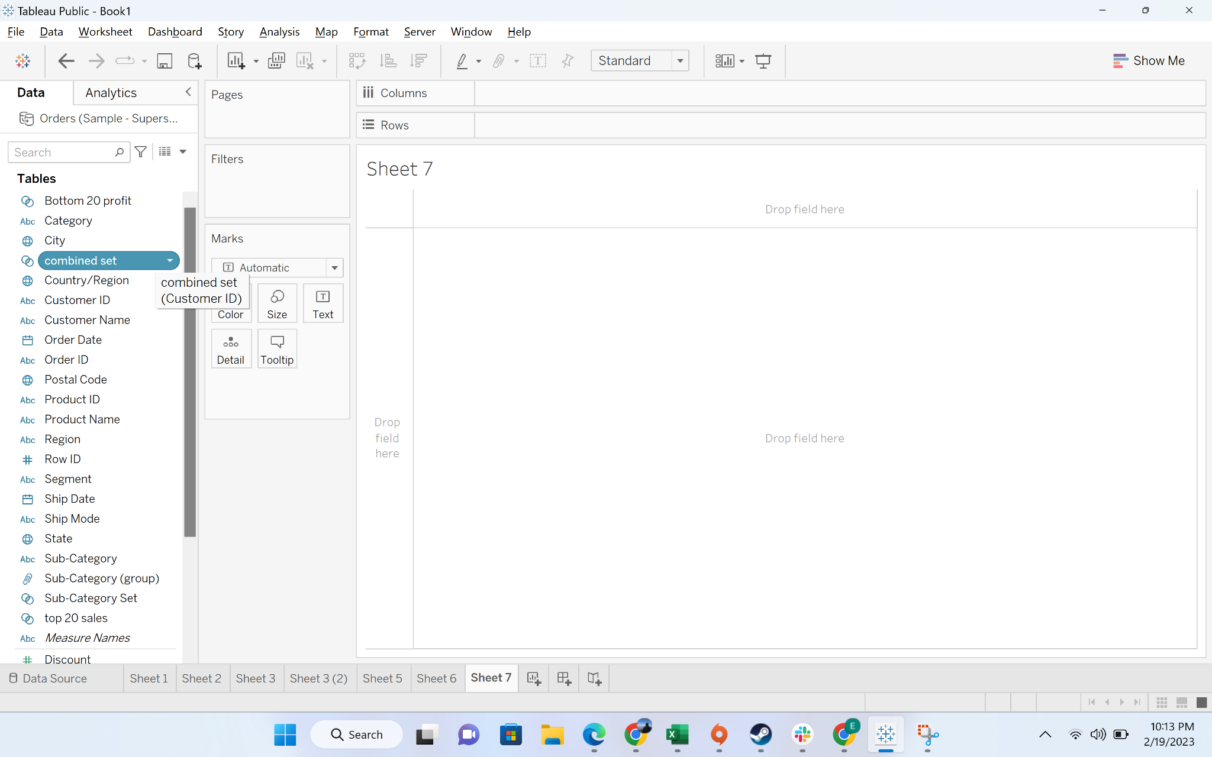

* Create a tabular view for each customer along with sales and profit

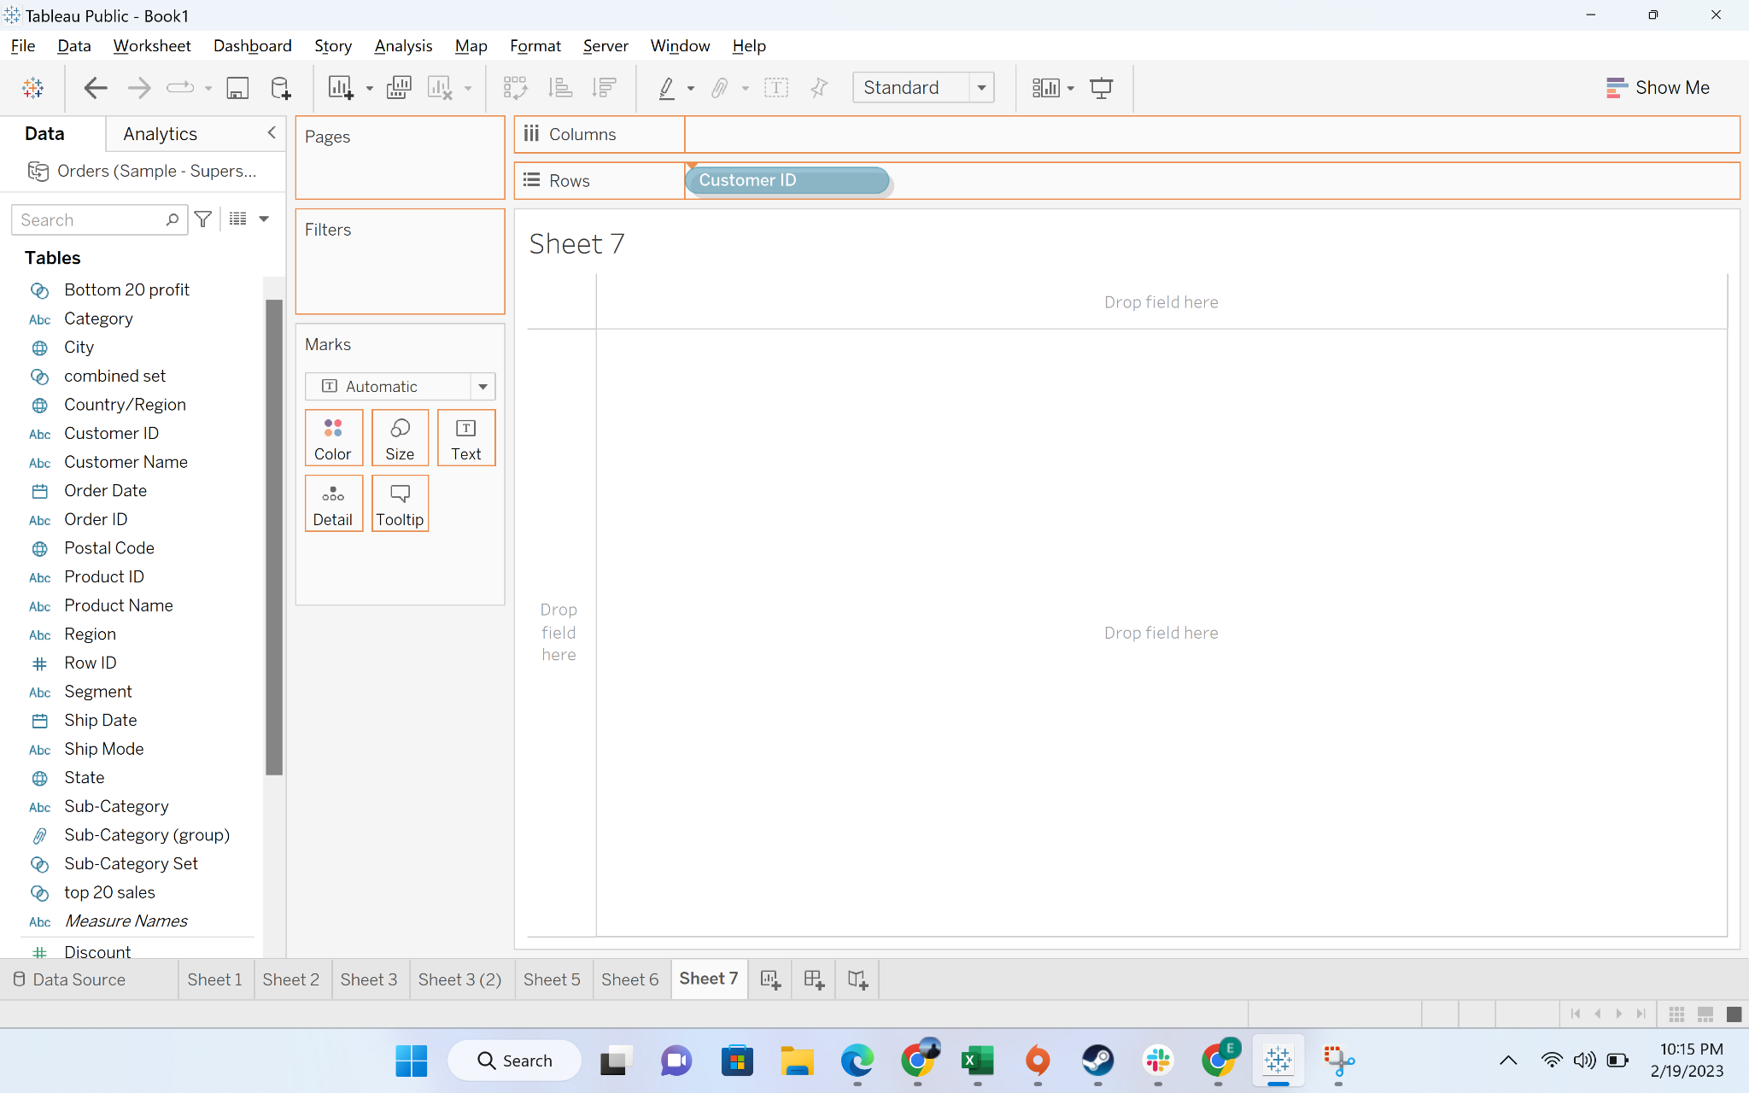

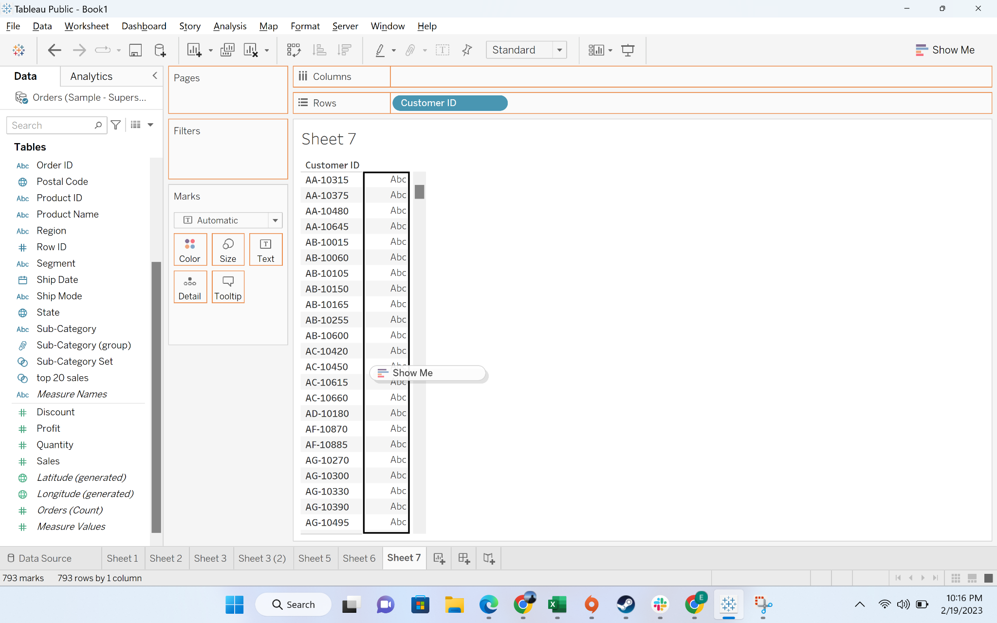

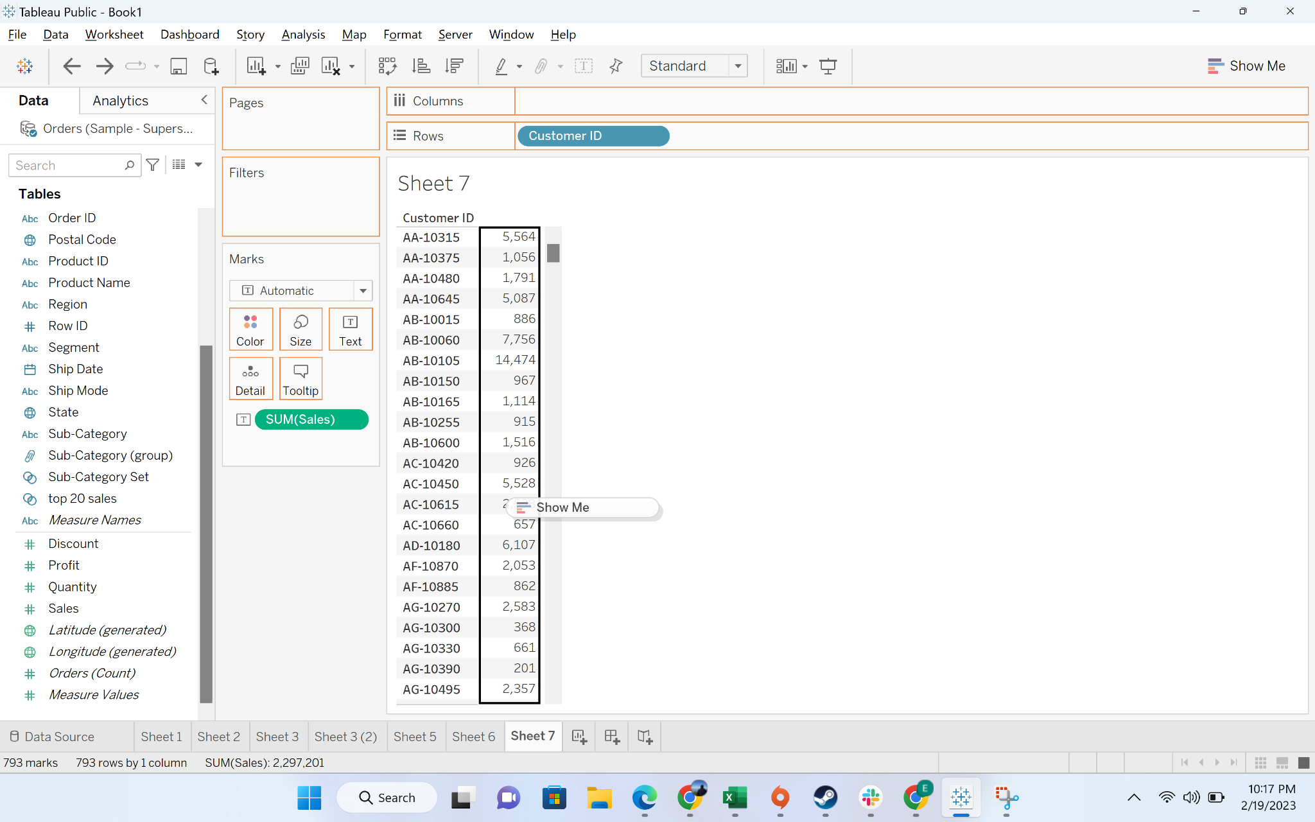

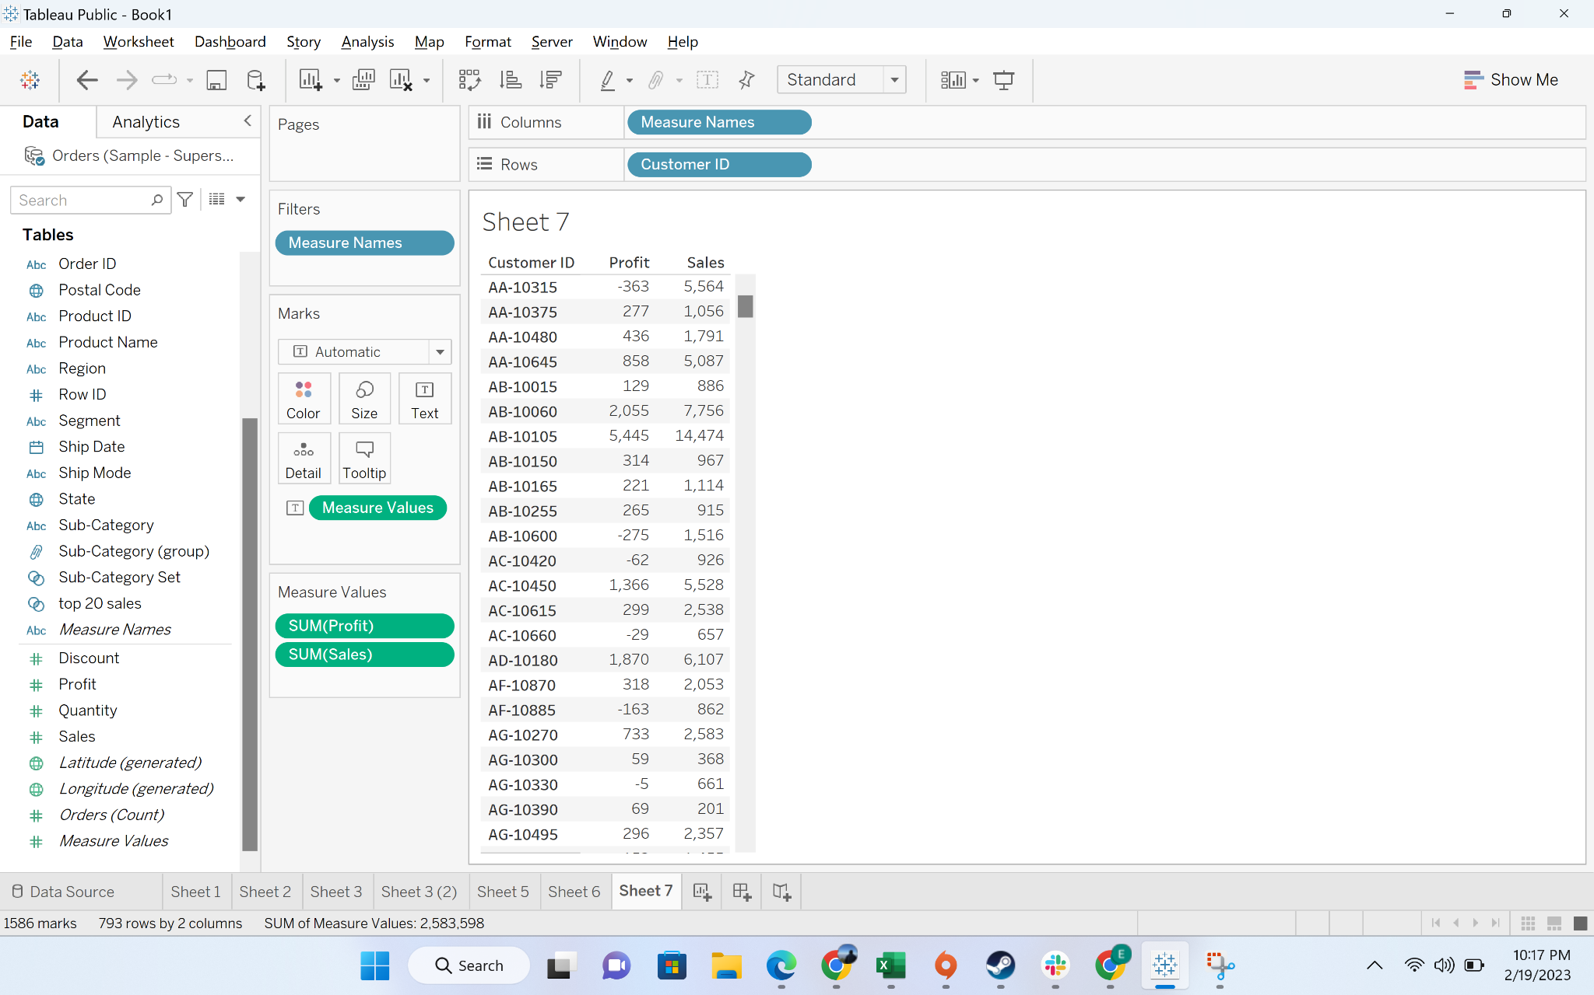

* Move the combined set to filter

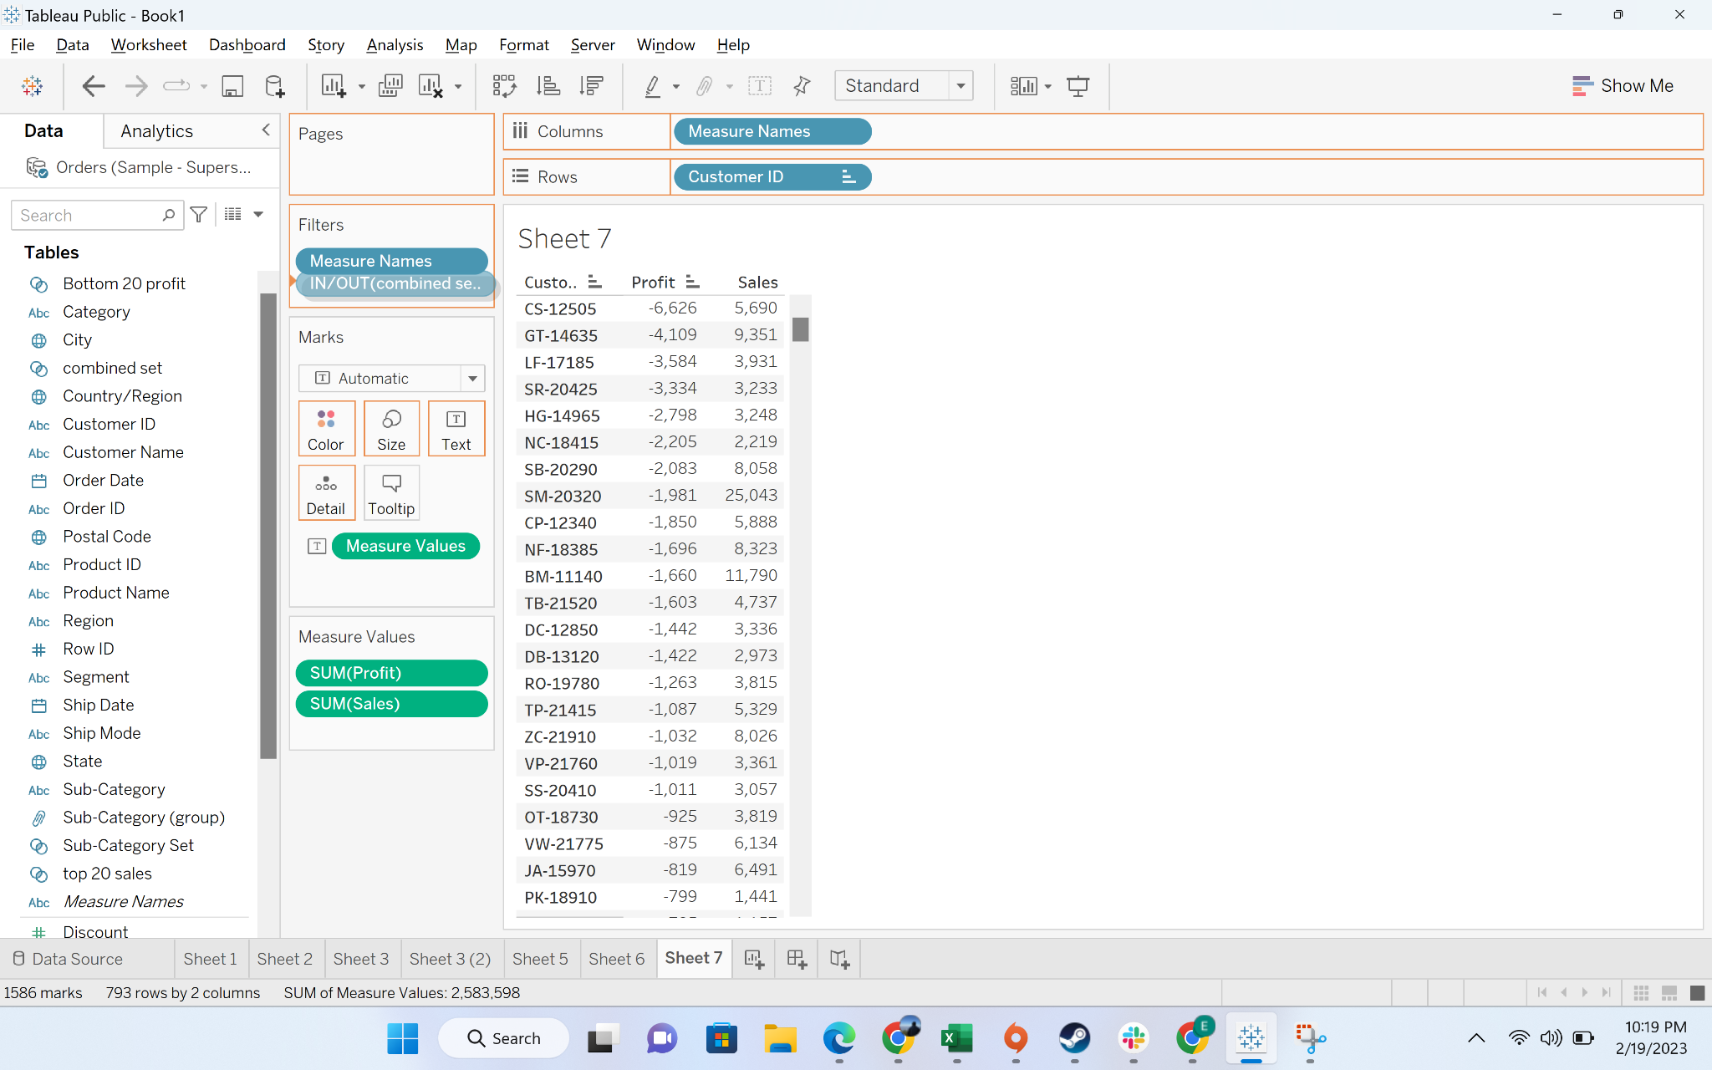

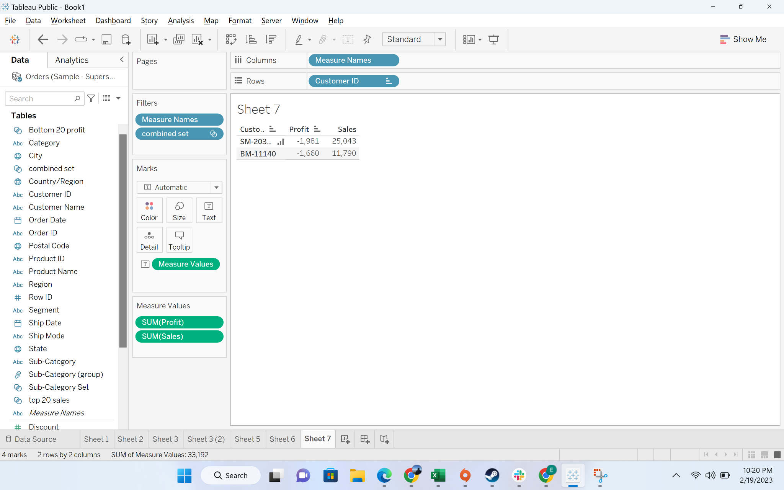

#### **Business problem 8**: Allow users to filter out the top 10 products subcategories by average discount.

Solution:

* **Business Context**
  + More than often, business stakeholders want the functionality to slice and dice data. For example, they might want to see the top 10 customers by sales. They might want to see which are the orders with negative profit. Hence, they need a functionality to customize the chart per their need
* **Intro to set:**
  + A parameter is a workbook variable such as a number, date, or string that can replace a constant value in a calculation, filter, or reference line.
* **Demonstration of creating a parameter**
  + Step-1: Reaching the parameter creation option

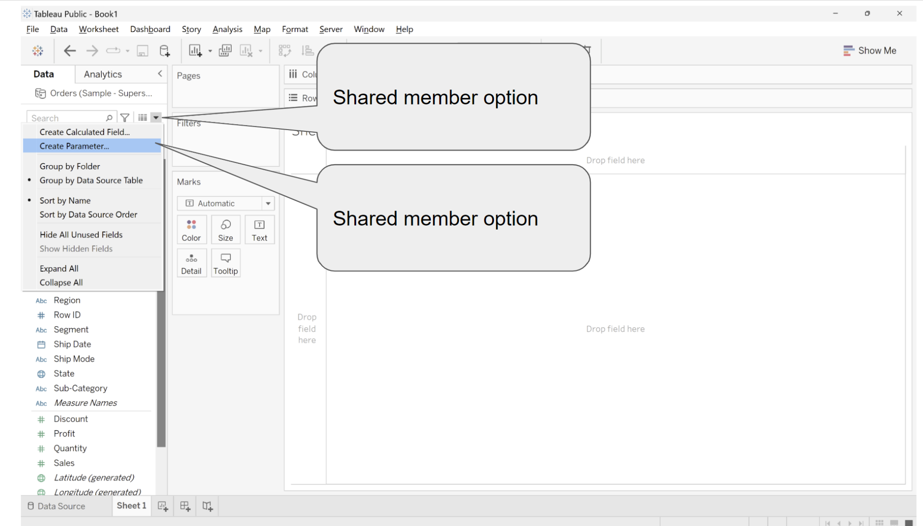

* + Step-2:Understanding the interface

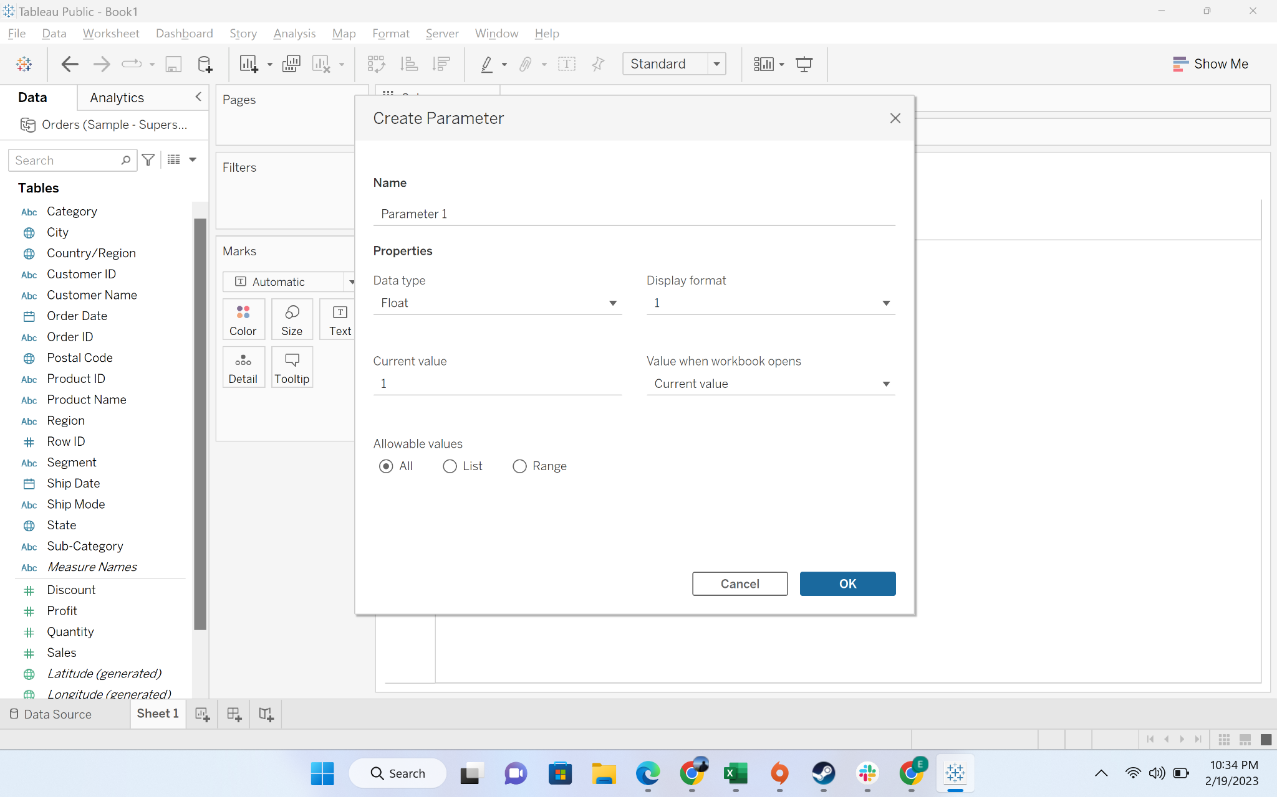

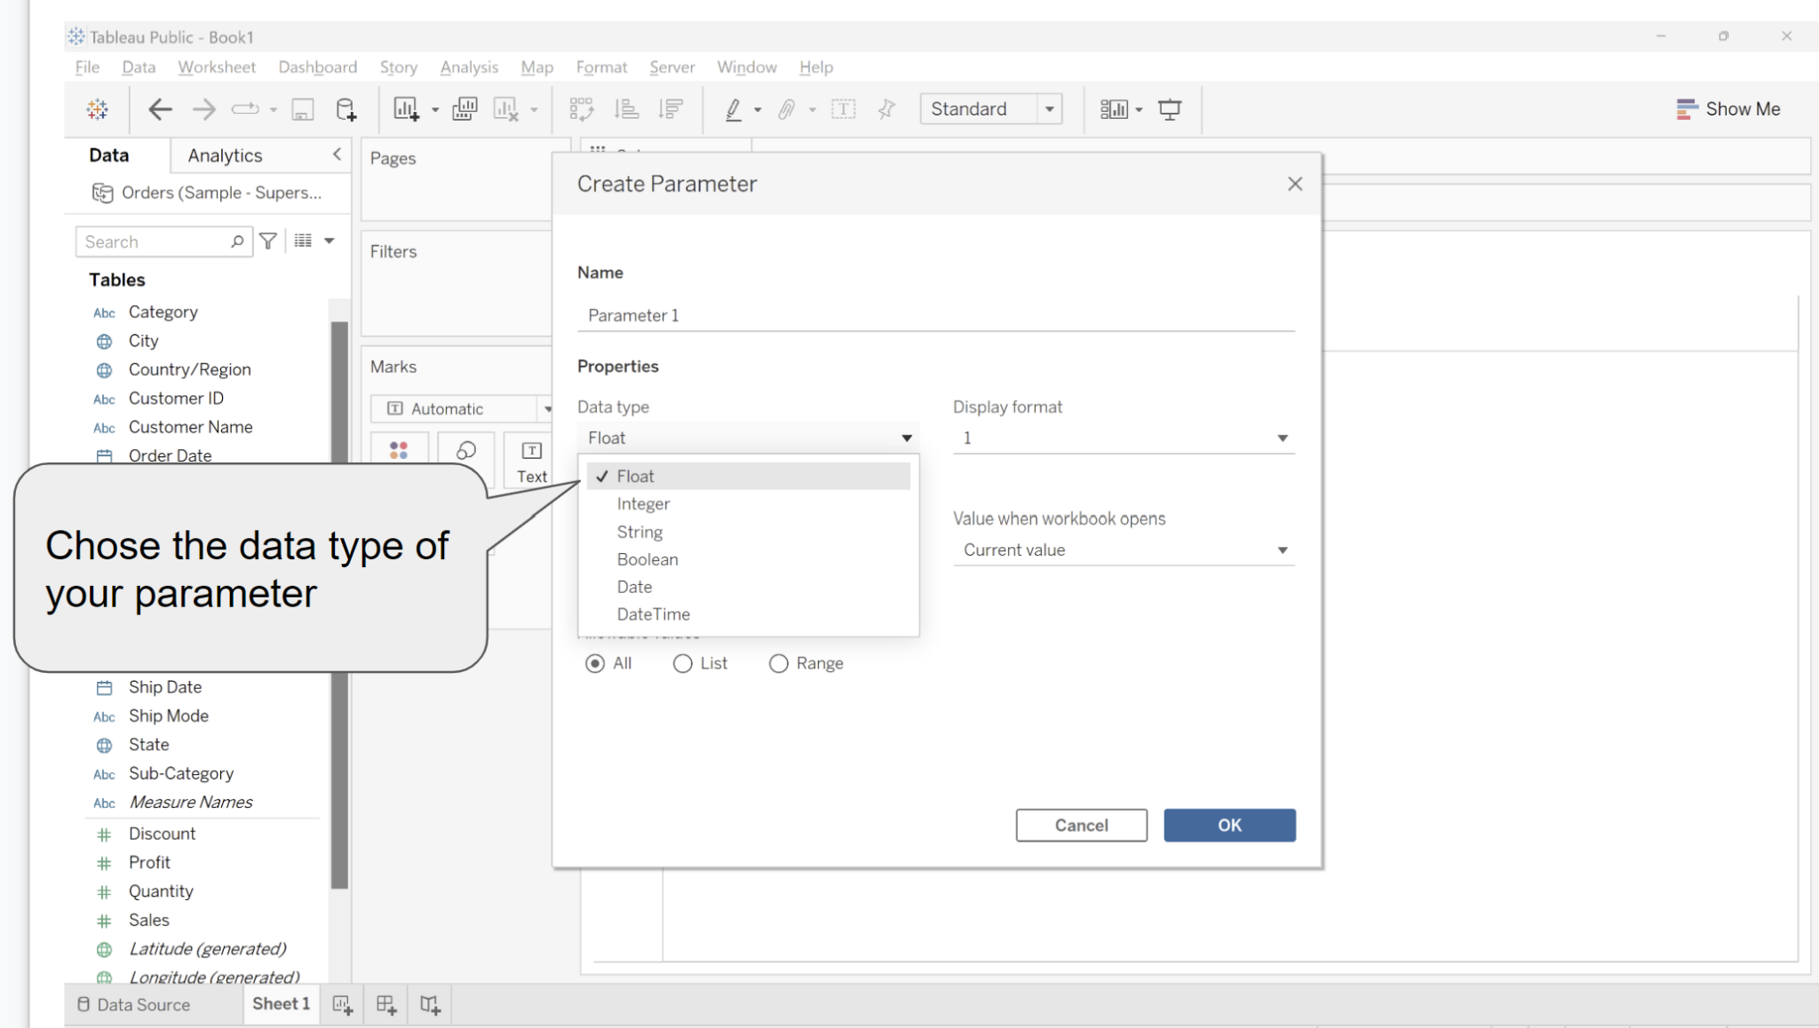

* + Step-3:Deciding allowable values

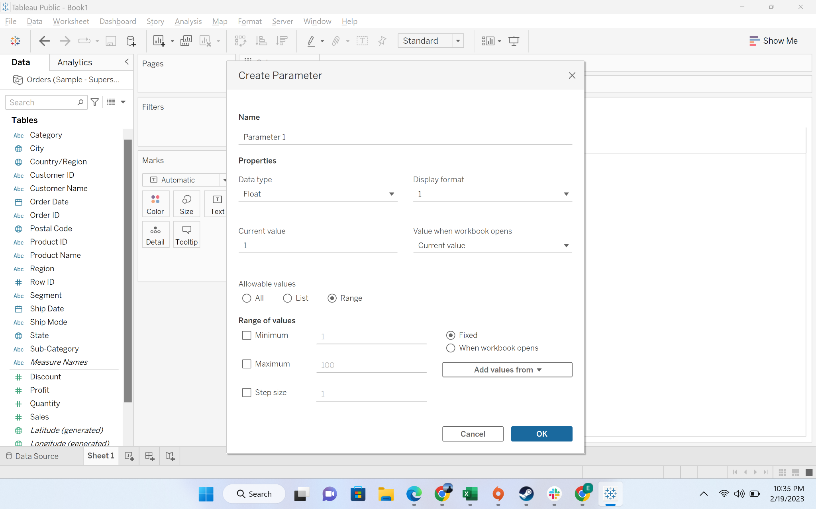

* + Step-4: Parameter creation for the problem

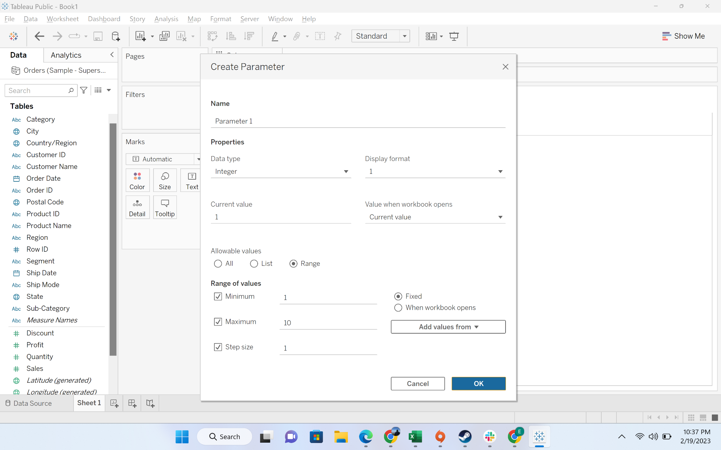

* + Step-5: Parameter created

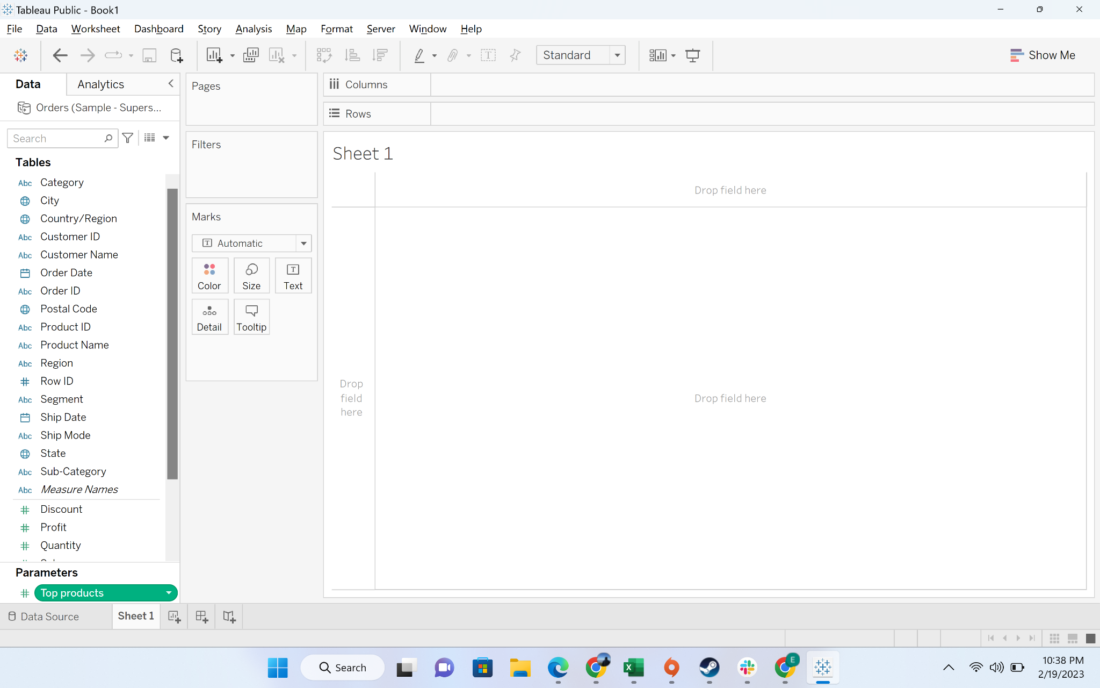

* + Step-6: Create a column chart by dragging “sub-category” to columns, discount to rows. Discount by default choose sum. Let’s convert it into average

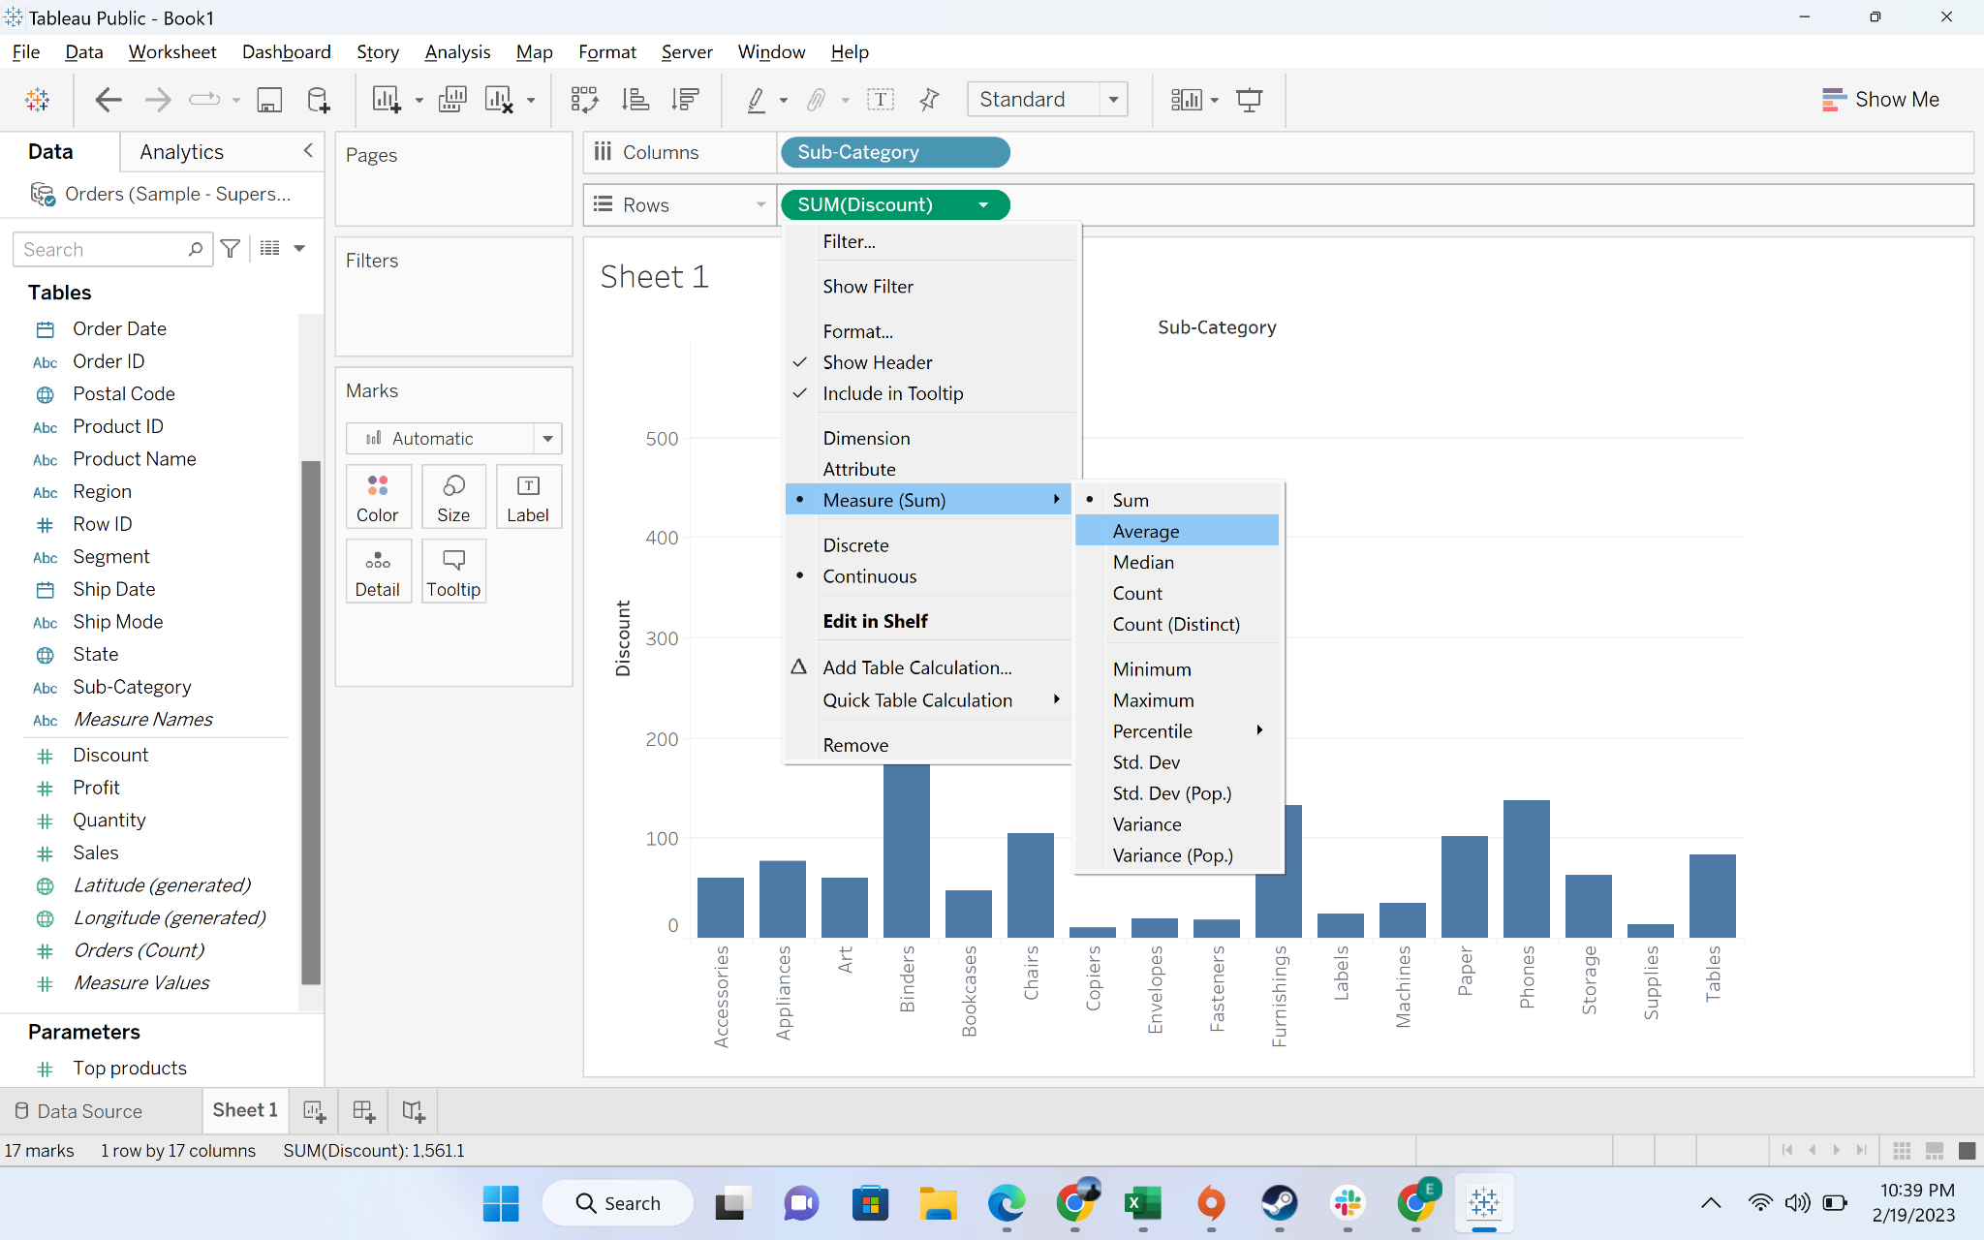

* + Step-7: Choose the option to show parameter

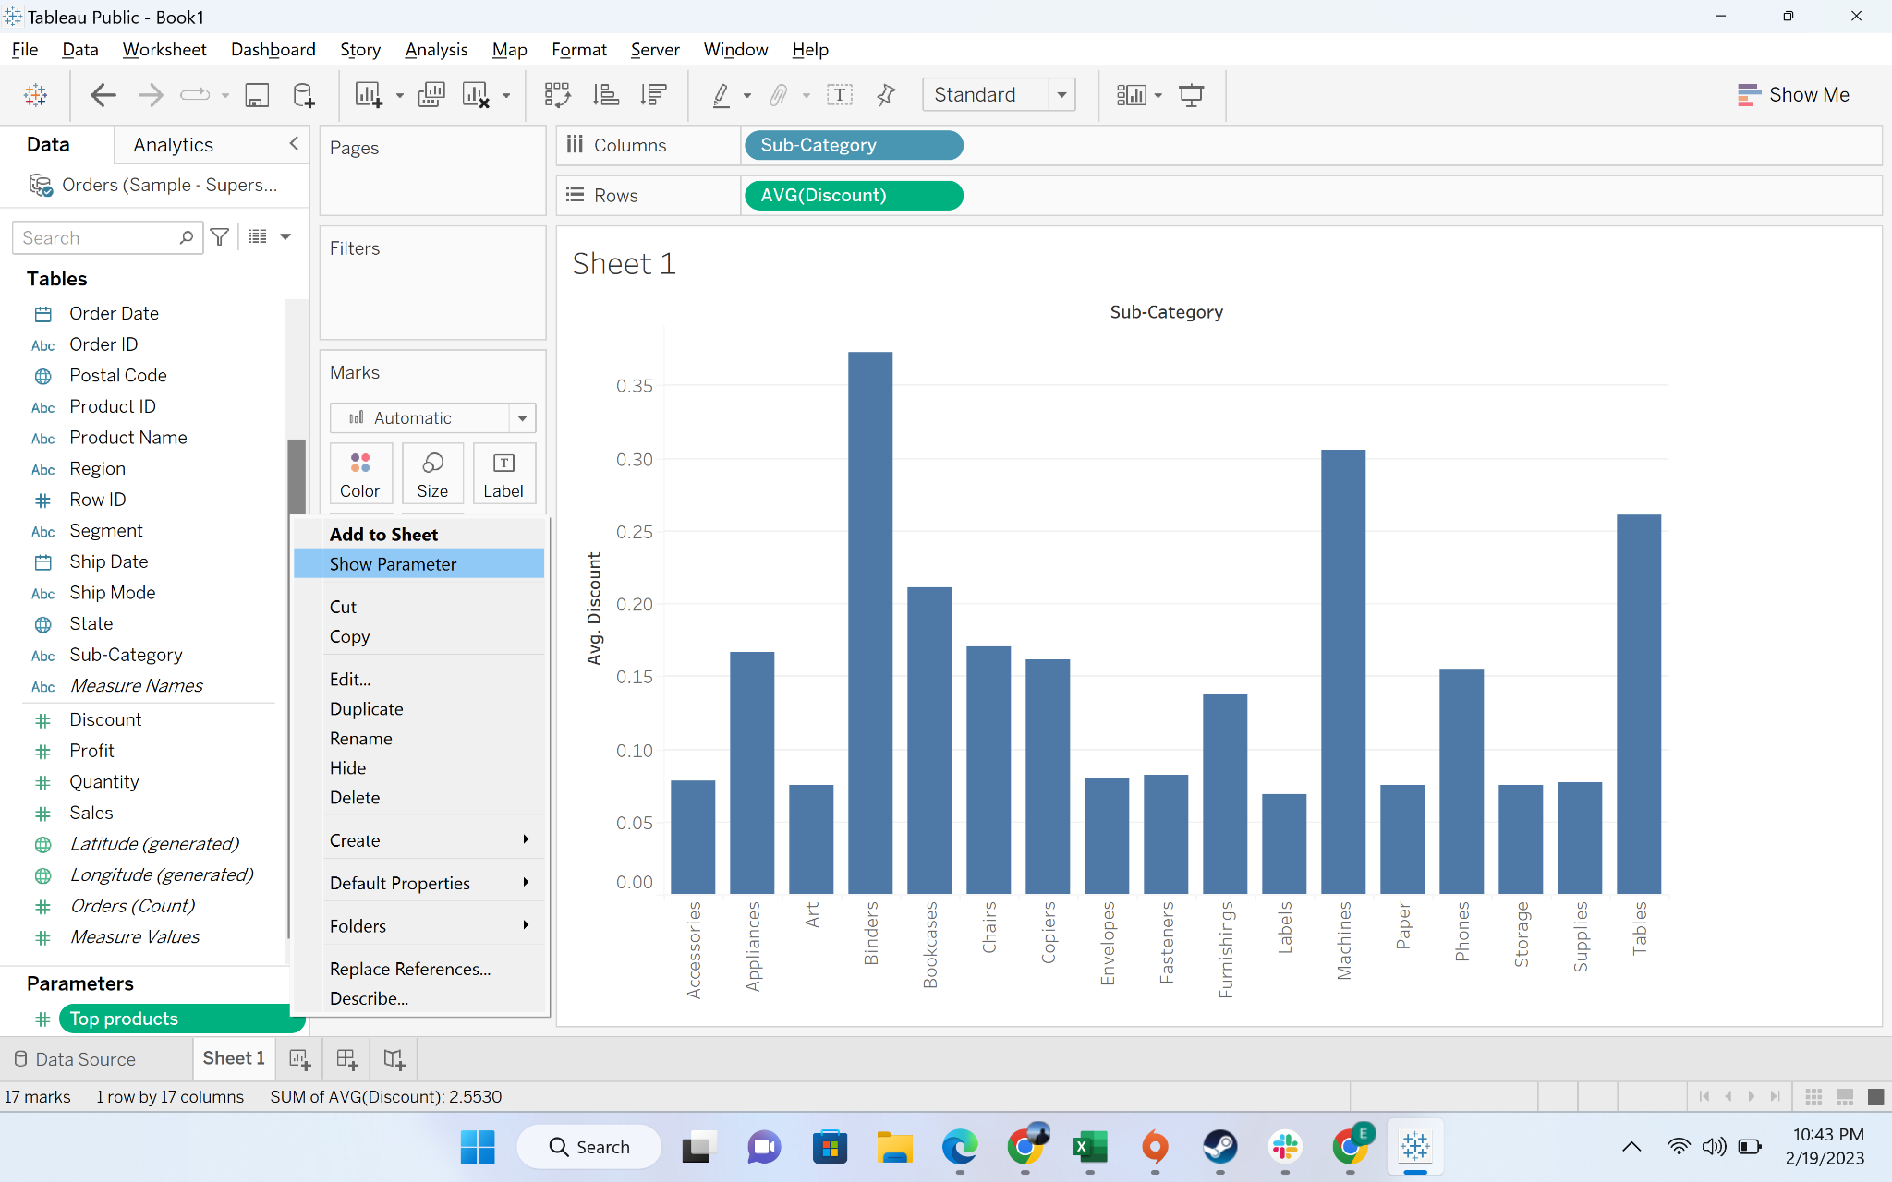

* + Step-8: Move subcategory to the filters and providing input from parameter

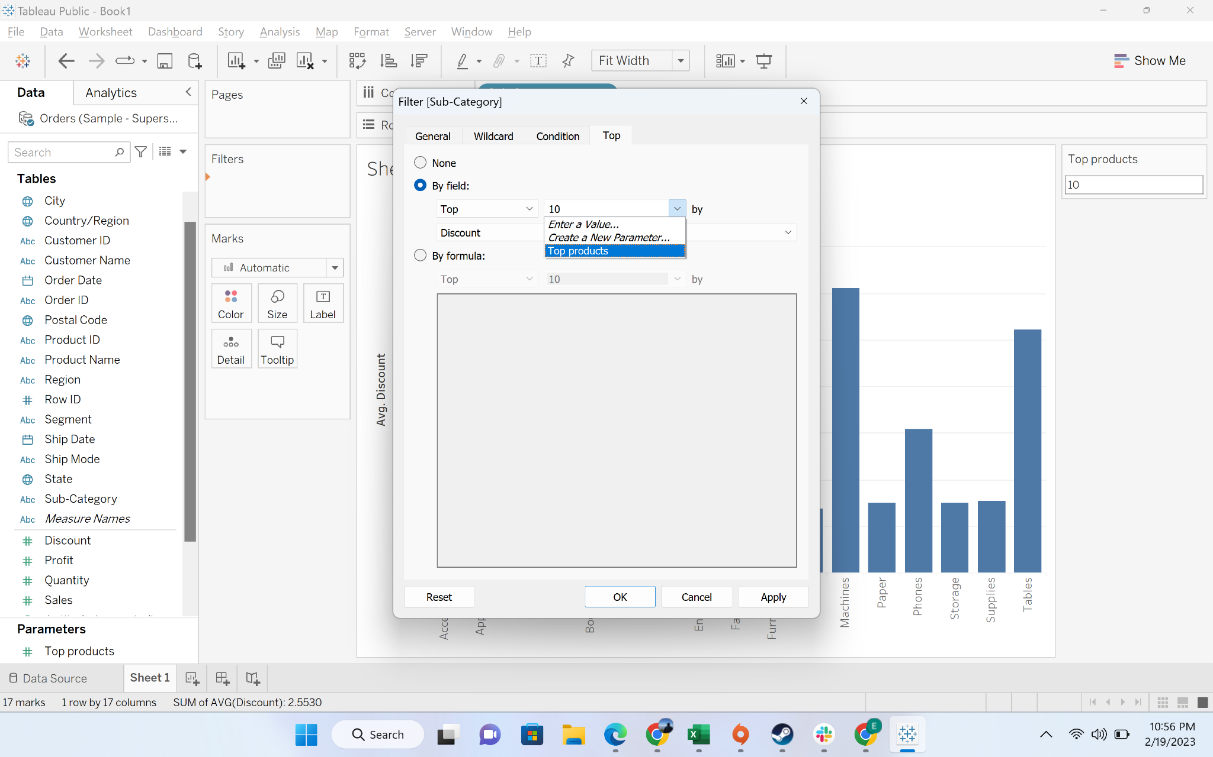

* + Step-9: Put 2 in the parameter

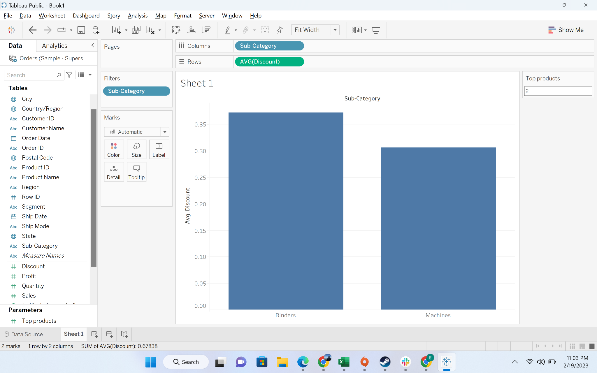

#### Business problem 9: Build a Hierarchy of Product category and Sub Category and have a plot which displays sales of product by category and drill it down using the hierarchy to display sales by sub category

* **Business Context**
  + In a lot of reporting, leadership want a drill down structure. For example: sales at a national level, then region, and then states. We can achieve this view by hierarchy
* **Intro to hierarchy :**
  + The Hierarchy in Tableau is **an arrangement where the entities are presented at various levels**. In common terms, Hierarchy is a system or organization that has many levels from highest to lowest; similarly, in Tableau, we can create hierarchies by bringing one dimension as a level under the principal dimension
* **Demonstration of creating a hierarchy** 
  + Step-1: Drag Sub-category to the category column

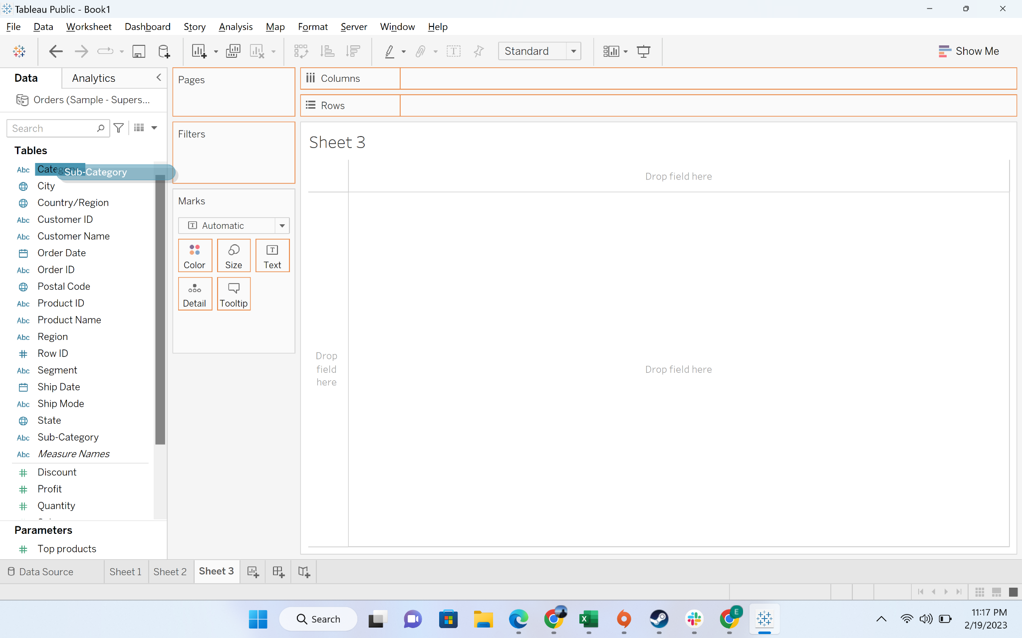

* + Step-2: Rename hierarchy to product

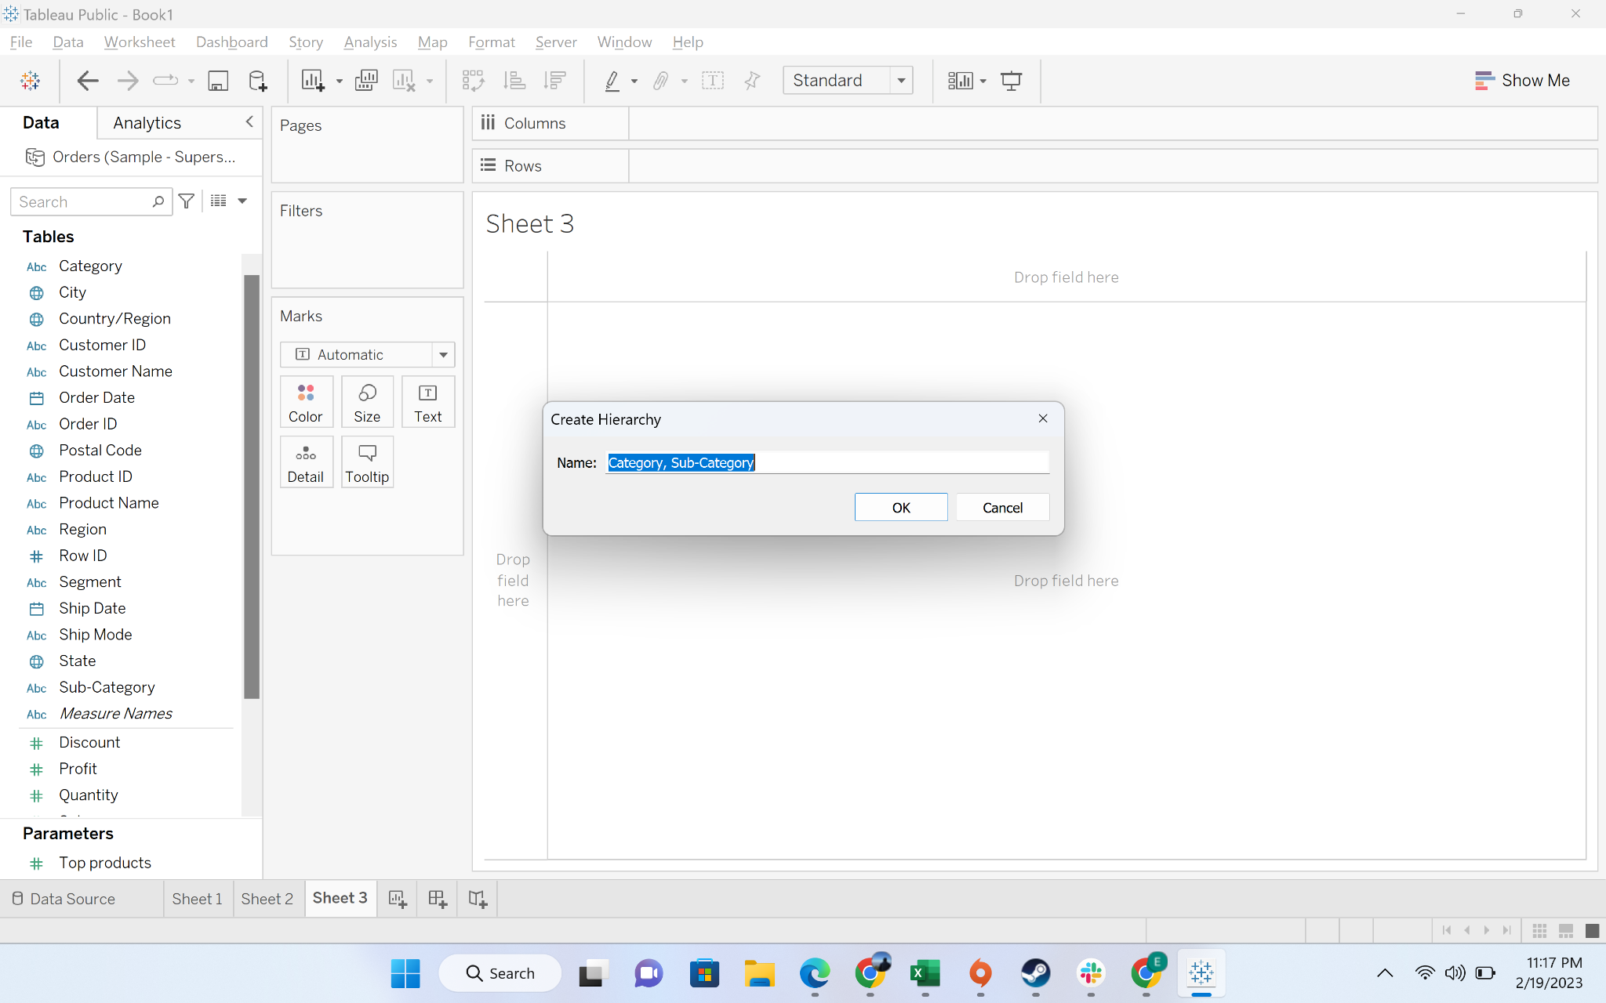

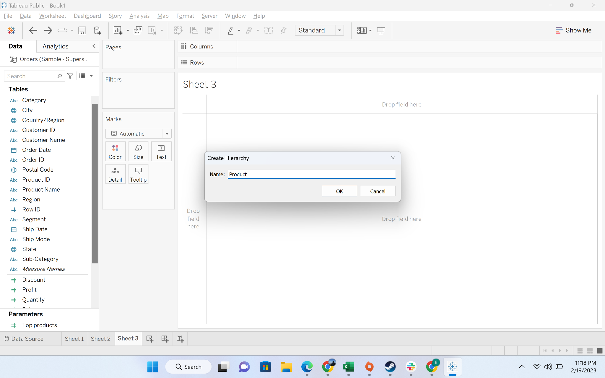

* + Step-3: You can see the hierarchy field

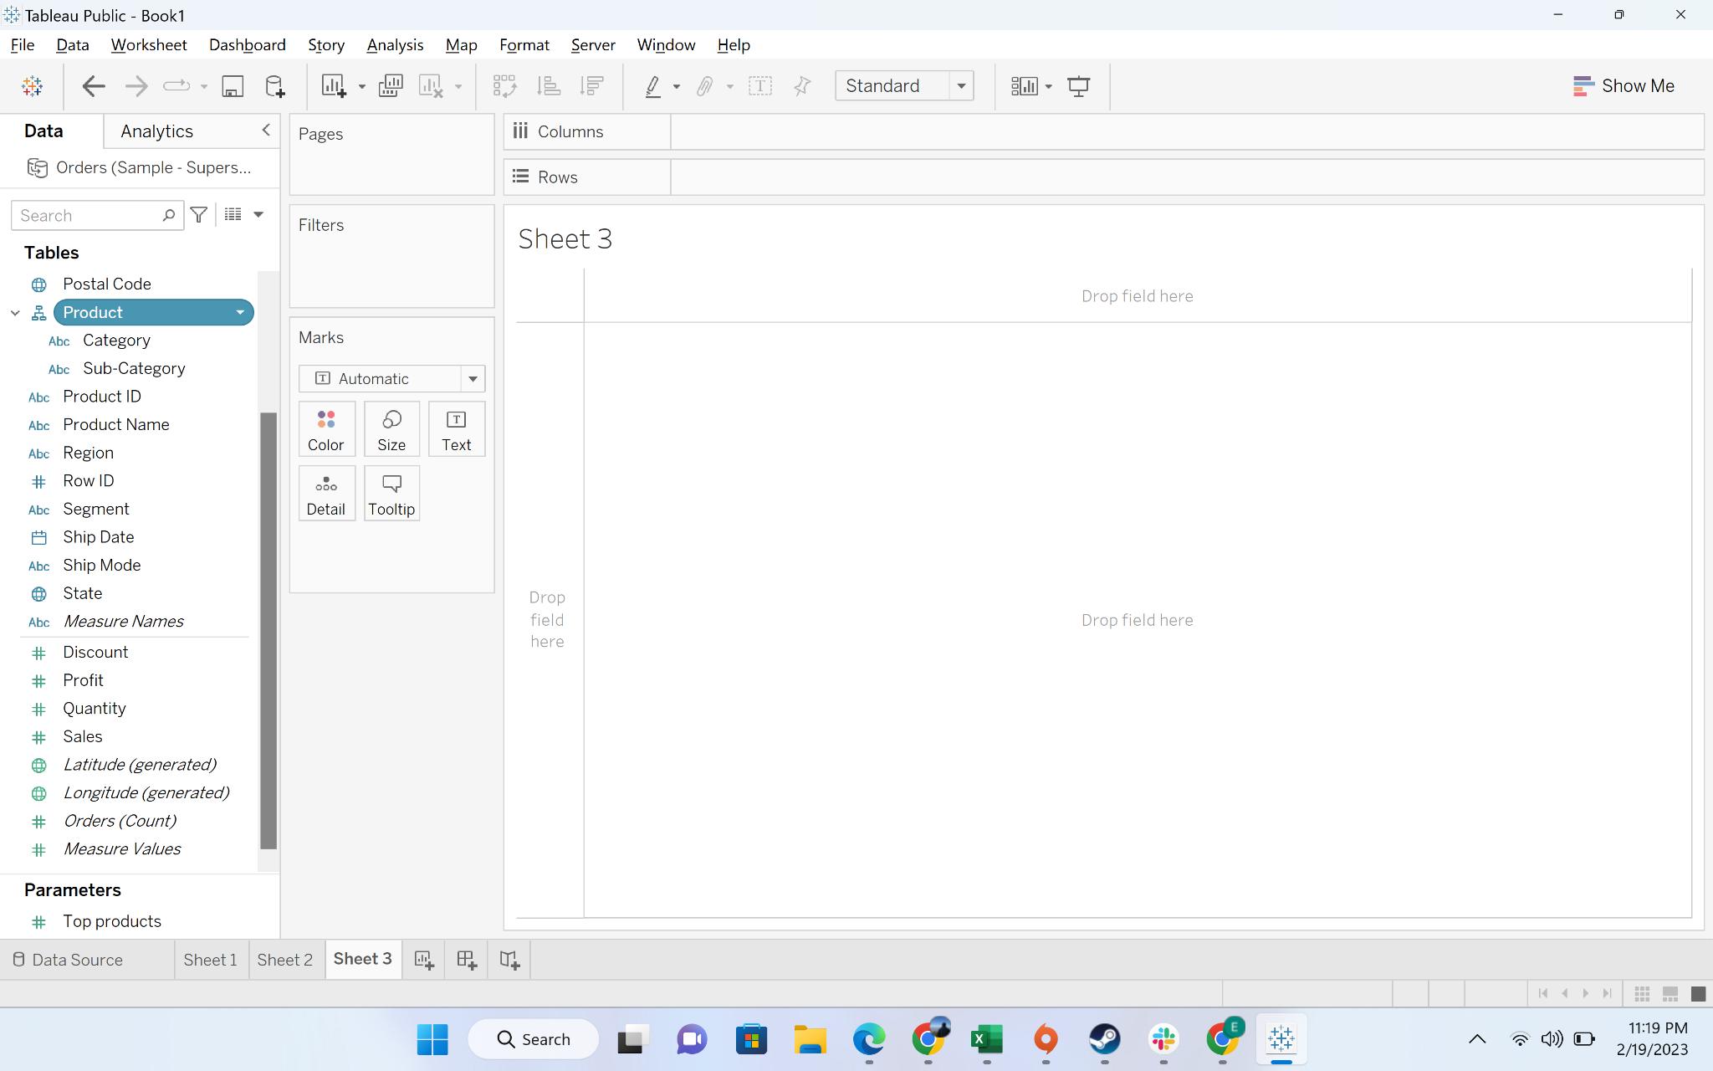

* + Step-4: Drag the product hierarchy to column and sales to row

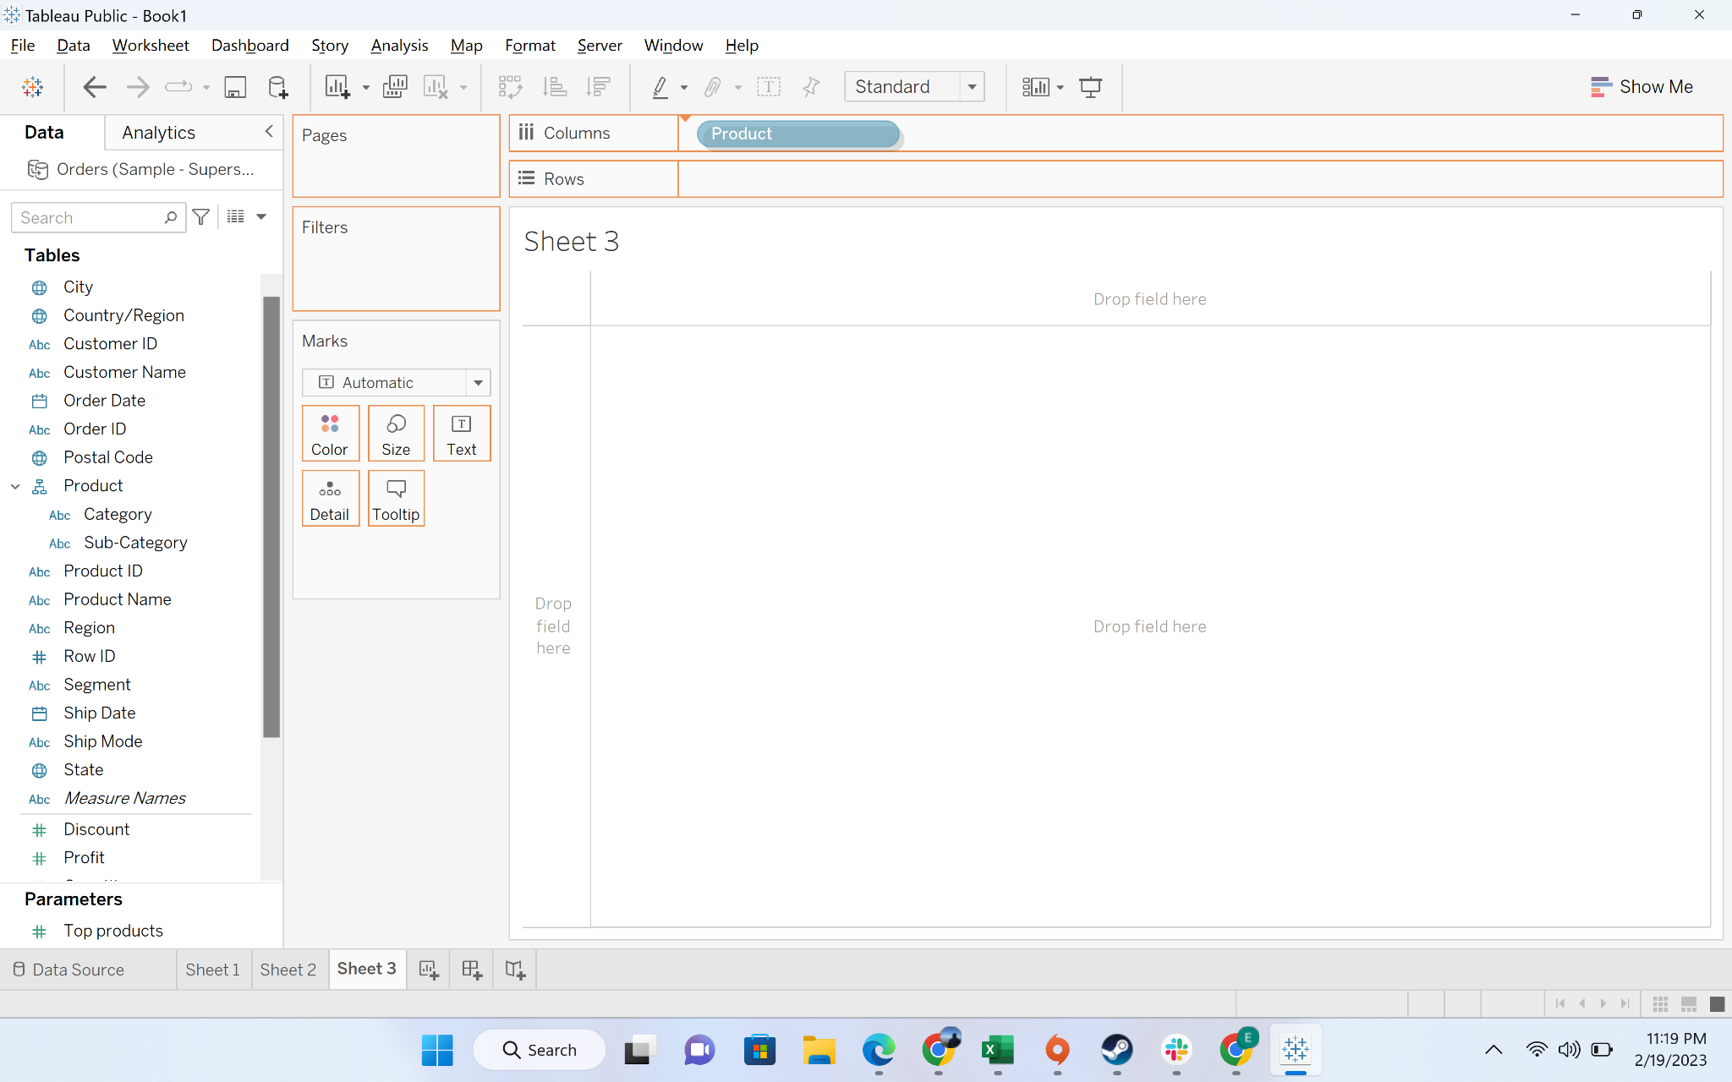

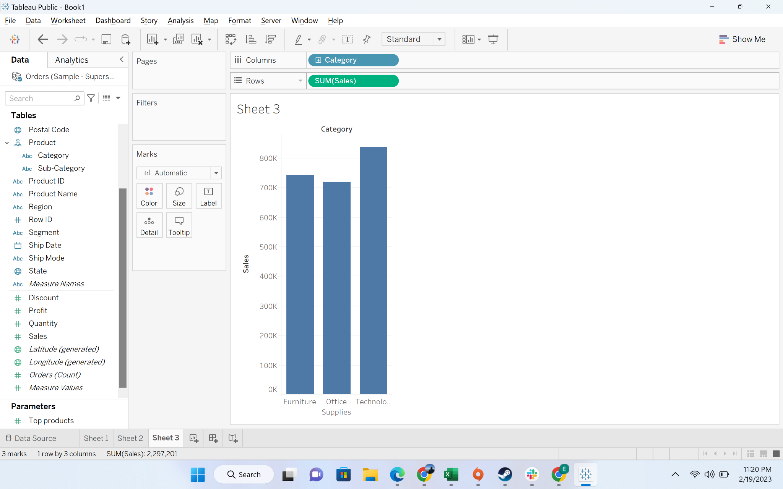

* + Step-5: click on the hierarchy to expand it and see the breakdown



 